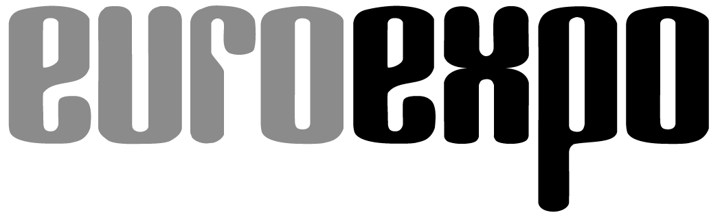
Messe- und Kongress-GmbH
Joseph-Dollinger-Bogen 7
D-80912 Munich, Germany
Phone: +49 (0)89 323 91-259
Fax: +49 (0)89 323 91-246
www.euroexpo.de
www.logimat-messe.de
www.tradeworld.de

March 8–10, 2016, Stuttgart Trade Fair Center

Presented at:

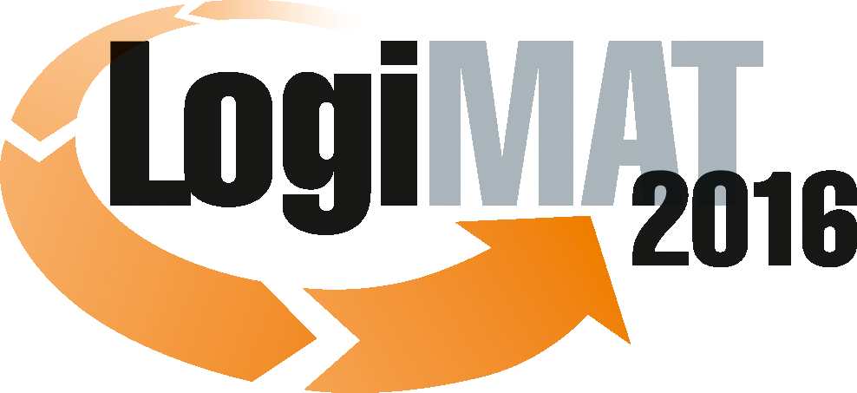

14th International Trade Fair for Distribution, Materials Handling, and Information Flow

Munich, March 8, 2016

Press Release

Position Paper – TradeWorld 2016 in Stuttgart
Integrated channels, efficient processes

A quick click – and then a long wait? That’s a deal-breaker in e-commerce. Customers want increasingly quick and flexible delivery options for goods they order online. The growing e-commerce and omnichannel markets require a smooth flow of goods. Today’s commercial enterprises need to integrate the flow of goods and information from various merchants and shippers as well as the manufacturers, service providers, and consumers involved in a transaction. The TradeWorld platform will be hosted for the third time in conjunction with the LogiMAT intralogistics trade fair, March 8–10 at the Stuttgart Trade Fair Center. The focus is on solutions and current trends in the B2B and B2C sales and distribution processes closely associated with logistics.

E-commerce is booming, and retail businesses that hope to succeed can no longer avoid managing both offline and online channels with the same degree of professionalism. Increased digitization is also changing established structures and posing new challenges for businesses.
TradeWorld looks at the entire process chain and brings together experts from across the spectrum of today’s omnichannel sales and distribution processes. Visitors to the TradeWorld exhibitors in Hall 6 will find solutions for retail 4.0, including e-procurement, payment, marketing, webshops, shipment management, fulfillment, and returns management. Given the growth in e-commerce, many LogiMAT exhibitors are also focusing more and more on their intralogistics products and systems for smooth omnichannel workflows, including warehousing, picking, conveyance technology, packaging, identification, and IT integration. These dual themes highlight the close interconnectedness of trade processes and logistics.

Challenges, trends, and drivers
Storefront retail and the various digital sales channels are increasingly merging, transforming commercial business models in the process. Nearly two-thirds of German online retailers maintain both a webshop and traditional brick-and-mortar stores. At the same time, e-commerce is driving an increased personalization of products and shrinking of order sizes, even as customers demand fast processing of orders and returns. Technological developments such as 3D printing will further the trend toward a more diversified product landscape. This is transforming logistical processes – from order processing and warehousing to the picking, packing, and shipping of the ordered goods, including delivery by a fulfillment service provider and the return of the goods, where necessary. Businesses today cannot succeed without optimized logistics.
New technologies such as iBeacons, which can already communicate with Android and iOS smartphones, enable totally new solutions for identifying, recording, and monitoring goods in transit or generating personalized product information at the point of sale. This opens up entirely new sales approach and marketing models. Customers today might have their online orders shipped to their home, their workplace, a trusted merchant, or somewhere else – and return from any of these locations as well. This creates big challenges for managing shipments and maintaining good “last-mile” efficiency.
Statement by Dr. Petra Seebauer, Managing Director of EUROEXPO Messe- und Kongress-GmbH in Munich and Director of TradeWorld 2016: “The key success factors for intense customer generation and retention in e-commerce and omnichannel are sales and marketing activities – and, above all, optimized logistics, which makes the smart integration of sales channels possible. TradeWorld and its slate of exhibitors address the trade-specific needs. Industry professionals benefit greatly from the decision to host TradeWorld as part of LogiMAT.”

TradeWorld profile and perspectives
TradeWorld is a unique event, focusing on the critical points in sales and distribution processes and on solutions for managing them. It offers movers and shakers from commercial enterprises in all B2B and B2C sectors a platform featuring a wealth of specialized information, products, services, and solutions to help them develop sustainable strategies for their e-commerce and omnichannel business models.
A series of presentations at this year’s TradeWorld offers insight into such themes as Fulfillment – fit for international e-commerce, Payments in digital commerce, Software applications in omnichannel trading, Urban logistics: solutions urgently required, E-commerce in B2B & B2C – two worlds, one strategy?, and Retail 4.0 – Is logistics fit for the trends in e-commerce?
Special attention is also given to alternative last-mile delivery concepts and same-day delivery. Same-day delivery concepts and even specific time slots disrupt the traditional service portfolio of parcel services and underscore the need for new product ideas in the package delivery market. This presents logistical challenges when it comes to special warehousing, goods buffering, and especially the degree of automation in picking – to name but a few points. TradeWorld has responded with a special exhibition entitled Urban logistics: Alternative vehicle concepts for city logistics. The exhibition presents low-emission vehicles that parcel service providers are already using today, including various electric trucks and cargo e-bikes.
Statement by Dr. Petra Seebauer, Managing Director of EUROEXPO Messe- und Kongress-GmbH in Munich and Director of TradeWorld 2016: “In addition to the last mile and current discussions about same-day delivery, we will of course also continue to follow developments in mobile payment, which even traditional banks are now embracing. So there are a lot of strategic challenges that TradeWorld, with its direct connection to LogiMAT, can address.”

For more information, please visit: www.logimat-messe.de and www.tradeworld.de

Munich, 6,436 characters – This text may be reprinted free of charge, but please send a copy to EUROEXPO Messe- und Kongress-GmbH, Press and Public Relations Department, 80912 Munich.

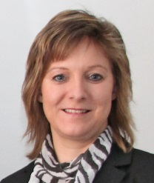 | Dr. Petra Seebauer  Managing Director of EUROEXPO Messe- und Kongress-GmbH in Munich  and Director of TradeWorld 2016

