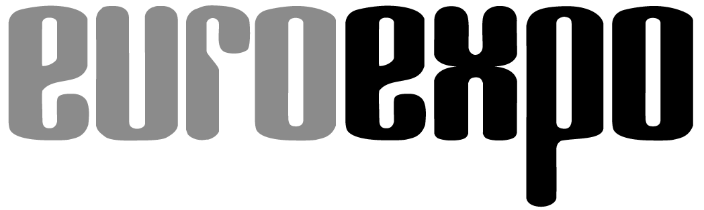
Messe- und Kongress-GmbH
Joseph-Dollinger-Bogen 7
D-80807 Munich, Germany
Phone: +49 89 32 391 259
Fax: +49 89 32 391 246
www.euroexpo.de/en
www.logimat-messe.de/en
www.logimat.digital

Munich, June 10, 2021

Press Release

LogiMAT.digital Summer Summit
A full three-day program with the quality you expect from LogiMAT

A sophisticated program of events with the added value of an industry conference: This is what has defined the LogiMAT brand and its success. Program highlights—including the BEST PRODUCT Awards Ceremony, IFT Day, and lecture series on today’s challenges with direct real-world tips—will now be livestreamed from Stuttgart at LogiMAT.digital during the “LogiMAT.digital Summer Summit,” June 22–24, 2021.

Even though the international trade show LogiMAT Stuttgart had to be postponed to March 2022, the international Intralogistics Community can still experience popular event highlights livestreamed at www.logimat.digital from June 22 to 24. Registration is free and without obligation: The same added value in proven LogiMAT quality benefits individuals and companies alike.

The "LogiMAT.digital Summer Summit” opens on June 22 at 10 a.m. The first day offers a LogiMAT Daily Roundtable and an exciting series of lectures focusing on AGVs before all eyes turn to the BEST PRODUCT Awards Ceremony. Industry journalist Anja Seemann will moderate the three-day program and present the winners from 2020—which included two startups—with the award that they were unfortunately not able to receive live last year. They will address the innovative nature of their solutions, especially in light of the current challenges, where transparency and efficiency are being put to the test. The winners will present the award-winning solutions: Kern AG from Switzerland is represented with its product “PackOnTime 2box” in the category of “Identification, Packaging and Loading Technology, Load Securing”; Wiferion GmbH with its product “etaLINK 12000” in the category of “Picking, Conveying, Lifting, and Storing Technology”; and, last but not least, MotionMiners GmbH with its product “Manual Process Intelligence” in the category of “Software, Communications, IT.”

The gala Awards Ceremony for BEST PRODUCT 2021 with this year’s winners follows on June 22 at 7 p.m. (Central European Summer Time). This year, LogiMAT exhibitors were once again called upon to submit their innovative products and solutions that have made a contribution to streamlining processes, cutting costs, and enhancing productivity in intralogistics. Over a hundred businesses responded to the event organizer’s invitation—giving the jury the tremendous challenge of carefully reviewing and critically evaluating the submissions. “It was a great pleasure for us to see that, especially or perhaps even more so in these times, the industry’s enthusiasm for innovation is unbridled. Those who identify critical disruptions as vulnerabilities and find solutions will move the industry forward. This gives us the courage to cast our gaze forward,” remarks Dr. Johannes Fottner, Professor and Chair of the Institute for Materials Handling, Material Flow, Logistics at the Technical University of Munich and Jury President. The award-winning companies, through their products, are helping to make processes more stable yet flexible in adapting to changes. By improving efficiency, they are ultimately boosting the productivity of the intralogistics industry.

The next two days, June 23 and 24, will also feature a mix of distinguished roundtables and lecture series with leading experts from the academic and business communities. The topics range from “Presentation of the New VDI Guide to AGV Planning” and “Agility in Selecting and Implementing a WMS” to “Digital Twins and Go-Live,” “Value Stream–Oriented Production Logistics” and “Optimizing the Digital Supply Chain through Auto ID Technologies.” Naturally, there will be time set aside for the IFT Day sessions with the familiar theme of “Intralogistics – Future – Technology.” IFT Day is traditionally hosted each year at LogiMAT Stuttgart by the Institute of Mechanical Handling and Logistics (IFT) of the University of Stuttgart, with a focus on industrial and research-driven solutions. The digital event on Wednesday, June 23, features a one-hour lecture series on “Innovative Techniques for Decentralized Material Staging” and a panel discussion on “Plug & Supply in Intralogistics: Vision of the Future or Living Reality?” Most of the events at the LogiMAT.digital Summer Summit will be simultaneously interpreted into English.

“Even though we won’t be able to greet any industry professionals on site this year, we’ll at least be livestreaming from the Messe Stuttgart convention center. That’s our way of transmitting the LogiMAT feeling to those who tune in over the three-day event. It serves as a digital bridge to LogiMAT: from Bangkok in November 2021 to Stuttgart in March 2022, which we are working very hard to present as live events,” says Peter Kazander, Managing Director of EUROEXPO Messe- und Kongress-GmbH.

The detailed agenda of the LogiMAT.digital Summer Summit is attached. For detailed information about the platform please visit: www.logimat.digital.

The next live, on-site LogiMAT Stuttgart will take place March 8–10, 2022.

Organizer: EUROEXPO Messe- und Kongress-GmbH
Joseph-Dollinger-Bogen 7 | 80807 Munich, Germany
Phone: +49 89 32 391 259 | Fax: +49 89 32 391 246
www.logimat-messe.de | www.logimat.digital

4,833 characters (with spaces)

Munich, June 10, 2021—This text may be reprinted free of charge, but please send a copy to EUROEXPO Messe- und Kongress-GmbH, Press and Public Relations Department, 80912 Munich.

About LogiMAT.digital:
LogiMAT.digital is the year-round professional information and communications platform of the Intralogistics Community. At its heart is an AI-supported interactive matchmaking tool with integrated chat and livestreaming. LogiMAT.digital is available to participants from April 2021 through March 2022 and will feature regular expert talks, workshops, presentations, and lecture series during this time. Registration is free.

