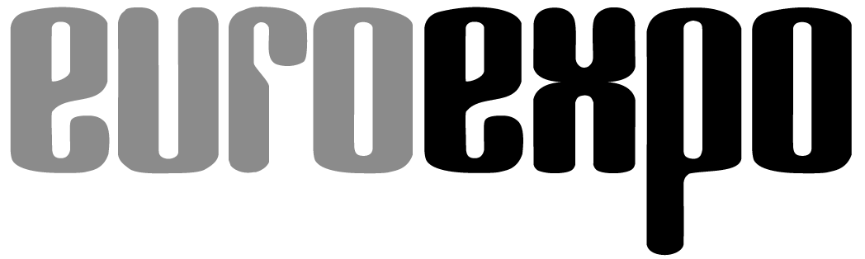
Messe- und Kongress-GmbH
Joseph-Dollinger-Bogen 7
D-80807 Munich, Germany
Phone: +49 89 32 391 259
Fax: +49 89 32 391 246
www.euroexpo.de/en
www.logimat-messe.de/en
www.tradeworld.de/en

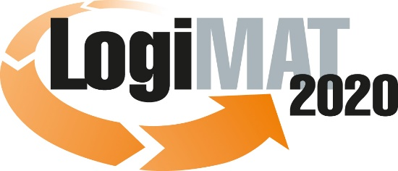

18th International Trade Show for
Intralogistics Solutions & Process Management
March 10–12, 2020 | Messe Stuttgart

Also featured at LogiMAT:
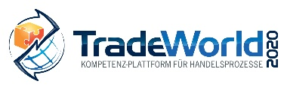

Munich, February 11, 2020

LogiMAT 2020 in Stuttgart

Forks in the road to the future:
Cutting-edge forklift truck technology

International forklift truck manufacturers are reinforcing the continued success of their equipment by introducing a wide variety of new products, innovations, and solutions at LogiMAT—the 18th International Trade Show for Intralogistics Solutions and Process Management. Their presence also underscores the international importance of LogiMAT as the number-one industry trade show.

When it comes to flexibility in transporting goods in and around the warehouse, forklift trucks are the top choice. And demand for the trucks persists. One sign of this demand is that the volume of annual factory deliveries by manufacturers across all five equipment classes has more than doubled since 2000 to some 1.3 million trucks today. In Europe alone, almost 100,000 electric forklifts are now delivered each year. The reasons for this continued success are many and varied. Aside from the obvious flexibility such vehicles offer, manufacturers have tapped into new markets in recent decades by targeting their products to other specific applications. Over this same time period, forklift trucks have also served as an excellent testing ground for lithium-ion and iron-phosphate batteries, fuel cells, and other drive technologies offering an alternative to the lead-acid batteries typically found in older electric forklifts.

Internal combustion engines that burn natural gas or hydrogen have long been common in the industry—and are becoming an increasingly important option for their more sustainable footprint. Clean Intralogistics Net—an interest group of 14 industrial and technology companies, battery makers, and vehicle and forklift trucks manufacturers such as Jungheinrich, Linde, Still, and Toyota—predicts a key role for fuel cells in the new decade amid the greater focus on green intralogistics and sustainable mobility.

With the development of driver assistance systems, manufacturers have greatly improved the ergonomics for forklift truck operators, and by establishing a software link through fleet management systems, they have also built a foundation for the development of driverless operation. Last but not least, qualified suppliers presenting new innovations in the area of equipment and attachments are continually discovering new potential optimizations, making no small contribution to the flexibility of these products. Forklift truck manufacturers from around the world are presenting their latest innovations and enhancements, including many never before seen anywhere else, to the critical eye of international industry insiders at LogiMAT, the 18th International Trade Show for Intralogistics Solutions & Process Management, March 10–12 in Stuttgart. And for the first time in the history of LogiMAT, Linde Material Handling is also hosting live presentations of internal combustion forklifts in the outdoor area between Halls 10 and 8. Jungheinrich will also show innovative forklift truck technology between Halls 9 and 7.

World premieres in all equipment classes

“Automation is increasingly boosting productivity in material handling to meet the demands of digital transformation. These developments are impacting the forklift truck industry as well,” notes LogiMAT Exhibition Director Michael Ruchty of Munich-based event organizer EUROEXPO Messe- und Kongress-GmbH. “The industry has risen to these challenges with smart driver assistance systems, increased optimization of forklift truck ergonomics, the embrace of alternative drive solutions, and designs for driverless, autonomous forklifts. The innovations this generates also yield benefits for conventional equipment and help push advances in traditional forklift trucks. The complete pantheon of top industrial truck manufacturers and many of the biggest names in equipment attachments and are presenting these innovations at LogiMAT 2020 in Halls 7, 9, and 10 of the Messe Stuttgart convention center.”

Driven by current demands, the electromobility options on display range from brand-new cab retrofit models to compact multidirectional sideloaders and other solutions for drive systems and autonomous guided vehicles. New safety and dialog features for driver assistance systems and several global innovations such as bulk box handlers will also be among the attachments on display.

Clark Europe GmbH (Hall 10, Booth D61) is coming to Stuttgart to show off its newly launched electric four-wheel forklift series EPXi. The counterbalance trucks are available with one-piece or split driver’s doors and retrofittable cab variants, from weatherproof canopies to full cabs. With load capacities of 2.0 to 3.2 metric tons, they are making significant inroads into uses once the exclusive domain of combustion engines. Clark is also unveiling a new order picker and its extended portfolio of warehouse technology vehicles with lithium-ion technology.

Chinese manufacturer BYD Europe B.V. (Hall 10, Booth A69) has relied on iron-phosphate batteries for its drive technology from the outset. At LogiMAT, BYD presents innovations in rapid charging technology. Burger Hub- und Transportmittel GmbH (Hall 10, Booth C45), the German general importer for the Chinese manufacturer Hangcha, is coming to LogiMAT with a new, compact high-lift pallet truck, a 3-wheel tractor, and the new XC front loader. Hangcha’s latest series features four models in lifting capacity classes ranging from 2.0 to 3.5 metric tons and powered by lithium-ion batteries. Each model is available in heavy-duty and light-duty versions that differ primarily in their travel and lifting speed. Movexx International B.V. (Hall 9, Booth C05) is also bringing a new electric tug to Stuttgart. The MD1000 has a modular design and is moved like a transport cart with four swivel castors.

Hubtex Maschinenbau GmbH & Co. KG (Hall 10, Booth D05) and OMG srl. (Hall 9, Booth D77) are using the event to introduce their new electric multidirectional sideloaders to an industry audience. The company reports that models of the Hubtex 2820 and 2821 series are produced “as part of our multi-phase automation strategy” on a new PhoeniX equipment platform. With a frame length of 2,100 mm, the 2820 series is the smallest and most compact vehicle among the new PhoeniX models. It is nevertheless suitable for handling long goods in narrow warehouse aisles and is intended as an alternative to four-way reach trucks. OMG srl, on the other hand, is focusing on load capacities of up to 8 metric tons with the new, multidirectional electric sideloader type Fiora. Operators can select different drive programs with side or front-wheel drive designed to match the transported load and working environment.

Stainless steel forklift trucks

Novelties and rarities will also be on display at the booths of Yale Europe Materials Handling (Hall 9, Booth B33), Still GmbH (Hall 10, Booths B41 and B51), Samag Industriale srl. (Hall 9, Booth A65), and the Swedish forklift manufacturer Semax Material Handling AB (Hall 9, Booth F81). In addition to the new ERP20-35UX 4-wheel electric counterbalance truck, Yale is offering an exclusive look at the prototype of a new type of concept truck with fully integrated lithium-ion batteries. At Still, the focus is on the new RX 60, to be presented to the general public for the first time at LogiMAT. The electric forklift offers travel speeds of up to 21 km/h and improved lifting speeds in the 2.5 to 3.5 metric ton weight class, equaling the performance of diesel or LPG models.

The Swedish company Semax presents a counterbalance truck with an innovative design concept: The truck, designed primarily for transporting rolls in the paper and steel industries and for transport-sensitive goods in panel factories and breweries, features lift masts mounted behind the driver’s cab. The potential applications are virtually endless thanks to the telescopic feed, compact design, a product range from 4 to 25 metric tons, and the choice between electric and diesel drive. Samag Industriale srl. (Hall 9, Booth A65), on the other hand, captures a narrow market with its stainless steel Inox line: designed for all workplaces that require cleanliness, hygiene, and anti-corrosion protection. The high-lift and low-lift pallet trucks and of the Italian manufacturer are made entirely of inox stainless steel or corrosion-resistant material.

Linde Material Handling GmbH (Hall 10, Booths B21 and B17) unveils its new Linde H20 to H35 IC trucks in the load capacity range of 2.0 to 3.5 metric tons and presents the new Linde V08 medium-lift order picker. The pickers are available in two versions: one with a fixed operating platform connected to the forks with access to the load arms, the other with the driver’s platform closed at the back and featuring an integrated backrest. Linde is also presenting the cloud-based version of its “Linde connect” fleet management system.

Jungheinrich AG is putting digitization and automation at the center of its trade show presentation (Hall 9, Stand B05) and is presenting networked solutions for the warehouse of the future. In a complex showcase covering an area of 160 square metres, the Hamburg-based intralogistics company will, for example, allow the automated pallet truck ERC 213a and the automated vertical order picker EKS 215a to interact with conveyor technology as well as a self-driving under pallet carrier, moving in the pallet channel. With regard to assistance systems, five systems will also be explained to the trade visitors in detail and a technological world first will also be presented.

Suppliers and equipment providers, most of which are smaller businesses, are also presenting a wide range of innovations and new developments at LogiMAT 2020. Attachment manufacturer KAUP GmbH & Co. KG (Hall 10, Booth F05), for example, is unveiling its Smart Load Control for the first time anywhere in the world in Stuttgart. The patented control system regulates the clamping force of bulk box handlers based on the load and protects the transported goods. Florian Eichinger GmbH (Hall 9, Booth D30) is presenting new work baskets for forklifts, tipping containers, and drum handling systems as part of its new range of forklift attachments. MEYER GmbH (Hall 10, Booth G61) presents the new ISO 4 fork positioner type 6-2612G-Z with integrated fork camera in Stuttgart. The addition makes it easier to use the attachment in difficult visibility conditions. And Muvtons Castors Pyt. Ltd (Hall 10, Booth D70) is exhibiting the current range of wheels and castors for heavy and extra-heavy loads.

“The aforementioned examples demonstrate that the exhibitors in the forklift truck segment at LogiMAT in March are offering industry professionals many noteworthy innovations and future-oriented solutions,” concludes Exhibition Director Ruchty. “Many of the smart driver assistance and fleet management systems also on display ensure a deeper integration of industrial trucks into the processes. Those investing in fleets need to know which manufacturers are strong in which areas. LogiMAT offers the ideal decision-making foundation with the unique opportunity to compare international manufacturers and gain first-hand information.”

Organizer:
EUROEXPO Messe- und Kongress-GmbH | Joseph-Dollinger-Bogen 7, 80807 Munich
Phone: +49 89 32 391 259 | Fax: +49 89 32 391 246
www.logimat-messe.de | www.tradeworld.de
11,132 characters (with spaces)
Munich, February 11, 2020—This text may be reprinted free of charge, but please send a copy to EUROEXPO Messe- und Kongress-GmbH, Press and Public Relations Department, 80912 Munich.

About LogiMAT
LogiMAT, the 18th International Trade Show for Intralogistics Solutions and Process Management, is coming to the Messe Stuttgart convention center, directly adjacent to Stuttgart International Airport, March 10–12, 2020. Presented by EUROEXPO Messe- und Kongress-GmbH, LogiMAT ranks as the world’s largest trade show for intralogistics solutions with a complete market overview of everything driving the intralogistics industry, from procurement to production to shipping. International exhibitors gather early in the year to showcase innovative technologies, products, systems, and solutions for streamlining operations, optimizing processes, and cutting costs in a company’s internal logistics. Beyond the exhibitor booths, visitors can also experience a different program of presentations each day covering a wide range of topics.
EUROEXPO has also partnered with Landesmesse Stuttgart since 2014 to present the annual LogiMAT China, which returns to Shanghai alongside transport logistic China, June 16–18, 2020.
Bangkok, Thailand, is a new venue in the portfolio. “LogiMAT | Intelligent Warehouse” makes its debut May 13–15, 2020. It focuses on the Southeast Asian market and follows in the footsteps of “Intelligent Warehouse,” which was presented by local organizer Expolink Global Networks Ltd. from 2015 to 2019.

