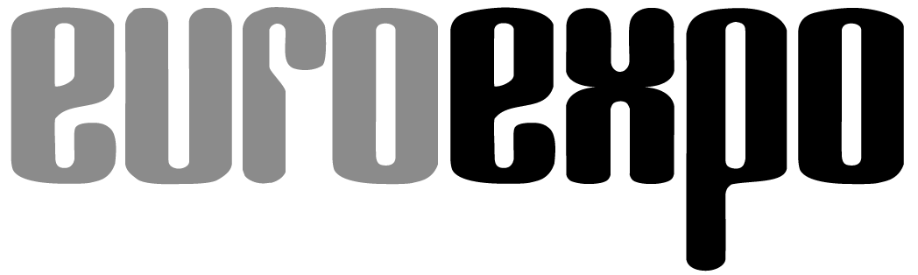
Messe- und Kongress-GmbH
Joseph-Dollinger-Bogen 7
D-80807 Munich, Germany
Phone: +49 89 32 391 259
Fax: +49 89 32 391 246
www.euroexpo.de/en
www.logimat-messe.de/en

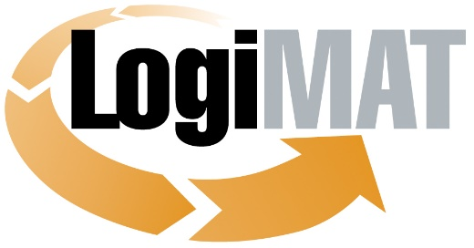

International Trade Show for
Intralogistics Solutions and Process Management
May 31–June 2, 2022 | Messe Stuttgart

Munich, June 2, 2022

Press Release

LogiMAT 2022 in Stuttgart—Wrap-Up Report
Expectations Greatly Exceeded

Munich, June 2, 2022—LogiMAT 2022 scores a big win in the post-pandemic era, re-emerging with a broad slate of exhibitors and a highly engaged visitor base. High-profile business deals and partnerships coupled with in-depth networking opportunities underscore the reputation of the International Trade Show for Intralogistics Solutions and Process Management as a leading communications hub where industry leaders come to do business.

LogiMAT 2022 drew to a close this afternoon in Stuttgart, showing stability across all leading indicators in the trade show business. The leading international trade show for the intralogistics industry was able to build seamlessly on the success of its previous events with numbers edging back up toward pre-pandemic levels. “A successful reboot after a nearly 40-month Covid-induced interruption,” notes Exhibition Director Michael Ruchty of EUROEXPO Messe- und Kongress-GmbH in Munich, which organizes LogiMAT. “Adjusted for the pandemic-related restrictions, the results across the board show a continuation of the LogiMAT success story.”

“Smart – Sustainable – Safe” was the theme of this year’s three-day event, bringing together 1,571 registered exhibitors from 39 countries, including 393 first-time exhibitors and 74 big-name vendors from overseas—all showcasing their latest products, systems, and solutions for reliable automation and digital transformation. A wide range of new products, including some never before exhibited anywhere in the world, provided powerful inspiration for smart, forward-looking intralogistics processes. The Messe Stuttgart convention center was once again completely booked this year, with exhibitors spread across 125,000+ square meters in all ten exhibit halls.

After a pandemic shutdown of two-and-a-half years, 50,000 industry professionals seized the opportunity to explore and directly compare the latest technologies and their integration into intelligent, future-proof systems—live and in person. At peak times on the second day of the event, 3,000 industry professionals streamed through the turnstiles at the entrance within ten minutes.

More than a quarter of the visitors work for large companies with 1,000 to 9,999 employees. Broken down by industry, 58.8% of visitors came from the manufacturing sector, 12.4% from wholesale, and another 4.3% from retail. Some 6.9% of visitors work in freight forwarding, with most (52.8%) holding a position of responsibility for purchasing decisions at their company. For them, LogiMAT is the primary platform for information on the latest solutions for efficient intralogistics. Among all visitors, 55.1% came to learn about innovations and trends, while 27.7% wanted to make new business connections. There was particular interest in innovations in the product domains of material handling and warehousing technology (55.8%), industrial trucks (38.3%), and AGV/AMR technology (18.3%). (Multiple responses were possible.)

Some 36.5% of the industry professionals who came to Stuttgart also had specific investment projects in mind. The high number of sales contracts, business deals, and partnership initiatives signed at LogiMAT underscore the character of LogiMAT as a hub for information, education, and communication where people come to do business. A full 5.2 percent of the visiting industry professionals awarded a contract during the show, while 31.7 percent plan to do so immediately afterward. This naturally resonated well with exhibitors, all of whom emphasize the quality and sophistication of the contacts they made.

Some 38.5% of visitors traveled more than 300 kilometers to attend LogiMAT. The high level of interest among international industry professionals and exhibitors remained stable. Data gathered by the independent Basel-based market research institute Wissler & Partner shows that one in five event attendees came to Stuttgart from outside Germany. Of these international guests, 73.8% came from other EU countries, 7.9% from non-EU countries, and 8.3% from Asia, the Americas, and other areas overseas.

“We’re extremely pleased with the numbers for LogiMAT 2022 and how it unfolded,” concludes Exhibition Director Michael Ruchty. “LogiMAT 2022 continues online through the LogiMAT.digital platform. The 14 stimulating presentations from the high-quality accompanying program in the LogiMAT Arena spanning all three days will be streamed on LogiMAT.digital in the coming weeks.”

LogiMAT returns to Stuttgart April 25–27, 2023.

Organized by: EUROEXPO Messe- und Kongress-GmbH
Joseph-Dollinger-Bogen 7 | 80807 Munich, Germany
Phone: +49 89 32 391 259 | Fax: +49 89 32 391 246
www.logimat-messe.de | www.logimat.digital

4,641 characters (with spaces)

Munich, June 2, 2022—This text may be reprinted free of charge, but please send a copy to EUROEXPO Messe- und Kongress-GmbH, Press and Public Relations Department, 80912 Munich.

LogiMAT testimonials from international exhibitors

“LogiMAT is where we meet the decision-makers in logistics—the senior executives and chief logistics officers of major retailers. No other trade show offers us that. As a startup, we’ve already had at least three very promising conversations, with follow-up meetings booked.”
Selim Ben Aissa, Operations Manager, CityLog GmbH

“LogiMAT is a real industry trade show, where logistics experts come to meet. This gives lasting value to the conversations we have at our booth. As a global enterprise, we also appreciate the event’s increasing internationalization, which greatly expands the reach of our trade show presence.”
Michael Krell, Head of Field Sales Land, Schenker Deutschland AG

“LogiMAT offers us a fantastic international platform to talk to potential customers about our fulfillment execution system. We are delighted to see the strong interest in our solutions from Europe and beyond. The show met our expectations.”
Matthew O’Brien, Senior Vice President, 6 River Systems, USA

“As a young company, we were able to raise our profile considerably at LogiMAT. It’s very easy here to start up a conversation with prospective customers from our target groups. Overall, we had an overwhelming turnout and were very well received.”
Imen Oneslati, Business Development Representative, HOW.FM SoundReply Solutions

“For us as a niche supplier on the world market, the increasing internationalization of LogiMAT is a particular advantage. That’s why it’s the perfect opportunity to show off our latest products to an international audience.”
Marc Liske, Head of Marketing, Hubtex

“As a company headquartered in India, we use LogiMAT as a springboard for the European market and have made some excellent contacts here. We will definitely be back.”
Kanika Bhalla, Chief Growth Officer, Head of Corporate Development, Increff (Bangalore, India)

“LogiMAT has once again proved to be one of the most important trade shows worldwide for Kardex. Our initial evaluations indicate that the leads generated here are significantly more solid and of much higher quality than in 2019. Demand for automated storage capacity is really skyrocketing.”
Hans-Jürgen Heitzer, Head of Division Kardex Mlog, Kardex

“LogiMAT has become the premier trade show for intralogistics in Germany. It offers an opportunity to share ideas on a larger scale in person.”
Stefan Prokosch, SVP Brand Management, Linde Material Handling

“In our estimation, the event attendance was similar to pre-pandemic times—something we would not have expected. The conversations we had about packaging solutions were quite detailed, and we issued lots of quotes.”
Dr. Norman Bock, Director of Customer Management, Prodinger Verpackung

“Trade shows are back again thanks to LogiMAT. It all feels completely normal and we look forward to seeing customers and partners again.”
Bingning Liu, Director of Growth Marketing, Workaround GmbH (ProGlove)

“Internationally, LogiMAT is the leading trade show for intralogistics solutions and process management. We are very much looking forward to finally meeting our customers and industry colleagues face to face again at an in-person event and discussing their current concerns. LogiMAT offers the ideal platform for this.”
Dr. Giovanni Prestifilippo, Managing Director, PSI Logistics GmbH

“LogiMAT 2022 brought us a huge rush of visitors, who came to us not only from all over Europe but in some cases even from Israel and the US. This is what makes trade shows so much fun, and our preparations really paid off. LogiMAT will remain a must-attend event for us in the future.”
Marie-Claire Mause, Online Marketing, Seuster KG

“For us, it was the first time we exhibited at LogiMAT. In our search for new European importers for our products, we made some very promising contacts and had some interesting discussions. I am optimistic that this will help us achieve our goals.”
Mariana Ho, Société Commerciale Euro-Taiwanaise, Taiwan

“As a thriving trade show for intralogistics, LogiMAT is a key event highlight for Still and an essential platform for meeting and talking with our customers and the industry’s major thought leaders.”
Frank Müller, Senior Vice President of Brand Management / Sales & Service Steering, Still EMEA

“For us, it’s a great feeling to be back at LogiMAT. We were at least as busy as in 2019 and managed to generate highly qualified leads. We are completely satisfied.”
Frank Leiter, Head of Marketing and Sales, Wanko Informationslogistik GmbH

“The show confirms the current trends in the logistics industry: In our discussions with colleagues, we sense a great need for today’s digital technologies.”
Cordula Steinhart, Marketing Manager, Zetes GmbH

