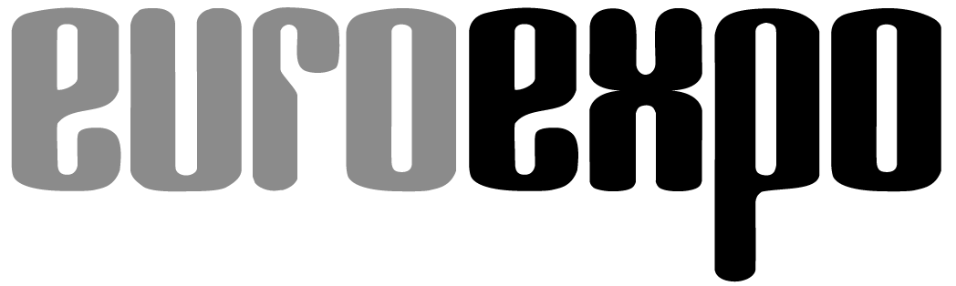
Messe- und Kongress-GmbH
Joseph-Dollinger-Bogen 7
D-80807 Munich, Germany
Phone: +49 89 32 391 259
Fax: +49 89 32 391 246
www.euroexpo.de/en
www.logimat-messe.de/en
www.logimat.digital
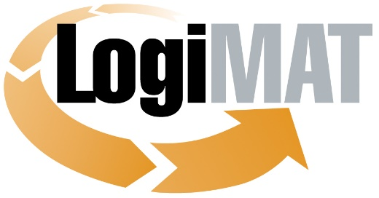

International Trade Show for
Intralogistics Solutions and Process Management
April 25–27, 2023 | Messe Stuttgart

Munich, March 7, 2023

Press Release

LogiMAT in Stuttgart—Identification and Packaging Technologies
LogiMAT Offers a Glimpse into the Future of AIDC and Packaging

Munich, March 7, 2023—The world’s leading experts for automatic identification and data capture (AIDC) and packaging are coming to Stuttgart to present their latest innovations at LogiMAT 2023. Exhibitors from both industries are bringing along a broad spectrum of products to promote sustainability, automation, and digital transformation in intralogistics—from futuristic RFID applications and reuse/recycling system components to cutting-edge materials and machinery for customized outer packaging on demand.

Streamlining processes and achieving sustainability are two of the main challenges facing both the AIDC and packaging industries. Users and consumers are increasingly demanding packaging solutions that are green, reusable, and versatile—and manufacturers must rise to the challenge. The trends emerging in the packaging industry will define the markets in the coming years amid transformative changes from the circular economy. Packaging materials will be used more sparingly and overall demand will decline even as paper and cardboard continue to replace plastics and single-use materials. “The products on display at LogiMAT 2023 reveal the current trend in packing solutions to accommodate the growing demand for reusable, recycled, or upcycled materials and solutions,” observes Exhibition Director Michael Ruchty of event organizer EUROEXPO Messe- und Kongress-GmbH in Munich.

The AIDC and packaging industries are developing forgery-proof features on many fronts. Beyond optical readable media, the AIDC industry is incorporating modern technologies and offering solutions to protect products, brands, and assets; to streamline warehousing; and for tracking and tracing. International manufacturers and providers of both industries will reflect these trends at LogiMAT 2023 with their latest products and solutions for sustainable intralogistics, digital transformation, and process automation.

This year, AIDC and packaging providers are concentrated in Halls 2 and 4 and along the entire south side in the East Entrance. Visitors can look forward to a broad spectrum of products ranging from next-gen plastic labels, new battery-free smart labels, scanning gates for code capture, on-the-fly and Airpop packaging for temperature-sensitive shipments, and cutting-edge fully automated end-to-end systems for paper bag packaging equipment.

RFID label housing from the 3D printer

This year’s AIDC solutions focus heavily on RFID solutions. Modern industrial automation and IoT applications require smart devices and systems that can organize themselves as a swarm and, with ever smaller chips, control their own path through material flows. RFID offers viable options for storing and exchanging the required data. GOD Barcode Marketing (Hall 4, Booth 4D05) has expanded its portfolio and is presenting a new RFID reader in the form of an RFID tunnel that automatically identifies and captures data in seconds. The Faubel Group (Hall 2, Booth 2B25) unveils its maintenance-free, battery-free smart labels that work through a cloud-based app and are available as a standard model or with an optional 3D-printed housing that can be attached with screws, adhesives, magnets, or Velcro. iDTRONIC (Hall 2, Booth 2C05) is highlighting the role of RFID solutions in protecting products, brands, and assets with what it calls a “one-of-a-kind, ultra-flat, compact RFID TrackMini for identifying people or assets in indoor and outdoor settings” in a lightweight 3-mm design that tips the scales at just 13 grams. Neosid Pemetzrieder (Hall 2, Booth 2C05) is coming to Stuttgart to introduce its own NFC-enabled mini-transponders for reliable RFID applications in metallic environments.

The Schreiner Group (Hall 2, Booth 2C05) is presenting its DistaFerr-series labels, another RFID solution adapted to metallic environments, which Schreiner says can take into account the special physical properties of metal, work perfectly on ESD containers, meet the strict requirements of returnable transport items, and withstand extreme temperatures of up to 230°C. The Inotec Group (Hall 2, Booth 2D15) is exhibiting a patented RFID multilevel label for the warehouse that combines all levels of a shelf in a single label.

Alongside these RFID innovations, the AIDC industry is also showing new products in traditional fields at LogiMAT 2023. AIT Goehner (Hall 2, Booth 2D11) is presenting its versatile SmartGate, a loading dock scanning gate that automatically captures all 1D and 2D codes on up to three sides of a pallet moving past the gate at up to 4 km/h. AMobile Intelligent (Hall 4, Booth 4A64) is introducing its handheld 5G Rugged Android™ and HT102 10" tablet.

The printers on display in both exhibit halls of the AIDC industry include new multipurpose units and applicators. Ernst Reiner (Hall 4, Booth 4G08) is presenting its jetStamp® 1025 sense, which combines identification and capture in a single versatile solution: a mobile 3-in-1 printer that, combined with an attachable scanner for 1D and 2D codes, can capture and process data, then print or apply new company- or product-specific markings. Seiko Instruments (Hall 4, Booth 4F34) is unveiling its new SLP720RT label and receipt printer series for self-adhesive liner-free labels that attach to almost any surface. BLUHM Systeme (Hall 2, Booth 2A07) has re-engineered the Legi Air AP 182 pallet labeler with an applicator that can program seven travel paths for labeling up to 120 pallets per hour on two or three sides. COT Computer OEM Trading (Hall 4, Booth 4C09) is coming to Stuttgart with a special e-paper solution that can be mounted on unit load devices and other surfaces, replacing the printing process in traditional label printing and saving consumables by using optical wireless communication to load all the necessary data in image format onto COT e-paper without any need for Wi-Fi, Bluetooth, or RFID.

End-to-end solution for custom transport boxes

Representatives of the packaging industry are coming to Stuttgart with a similarly broad spectrum of innovations. The industry must deliver innovative solutions in response to the diverse challenges it faces, including a scarcity of resources, higher material and production costs, and the growing demand for sustainability. The LogiMAT 2023 exhibitors are rising to these challenges with components for reuse and recycling systems, automated packaging equipment for customized outer packaging on demand, and solutions for optimizing material consumption. BVM Brunner (Hall 4, Booth 4B21) offers a good example with its Papertec packaging solutions, which customize the paper format to the individual package contents, from socks to jackets and beyond. Sparck Technologies (Hall 2, Booth 2B31) follows a similar approach with its CVP Everest and CVP Impack automated packaging machines, which measure, cut, fold, glue, and label up to 1,100 custom-fit auto-boxes per hour.

FPS Flexpack (Hall 2, Booth 2D18) is exhibiting its WAPAL honeycomb pallet and its PaperStretch pallet wrap as sustainable solutions for businesses who wish to migrate away from plastic packaging to paper or cardboard alternatives. PaperStretch is made from natural kraft paper using PEFC-certified fibers and is fully recyclable. The WAPAL pallet is also fully recyclable, and its structure cuts down on material consumption. WAPAL pallets are 75% lighter than comparable wooden pallets and, with no international import restrictions, are recommended by the manufacturer for air transport. WEBER Verpackungen (Hall 4, Booth 4B02) is presenting its e-commerce shipping bag Send Bag and the first resealable paper bag Loc Bag, both made from 100% recycling paper, as other sustainable alternatives to plastic. Karopack (Hall 2, Booth 2F30) is presenting new tear-resistant and dust-impermeable cushioning pads made from recycled cardboard as a cost-effective transport protection material for a wide range of industries and applications.

Raw materials and products in closed-loop systems

The international representatives of the plastics processing packaging industry at LogiMAT 2023 are focusing on recycling and reuse with their new sustainability-themed packaging solutions. OHLRO Hartschaum (Hall 2, Booth 2F14) is introducing its new temperature-stable Cycle thermobox featuring recycled styrofoam content, which customers can arrange to return to OHLRO for recycling. ORBIS Europe (Hall 4, Booth 4G64) is promoting sustainability with a focus on raw material cycles. At LogiMAT 2023, Orbis is presenting PlastiCorr®, a new type of reusable packaging solution designed to replace boxes made of corrugated board and cardboard in the hazardous goods sector. Orbis buys back the plastic products at the end of their useful life, recycles them, and uses them for new products. Smart-Flow Europe from Belgium (Hall 4, Booth 4B71) is showcasing the SF 600P PREM, a new plastic “half” Euro pallet as well as the foldable, variable-height G-4622 and G-6433 returnable plastic boxes—all 100% recyclable. Craemer (Hall 4, Booth 4B27) will also be presenting the first-of-its-kind HB3, which it calls the “first and only completely closed pallet box on the market with welded runners.” The box has a tare weight of around 42 kg (without reinforcement profiles), holds a volume of 580 liters, can withstand a stacking load of over 5,000 kg, and has a payload of 900 kg.

Accompanying program also to focus on AIDC and packaging

Parallel to the exhibits of the international AIDC and packaging industries, the Tracking & Tracing Theatre (Hall 2, Booth 2C09) is presenting contemporary use cases for AIDC technologies. The informative events will focus on the potential of AIDC to transform the supply chain and usher in the smart factory. Visitors can also find support in identifying opportunities for optimizing and digitizing processes in their own companies. The trade association AIM-D is also hosting the expert forum “Digital Supply Chain: Design and Optimization” on the event’s third day in the LogiMAT Arena, East Entrance Atrium. The expert panel will talk about software and cloud integration and security aspects of AIDC systems. “With the range of exhibitors and information on offer in Halls 2 and 4, the innovations on display elsewhere throughout the show, and the solutions being outlined, LogiMAT 2023 offers a glimpse into the future of AIDC and packaging,” concludes Exhibition Director Ruchty. “The focus on efficient processes and sustainability gives visiting professionals all the key ingredients they need to make sound long-term investment decisions. This is not an opportunity to be missed, especially for those poised to invest in or upgrade to a state-of-the-art AIDC or packaging solution.”

Organized by: EUROEXPO Messe- und Kongress-GmbH
Joseph-Dollinger-Bogen 7 | 80807 Munich, Germany
Phone: +49 89 32 391 259 | Fax: +49 89 32 391 246
www.logimat-messe.de | www.logimat.digital

10,829 characters (with spaces)

Munich, March 7, 2023—This text may be reprinted free of charge, but please send a copy to EUROEXPO Messe- und Kongress-GmbH, Press and Public Relations Department, 80912 Munich.

About LogiMAT

LogiMAT, the International Trade Show for Intralogistics Solutions and Process Management, will take place at the Messe Stuttgart convention center, directly adjacent to Stuttgart International Airport, from April 25 to 27, 2023. Presented by EUROEXPO Messe- und Kongress-GmbH, LogiMAT ranks as the world’s largest trade show for intralogistics solutions with a complete market overview of everything driving the intralogistics industry, from procurement to production to shipping. International exhibitors showcase innovative technologies, products, systems, and solutions for streamlining operations, optimizing processes, and cutting costs in a company’s internal logistics. Beyond the exhibitor booths, visitors can also experience a different program of presentations each day covering a wide range of topics.
EUROEXPO has also partnered with Landesmesse Stuttgart since 2014 to present LogiMAT China, planned as an annual event and returning to Shanghai June 14–16, 2023.
Bangkok became the newest venue in the portfolio with the debut of LogiMAT | Intelligent Warehouse in 2022, presented with local organizer Expolink Global Networks Ltd. and focused on the Southeast Asian market. The next event takes place October 25–27, 2023.
LogiMAT.digital is the platform that brings together top providers of the world’s best intralogistics solutions with high-quality leads, bridging the time and space between on-site events.

