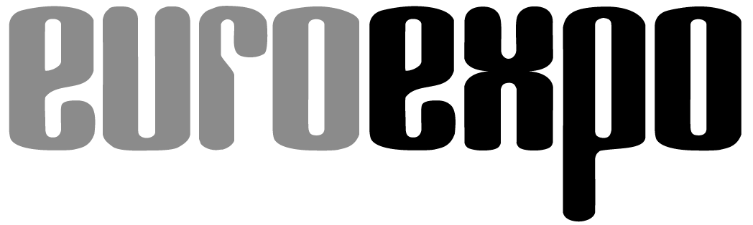
Messe- und Kongress-GmbH
Joseph-Dollinger-Bogen 7
80807 Munich, Germany
Phone: +49 89 32 391 259
Fax: +49 89 32 391 246
www.euroexpo.de/en
www.logimat-messe.de/en
www.logimat.digital
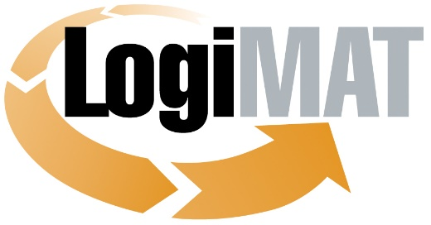

International Trade Show for
Intralogistics Solutions and Process Management
April 25–27, 2023 | Messe Stuttgart

Munich, April 27, 2023

Press Release

LogiMAT in Stuttgart—Post-Event Press Release
LogiMAT 2023 Achieves Best Results in Event’s History

Munich, April 27, 2023—LogiMAT 2023 has followed through on last year’s success and continued its growth trajectory by once again filling the entire exhibit space to capacity, maintaining a strong exhibitor contingent, and attracting the highest number of visitors in 20 years. All told, it’s the best result in the history of the intralogistics event. The international character of the trade show was bolstered by companies from 39 countries, with exhibitors from outside Germany accounting for a full 35%.

LogiMAT 2023 closed its doors on Thursday with a sharp increase in the number of visitors over last year. The three-day trade show drew a total of 62,343 industry professionals (+25%) to the Messe Stuttgart convention center, topping even the pre-pandemic numbers from 2019. “This was a LogiMAT for the record books,” enthused Exhibition Director Michael Ruchty from event organizer EUROEXPO GmbH in Munich. “LogiMAT 2023 drew the biggest visitor crowds in the event’s history. This, together with the growth in our contingent of international exhibitors, demonstrates that the LogiMAT brand is firmly established as the world’s leading intralogistics trade show and a must-attend event for businesses seeking forward-looking, efficient intralogistics processes.”

A total of 1,563 exhibitors from 39 nations filled all ten fully booked exhibit halls of the Messe Stuttgart convention center, presenting their latest developments and innovations for optimal material flows and efficient process management across 125,000 square meters of gross exhibit space (65,503 m² net, an increase of 8%). In the run-up to LogiMAT 2023, exhibitors announced more than 100 exclusive product debuts, including unique innovations not previously seen anywhere in the world, such as the Toposens ECHO ONE® 3D ultrasonic sensor that Meysens GmbH developed for echolocation in warehouses—which took home the “Best Product” award in the category of picking, conveying, lifting, and storing technology.

With the products and solutions on display plus the ever-popular accompanying program of presentations and panels, LogiMAT 2023 filled the need of today’s industry professionals to share and acquire knowledge on forward-looking investments. The spotlight here is on automation, digital transformation, and the integration of state-of-the-art technologies like robotics, sensors, and artificial intelligence (AI) to optimize intralogistical processes. Exhibitors and visiting industry professionals were also focused on the themes of sustainability and energy efficiency. Industry professionals used the on-site trade show to forge new business contacts and to sound out the market among the competition. Visitors reported that they came to LogiMAT looking specifically for automation solutions and that they found inspiration through the technological innovations on display and by the opportunity to explore potential partnerships. The exhibitors also reported on the high quality of customer contacts, leading to promising potential projects and partnerships. The visitor analysis compiled by the independent market research institute of Wissler & Partner from Basel, Switzerland, found that a high percentage of industry professionals came to LogiMAT with specific plans for investments. This is borne out by the experience of many attendees who reported placing orders at LogiMAT 2023.

French technology company Exotec and general contractor Unitechnik announced a partnership agreement. Bottobo Robotics from Turkey signed a four-figure contract with Wiferion for the supply of wireless charging systems. Hardware and software provider Ecovium placed an order with Lux CT Transportlogistik to install software for transportation and forwarding management. These deals underscore the importance of LogiMAT as a trade show where the industry comes to do business. Overall, more than 40% of visiting professionals placed an order or intend to do so immediately after the event. And 84.2% of visitors exercise decision-making authority within their respective companies.

This year’s LogiMAT was once again even more international than previous editions. Nearly one in two professionals traveled more than 300 km to attend. One in four came from outside of Germany, and about one in ten even came from overseas. Among the exhibitors at LogiMAT 2023, the share of companies based outside Germany grew to more than one-third this year. Another indicator of the international character: Among the 200 first-time exhibitors who came to Stuttgart, nearly 70 percent are based outside of Germany.

“The excellent bottom-line result of LogiMAT 2023 exceeds all expectations,” remarks Exhibition Director Ruchty. “Networking and an unfiltered exchange of knowledge and industry news among all the big-name developers, manufacturers, and solution providers with a record-setting number of visitors. Plus a whole slate of new international orders placed. This reinforces LogiMAT’s role as the must-attend intralogistics industry platform and a place where decision-makers come to do business.”

The next LogiMAT event is coming up soon: LogiMAT China takes place June 14–16 in Shanghai. After that, LogiMAT Intelligent Warehouse opens its doors October 25–27 in Bangkok. The next LogiMAT in Stuttgart will take place March 19–21, 2024.

Organized by: EUROEXPO Messe- und Kongress-GmbH
Joseph-Dollinger-Bogen 7 | 80807 Munich, Germany
Phone: +49 89 32 391 259 | Fax: +49 89 32 391 246
www.logimat-messe.de | www.logimat.digital | www.euroexpo.de

5,500 characters (with spaces)

Munich, April 27, 2023—This text may be reprinted free of charge, but please send a copy to EUROEXPO Messe- und Kongress-GmbH, Press and Public Relations Department, 80912 Munich.

About LogiMAT

LogiMAT, the International Trade Show for Intralogistics Solutions and Process Management, will return next year to the Messe Stuttgart convention center, directly adjacent to Stuttgart International Airport, March 19–21, 2024. Presented by EUROEXPO Messe- und Kongress-GmbH, LogiMAT ranks as the world’s largest trade show for intralogistics solutions with a complete market overview of everything driving the intralogistics industry, from procurement to production to shipping. International exhibitors showcase innovative technologies, products, systems, and solutions for streamlining operations, optimizing processes, and cutting costs in a company’s internal logistics. Beyond the exhibitor booths, visitors can also experience a different program of presentations each day covering a wide range of topics.
EUROEXPO has also partnered with Landesmesse Stuttgart since 2014 to present LogiMAT China, planned as an annual event and returning to Shanghai June 14–16, 2023.
Bangkok became the newest venue in the portfolio with the debut of LogiMAT | Intelligent Warehouse in 2022, presented with local organizer Expolink Global Networks Ltd. and focused on the Southeast Asian market. The next event takes place October 25–27, 2023.
LogiMAT.digital is the platform that brings together top providers of the world’s best intralogistics solutions with high-quality leads, bridging the time and space between on-site events.

“Leading intralogistics trade show”

EXHIBITOR TESTIMONIALS for LogiMAT 2023

“LogiMAT sets the standard across borders as an international trade show.”
Selim Ben Aissa, Managing Director, CityLog (Germany)

“I can draw a very positive balance. Above all, I am very happy with the quality of the attending professionals, which was markedly better even than last year.”
Stéven Friant, CEO, Happy Scoot (France)

“LogiMAT is a perfect symbiosis: Never is there as much dynamism in the market as on these three days.”
Johannes Hahn, Managing Director, OPUS//G, (Germany)

“We see LogiMAT as the leading intralogistics trade show. In 2023, the focus is on the bright side of the current challenges: Here in the EU we are poised to experience even greater cross-border convergence in how systems are developed, demand evolves, and projects are assigned.”
Paul Hermsen, Founder and Owner, Inther Group (Netherlands)

“It’s already our fourth LogiMAT and for us, the trip from Australia is worth the effort every time. Here we not only acquire new customers, we also get to know new resellers. This year we also generated lots of leads and got good feedback from our distributors. We’ll definitely be back in 2024.”
Louise Inglese, Founder and CEO, Genie Grips, (Australia)

“LogiMAT is the best opportunity for us anywhere in Europe to meet all the major players in the logistics industry who specialize in mobile robots. Here we have all the partners and businesses in one place.”
Gregor Modrijan, CEO, Mobotic (Slovenia)

“The entire intralogistics industry comes together in Stuttgart to network. LogiMAT has developed into one of the most important trade shows in Europe. Attendees have nonstop opportunities to learn about innovations and talk with experts about personalized solutions.”
Stefan Prokosch, Senior Vice President for Brand Management, Linde Material Handling (Germany)

“LogiMAT has been an excellent event for us. We are seeing a lot of interest in our AI-powered robotic automation from retailers and logistics providers across Europe. LogiMAT remains a very productive trade show for us, and we look forward to more conversations arising from this event.”
Anu Saha, Head of Product Marketing, Covariant (USA)

“For us, LogiMAT is the most important trade show, one at which we have always been able to generate very attractive leads and new orders. The activities in the run-up to the show make us confident that demand will remain undiminished.”
Hagen Schumann, General Manager, Klinkhammer Intralogistics (Germany)

“Everyone who’s anyone will be meeting in Stuttgart over the three-day event. For us, LogiMAT is the most important trade show for presenting our company’s latest system developments to an extremely knowledgeable audience.”
Markus Schlotter, Managing Director for Central Europe, Exotec (Germany)

“For us as an end-to-end provider of logistics and intralogistics solutions, LogiMAT in Stuttgart is the trade show par excellence, of course. Nowhere else is it possible to personally interact with so many customers and leads in one place in such a short time.”
Markus Zimmer, Head of Marketing and E-Commerce, Bito-Lagertechnik Bittmann (Germany)

