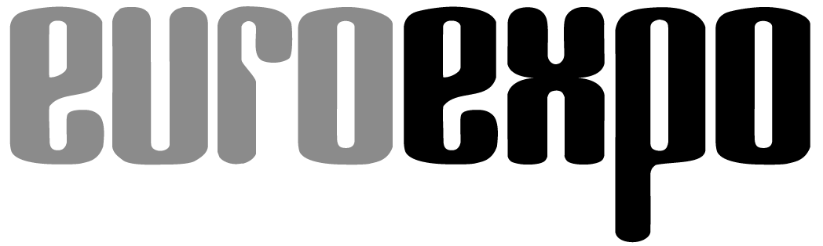
Messe- und Kongress-GmbH
Joseph-Dollinger-Bogen 7
D-80807 Munich, Germany
Phone: +49 89 32 391 259
Fax: +49 89 32 391 246
www.euroexpo.de/en
www.logimat-messe.de/en

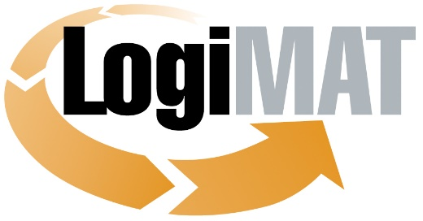

International Trade Show for
Intralogistics Solutions and Process Management
May 31–June 2, 2022 | Messe Stuttgart

Munich, April 26, 2022

Press Release

LogiMAT 2022 in Stuttgart
Packaging Solutions for a Smart Circular Economy

Munich, April 26, 2022—The packaging industry is coming to LogiMAT 2022, the International Trade Show for Intralogistics Solutions and Process Management, to exhibit the latest trends in material development and packaging equipment and solutions. The spotlight this year is on low-impact materials, volume-optimizing and recyclable packaging, and high-performance machinery for customizable packaging on demand.

The rising costs of materials, packaging, transport, and energy are pushing more and more companies to their limits, and this is compounded by the growing need for sustainability and a smaller environmental footprint. The need for cost savings and sustainable management is driving demand for reusable, recycled, or upcycled materials and solutions in the packaging sector. Demand is equally strong for automated package-cutting machinery that can produce customized packaging on demand and optimize resource consumption. At the same time, shippers seem to be reducing their consumption and using packaging and filling materials more consciously and efficiently. Statistics for 2020 published last fall by the Joint Committee of German Packaging Manufacturers (GADV) show a year-on-year decline in packaging materials, however moderate, for the first time in many years. Production volumes fell by 0.7% overall despite the boom in e-commerce, and while the volume of paper and cardboard remained relatively constant at the previous year’s level, plastics production dropped 2% and aluminum 3.4%. Innovative materials and material combinations for green packaging are supporting the trend toward more economical consumption. Packaging machines that accommodate volume-optimized, individualized packages are another factor, aided by the more efficient use of transport capacities and the reduced carbon emissions that this yields. “International manufacturers and suppliers from the packaging industry, who will be concentrated in Halls 4 and 6 at LogiMAT 2022, will present products and innovations spotlighting the latest trends in material development and packaging equipment and solutions,” promises Exhibition Director Michael Ruchty from event organizer EUROEXPO Messe- und Kongress-GmbH in Munich. “This also shows industry professionals how they can most effectively cut costs, achieve sustainability, and shrink their environmental impact.”

Paper injection molding packaging

De-Pack GmbH & Co. KG (Hall 4, Booth C71) and Karopack GmbH (Hall 4, Booth F73) are coming to Stuttgart with innovative ideas for new and sustainable packaging materials. De-Pack research shows that the average German consumer is responsible for some 108 kg of packaging waste annually, with plastic waste of 33 kg accounting for nearly a third. Environmentally friendly, recyclable, or even biodegradable packaging alternatives could go far to drive down these numbers. That’s the ambition behind reinpapier® packaging, which De-Pack will present at LogiMAT. It consists entirely of natural raw materials: industrial starch, paper fibers, and water. Using the paper injection molding process, it yields compostable, food-grade packaging that retains its shape and can be sterilized after gamma irradiation.

Karopack turns waste cardboard recycling into protective padding for transports. The company collects used cardboard and paper from customers within a radius of up to 150 km free of charge, processes it, then returns the cushioning material. Demand is high, especially for tear-resistant and dust-impermeable cushion pads, which are available in standard sizes between 180 x 220 mm and 180 x 540 mm as well as in special sizes. So the company is offering customers cardboard recycling systems with which they can process large stocks of waste cardboard into packaging cushions on their own with a capacity of up to 3 square meters of cushioning per hour.

In addition to new materials, international industry professionals at LogiMAT 2022 will be able to learn about a wide range of new solutions for efficient, sustainable packaging for shipping or product presentation. Fairfix GmbH (Hall 4, Booth D03) will be presenting the Corfex container storage system, which it calls “without parallel anywhere in the world” and which makes it possible to use storage capacities in steel shipping containers more efficiently. The patented storage system lets you retract raised floors in the container. When the cargo is stowed, the Corfex vertical supports are inserted into the recesses or corrugations in the container wall. Wooden crossbeams (manufactured under IPPC standards) then slide into and interlock with the supports for a self-supporting system.

Innovations in cold chain logistics

BOX – Genau Meine Kiste (Hall 4, Booth F66) and CMC SPS (Hall 4, Booth C45) will both present new transport box designs. BOX – Genau Meine Kiste is coming to LogiMAT with its modular construction kit design, featuring a specially developed profile system for wooden transport boxes, including reusable boxes. One unique feature: individual side walls of the box can be removed to load and unload the box from the side. Both the side panels and lid are also available in a four-color digital print finish. CMC SPS presents is new “Classy” luxury box, specially designed for packaging fragrances, luxury items, and fashion products. The box is more than a simple carrier, it’s a product presentation box, transforming brown cartons into premium packaging in a seamless and efficient automation process: luxury boxes on demand for e-fulfillment made from 100% recycled cartonboard. The sturdy box can also be used for returns, if needed.

Various packaging innovations have come onto the market to address the surge in refrigerated pharmaceutical transports. Gebhardt Logistic Solutions GmbH (Hall 1, Booth D60) is coming to Stuttgart with its new Isotec® TBX configurable thermal container, used for temperature-controlled transports of perishable goods or pharmaceuticals and designed to ensure the end-to-end cold chain during transport. A tracker from 4smartlogistics brings the container online, uploading real-time data on temperature, fill level, and much more to a secure cloud so that it can be accessed on a tablet. Tempack Packaging Solutions S.L. (Hall 4, Booth G36) will present reusable and disposable thermal packaging alternatives constructed from materials such as recycled cotton and recycled plastic bottles—the latest innovations from its new sustainable range of insulated solutions that enable the transport of temperature-sensitive products without the need for active cooling by “transforming” existing vehicles. Olivo Cold Logistics (Hall 6, Booth F35), the French leader in insulation solutions for cold chain logistics, will exhibit its insulated containers for the retail and food industries. An exclusive Olivo innovation is MINICRYO, a patented, automated, environmentally friendly, ergonomic EPP box for refrigerated and frozen products designed to support the growth of food e-commerce and last-mile logistics. Its technology is coupled with an integrated SnowDrop machine that uses dry ice to ensure a temperature of -78.5°C.

In the field of classic envelopes and cushioning materials, Weber Verpackungen GmbH & Co. KG (Hall 4, Booth C09) will be presenting Send Bag, a cost-effective shipping bag for e-commerce retailers. Made entirely of FSC®-certified recycled paper, the mailing bags are 100 percent recyclable and offer a sustainable alternative to plastic mailing bags or bulky cardboard boxes. Grifal S.P.A., co-exhibiting with Priotega GmbH (Hall 6, Booth A05), presents the latest evolution of the Mondaplen corrugated cushioning material, now also for paper packaging. The sustainable packaging material cArtù is made from 100 percent recycled paper and available in thicknesses ranging from 8 mm to 20 mm with open or closed corrugation. Grifal describes cArtù as a more cost-effective and flexible alternative to conventional PE foam materials.

Customized packages without additional filling material

The automation of packaging processes is focused on custom package cutting. Pro-System Verpackungstechnik GmbH (Hall 4, Booth D31) and Paul Hildebrandt AG (Hall 4, Booth C61) are among those presenting innovations in this area. Pro-System will exhibit PS SuperFLAT, an extremely flat stretch wrapper developed together with the Italian manufacturer Evopac S.R.L. that can wrap pallets as large as 1,200 x 1,000 mm. Its turntable, only 28 mm high, is driven by a high-performance chain developed using aerospace technology. Paul Hildebrandt AG (Hall 4, Booth C61) will present live demos of its OneWrap Plus stretch wrapper with prestretch system at LogiMAT 2022. Another focus this year is on the topic of sustainability. On that theme, Paul Hildebrandt will also present environmentally friendly packaging alternatives such as recycled stretch film and adhesive tape under its own laio® Green brand.

BVM Brunner GmbH & Co. KG (Hall 4, Booth B31) and Kern AG (Hall 4, Booth G68) will also present new packaging machines. BVM is coming to LogiMAT 2022 for the first-ever exhibit of its new Maxitec paper packaging machine, featuring fully automated packaging of products for shipping with a shipping label in a paper package sealed on all sides and made of single-variety kraft paper without PE coating or paper waste. The integrated resealing option allows the packaging to be reused for possible return. The required paper can be stocked as rolls to save space. Kern AG will be showing its PackOnTime 2box packaging system for the first time. The system measures the goods in a fully automated process, then produces customized packages from recycled corrugated board every seven seconds, protecting the items without the need for additional packaging filler material.

The products and services that the global packaging industry is bringing to LogiMAT 2022 showcase cutting-edge solutions to address today’s need for sustainability, efficiency, and cost-effectiveness in exports and shipping. The spectrum ranges from innovative components for container-supported recycling loops and newly developed recyclable materials to intelligent automation of packaging processes and shipping packaging that is tailored to individual articles and can be created on demand, thereby reducing transport volumes and carbon emissions. “The exhibitors will present a wide range of forward-looking strategies that can be used to reduce packaging and streamline packaging processes while saving precious resources,” explains Exhibition Director Ruchty. “LogiMAT offers a broad overview of the current state of packaging technology—and reinforces its reputation as the preeminent stage for the packaging industry and a place where international industry professionals come to do business.”

Organized by: EUROEXPO Messe- und Kongress-GmbH
Joseph-Dollinger-Bogen 7 | 80807 Munich, Germany
Phone: +49 89 32 391 259 | Fax: +49 89 32 391 246
www.logimat-messe.de | www.logimat.digital

10,864 characters (with spaces)

Munich, April 26, 2022—This text may be reprinted free of charge, but please send a copy to EUROEXPO Messe- und Kongress-GmbH, Press and Public Relations Department, 80912 Munich.

About LogiMAT

LogiMAT, the International Trade Show for Intralogistics Solutions and Process Management, will take place at the Messe Stuttgart convention center, directly adjacent to Stuttgart International Airport, from May 31 to June 2, 2022. Presented by EUROEXPO Messe- und Kongress-GmbH, LogiMAT ranks as the world’s largest trade show for intralogistics solutions with a complete market overview of everything driving the intralogistics industry, from procurement to production to shipping. International exhibitors showcase innovative technologies, products, systems, and solutions for streamlining operations, optimizing processes, and cutting costs in a company’s internal logistics. Beyond the exhibitor booths, visitors can also experience a different program of presentations each day in the East Entrance Atrium covering a wide range of topics.
EUROEXPO has also partnered with Landesmesse Stuttgart since 2014 to present the annual LogiMAT China, held in Shanghai alongside transport logistic China.
Bangkok is the site of LogiMAT | Intelligent Warehouse. Focused on the Southeast Asian market, this event follows in the footsteps of Intelligent Warehouse, presented by local organizer Expolink Global Networks Ltd. from 2015 to 2019.
LogiMAT.digital is the platform that brings together top providers of the world’s best intralogistics solutions with high-quality leads, bridging the time and space between on-site events.

