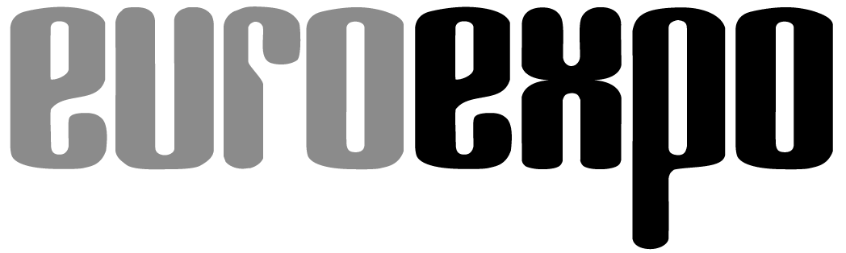
Messe- und Kongress-GmbH
Joseph-Dollinger-Bogen 7
D-80807 Munich, Germany
Phone: +49 89 32 391 259
Fax: +49 89 32 391 246
www.euroexpo.de/en
www.logimat-messe.de/en

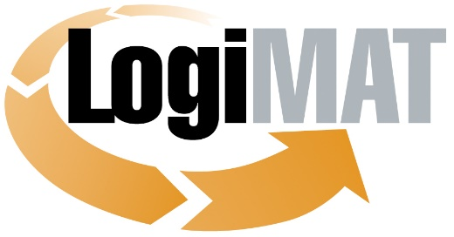

International Trade Show for
Intralogistics Solutions and Process Management
May 31–June 2, 2022 | Messe Stuttgart

Munich, April 12, 2022

Press Release

LogiMAT 2022 in Stuttgart
Best and Brightest: Forklift Trucks and More

Munich, April 12, 2022—The world’s leading manufacturers of industrial trucks will present their latest developments and innovations in mobile warehouse transport to an audience of global industry professionals at the International Trade Show for Intralogistics Solutions and Process Management. LogiMAT offers a compact overview with many products on display for the first time, underscoring its importance as the number-one industry trade show worldwide.

Exhibitors from the industrial truck sector are showcasing today’s leading industry trends in their presentations at LogiMAT 2022, the International Trade Show for Intralogistics Solutions and Process Management. A bit of background: The global material handling market once again exceeded the momentum of previous years, with all big-name manufacturers reporting significant double-digit gains in 2021. Jungheinrich reports “the most successful fiscal year in the company’s history” in 2021, including a surge of 45% in new orders. The Kion Group—whose subsidiaries Linde Material Handling, Still GmbH, and Baoli EMEA S.p.A. are among those represented at LogiMAT 2022—announced a year-on-year jump of 40.9% last year in new sales in its Industrial Trucks & Services division. The volume of new orders overall soared 51.0% from the previous year. The upward sales momentum was strongest in counterbalance forklift trucks, with a noticeable trend toward electric forklifts.

These positive results, as evidenced by the exhibitors of the industrial truck sector and the products they’re bringing to LogiMAT 2022, also point to several current industry trends. First, mobility and material flows in the warehouse clearly still rely on class 1 to 3 equipment such as lift trucks, tugger trains, counterbalance trucks, tiller-steered pedestrian stackers, articulated forklifts, reach trucks, and automated guided vehicles (AGVs). Second, the technology is electric and increasingly automated across the various handling and forklift processes. A third and longer-term trend that can be indirectly gleaned from the featured products is the strong interest and investment of manufacturers in AGVs and AMRs (autonomous mobile robots).

Nearly all AGV manufacturers are already active in this segment of the market. The integration of sensor technology and AI methods and processes highlight the trend toward autonomous transport vehicles. Still (Hall 10, Booth B41) is representing Germany in the European research project IMOCO (Intelligent Motion Control) with its OPX iGo neo order picker, which already operates autonomously in the rack aisle—with the aim of developing AGVs and AMRs into fully autonomous vehicles. Jungheinrich AG (Hall 9, Stand B05) is working on similar developments.

The AGV and AMR segment is another major presence at LogiMAT 2022, occupying all of Hall 2 for the first time, including the foyer. More than 80 exhibitors will be on hand to present their latest developments in AGVs and robot-based automation in intralogistics to an industry audience.

Platform transporter for up to 65 tons

Global industrial truck manufacturers are represented at LogiMAT 2022 primarily in the segment of manually guided vehicles, however, showcasing the latest equipment and accessories. All leading market players and nearly the complete lineup of international industrial truck manufacturers are presenting their latest products and services in Halls 9 and 10, including many never before exhibited. The products to be unveiled range from class 1 to 3 equipment, accessories and attachments, and driver assistance and fleet management systems to the latest solutions in the areas of alternative drive systems and battery and energy management. “We look forward to finally meeting up and reconnecting with our friends on site at our LogiMAT booth,” says Blade Feng, Forklift Business Unit Director, BYD Europe BV (Hall 10, Booth G61), capturing the mood among manufacturers. “We can hardly wait to show all the visitors our advanced alternative materials and handling solutions.”

The Rothaus Park and the outdoor areas between the halls also offer manufacturers such as Jungheinrich and Linde the opportunity to give attendees live demonstrations of their latest class 4 and 5 internal combustion forklifts, which comply with the current EU Stage V emission standard. “The additional outdoor area on the convention center grounds is the perfect place to demonstrate and show off the improvements and advantages of the new shooting stars with their diesel, LPG, and electric powertrains,” notes Stefan Prokosch, SVP of Brand Management at Linde Material Handling (Hall 10, Booth B21).

Jungheinrich AG, which is now also very active in warehouse technology and automated storage systems, has already announced that it will present at least one never-before-seen item and several new products. Sure to be featured among them will be the agile and compact LiftLiner® tugger train for the Jungheinrich EZS series 1, 3, and 5 electric tow tractors. At the start of the year, the Hamburg-based manufacturer also presented a new narrow-aisle forklift designed for driverless operation as an autonomous industrial truck, and this will likely also be on display at LogiMAT.

Hubtex Maschinenbau GmbH & Co. KG (Hall 10, Booth D05) is for the first time exhibiting a self-propelled platform transporter from the SFX modular system in models with load capacities of 25, 40, and 65 metric tons. The transporter is designed for manual applications indoors and outdoors and, with its modular design, can be equipped with various steering systems and a platform lift or configured as an AGV. STILL is coming to Stuttgart with a focus on AMR vehicles from the new ACH series, which will be exhibited publicly for the first time. The AMRs will be presented in symbiosis with automated vertical conveyors such as reach trucks or narrow-aisle forklifts. STILL will certainly also come to LogiMAT 2022 with the new LXT 120/350 and LXW 20/30 series of its electrically powered tractors and transport vehicles, which use the Descent Speed Regulation (DSR) assistance system. The DSR automatically adjusts travel speed for the gradient and load for greater safety and maximum handling capacity on sloped surfaces.

Premiere of new electric counterbalanced trucks

Hyster Europe (Hall 10, Booth C10) is putting the theme “Powering YOUR Possibilities” front and center in Stuttgart by featuring low-emission and zero-emission forklifts. The new Hyster® J10-18XD models with lithium-ion battery offer load capacities of up to 18 metric tons, a zero-emission design that aims to rival the performance of internal combustion models. LogiMAT 2022 visitors will also be among the first potential customers in Europe to set eyes on BYD’s new ECB20S forklift truck and their new SEF counterbalance series. The ECB20S three-wheel counterbalanced truck comes with two battery options and features an electric parking brake, the manufacturer’s latest energy-saving battery management system, and a redesigned hydraulic system. The exhibit will also include tools to make fleet management more transparent and optimize energy consumption and battery management using remote diagnostics.

A new counterbalanced truck from Swedish manufacturer Semax Material Handling AB (Hall 10, Booth G75), exhibited for the first time at LogiMAT, lives up to its manufacturer’s name of maximum visibility. The new compact stacker with the mast behind the cabin lets operators “see the max” and handle sensitive goods efficiently. The integrated telescopic extension (0–900 mm option) offers an outstanding reach for precision handling.

Add-on assistance system

PowerFleet GmbH (Hall 10, Booth C77), Abertax Technologies Ltd. (Hall 10, Booth C29), and Durwen Maschinenbau GmbH (Hall 10, Booth B39) are coming to Stuttgart with new products, accessories, and attachments. PowerFleet is exhibiting its VAI-100 for the first time, a camera-based pedestrian and vehicle warning system that can be retrofitted to existing equipment The system uses AI to recognize people, vehicles, and other obstacles within its working environment and sends a visual and acoustic signal to the operator if the distance falls below a defined safety distance. When coupled with the Vision Pro fleet management system, the VAI-100 can analyze any breach of safety zones and display the results in the software’s visibility tool.

Abertax Technologies presents the “Non-Metallic Liquid Level Sensor Electrode,” a patented new metal-free probe for measuring battery electrolyte levels in electronic products. Unlike conventional steel- or lead-based probes, the new level sensors are corrosion-free and easy to handle during installation. Durwen is coming to LogiMAT 2022 with a representative selection of its most important forklift attachments, including plug-and-play SmartFork fork positioners, a 180° paper roll clamp, and fork positioners combined with telescopic forks. The manufacturer touts its innovative new push/pull attachment and a new bale clamp with automatic dewiring. The new bale clamp cuts the binding transport wires on a wide variety of bales, such as those in the wastepaper and recycling industry. The bale material falls into the appropriate load and transport device once the clamp is opened. The clean cut wires remain in the gripper for easy disposal.

“With all these brand-new products on display, LogiMAT 2022 once again offers what has to be the most comprehensive overview of today’s equipment and solutions in the international material handling industry,” concludes Exhibition Director Michael Ruchty of EUROEXPO Messe- und Kongress-GmbH in Munich. “With their latest hardware innovations and driver assistance and fleet management systems, the exhibitors also make LogiMAT a platform and networking event second to none—and the best source of information for long-term investment decisions in the field of industrial trucks. You can’t find a greater concentration of expertise anywhere.”

Organized by: EUROEXPO Messe- und Kongress-GmbH
Joseph-Dollinger-Bogen 7 | 80807 Munich, Germany
Phone: +49 89 32 391 259 | Fax: +49 89 32 391 246
www.logimat-messe.de | www.logimat.digital

10,053 characters (with spaces)

Munich, April 12, 2022—This text may be reprinted free of charge, but please send a copy to EUROEXPO Messe- und Kongress-GmbH, Press and Public Relations, 80912 Munich.

About LogiMAT

LogiMAT, the International Trade Show for Intralogistics Solutions and Process Management, will take place at the Messe Stuttgart convention center, directly adjacent to Stuttgart International Airport, from May 31 to June 2, 2022. Presented by EUROEXPO Messe- und Kongress-GmbH, LogiMAT ranks as the world’s largest trade show for intralogistics solutions with a complete market overview of everything driving the intralogistics industry, from procurement to production to shipping. International exhibitors showcase innovative technologies, products, systems, and solutions for streamlining operations, optimizing processes, and cutting costs in a company’s internal logistics. Beyond the exhibitor booths, visitors can also experience a different program of presentations each day in the East Entrance Atrium covering a wide range of topics.
EUROEXPO has also partnered with Landesmesse Stuttgart since 2014 to present the annual LogiMAT China, held in Shanghai alongside transport logistic China.
Bangkok is the site of LogiMAT | Intelligent Warehouse. Focused on the Southeast Asian market, this event follows in the footsteps of Intelligent Warehouse, presented by local organizer Expolink Global Networks Ltd. from 2015 to 2019.
LogiMAT.digital is the platform that brings together top providers of the world’s best intralogistics solutions with high-quality leads, bridging the time and space between on-site events.

