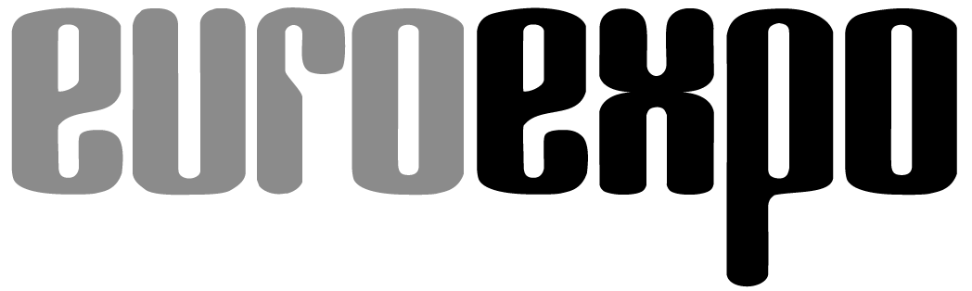
Messe- und Kongress-GmbH
Joseph-Dollinger-Bogen 7
D-80807 Munich, Germany
Phone: +49 89 32 391 259
Fax: +49 89 32 391 246
www.euroexpo.de/en
www.logimat-messe.de/en
www.logimat.digital

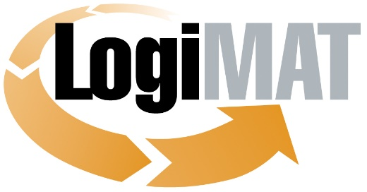

International Trade Show for
Intralogistics Solutions and Process Management
May 31–June 2, 2022 | Messe Stuttgart

Munich, May 31, 2022

Press Release

DO NOT RELEASE BEFORE
May 31, 2022, 11:00 a.m. CET

LogiMAT 2022 in Stuttgart
BEST PRODUCTS for High-Efficiency Intralogistics

Stuttgart, March 31, 2022—LogiMAT 2022, A versatile AMR, a high-efficiency intralogistics management platform that can synchronize entire fleets of vehicles, and a pallet classification system: Those are the three innovative standouts honored with this year’s prestigious BEST PRODUCT award at LogiMAT 2022.

The independent jury of scholars and journalists reviewed over 100 submissions and chose three winners that fully live up to the name of BEST PRODUCT as outstanding manifestations of the award criteria: They enhance productivity, reduce costs, and streamline operations. The award-winning companies, through their products, are helping to make processes more stable yet flexible in adapting to changes. By improving efficiency, they are ultimately boosting the productivity of the logistics industry. The BEST PRODUCT award was presented in the LogiMAT Arena during the gala opening ceremony on the first morning of the trade show. Presenting the awards was Prof. Johannes Fottner, Chair of the Institute for Materials Handling, Material Flow, Logistics at the Technical University of Munich.

In the category of “Order Picking, Conveying, Lifting, and Storing Technology,” the prize went to Bosch Rexroth AG (Hall 2, Booth B21), Assembly Technology product group, for the intralogistics solution around its ActiveShuttle autonomous mobile robot.

The AMR automates and standardizes the internal flow of goods and materials for efficient and transparent intralogistics workflows. ActiveShuttle has the flexibility to pick up warehouse dollies loaded with totes and reliably transport them to their destination. Fully automatic loading and unloading make manual load-handling a thing of the past. The integrated safety system allows ActiveShuttle to stop in time and safely navigate around any obstacles it encounters. The AMR features a safety laser scanner plus stereo cameras that produce a 3D scan of the room so that it can even detect any objects protruding into its path. ActiveShuttle is equipped for uninterrupted 24/7 operation, using robust laser navigation (SIL2, PLd) and a speed of up to 1 m/s to transport goods weighing up to 260 kg safely to their destination. The ActiveShuttle Management System (AMS) acts as a central nervous system for the entire ActiveShuttle fleet: The software displays the real-time status of the fleet, assigns pending transport orders to available vehicles, and allows the user to control and configure logistics planning scenarios. AMS offers highly flexible order management, where orders can be entered manually or imported automatically through third-party systems. The new touchscreen display integrated into the vehicle console ensures greater efficiency on site, because operators can now interact directly and intuitively with the mobile robot. This provides job and status info for greater transparency, speeds up diagnostics and troubleshooting, and simplifies the process of onboarding the AMR with the higher-level management system. ActiveShuttle can be implemented quickly without any need to adapt existing factory infrastructure. It has an intuitive user interface, is fully integrated, and can interact safely with humans.

In the category of “Identification, Packaging and Loading Technology, Load Securing,” the award went to SICK Vertriebs-GmbH (Hall 1, Booth F51) for its deep learning–based PACS pallet classification system.

PACS recognizes the pallet type from the branding on the pallet feet and uses a trained neural network to assign it to a class. The class is used to automatically assign a deposit, simplifying an otherwise onerous and often manual process. The compact system can be integrated into the logistics chain and is ideal for use in tight spaces. The modular design of PACS features a combination of hardware and software components from SICK. Depending on the project, one or more color cameras are used for image recording. The software tools SICK AppSpace and dStudio help you get your solution up and running quickly using standard hardware. The SICK AppSpace ecosystem makes it possible to tailor the solution to the specific needs of the customer on site. Intuitive user interfaces mean no prior knowledge of programming or machine learning is required to operate the system. Customers have the option to quickly and easily expand the range of the system with additional sensors for reading barcodes, dimensioning pallets, and much more.

In the category “Software, Communications, IT,” the winner was startup SYNAOS GmbH (Hall 2, Booth A21) for the intralogistics management platform SYNA.OS LOGISTICS, which uses AI and cutting-edge cloud technology to organize factories and logistics centers.

SYNAOS software is transforming intralogistics, using AI and cutting-edge cloud technology to make the new industrial revolution a reality. The unique SYNA.OS LOGISTICS software operating system synchronizes vehicles, forklifts, and mobile robots based on their real-time data—leveraging their very complexity as an advantage. Modules such as Order & Process Management, Asset Control, Storage Management, Vehicle & Operator Management, and Vehicle Localization optimize processes instantaneously using AI-based algorithms for heightened efficiency. The software uses the power of cloud computing to sort through billions of possibilities and choose the best solution every time.

Autonomous vehicles and forklifts in logistics centers often come from different hardware manufacturers and lack a centralized control system. The result is intralogistical chaos that makes precise planning difficult and drives up costs. SYNA.OS LOGISTICS uses a interface based on the VDA/VDMA standard VDA 5050 to integrate all vehicles in real time irrespective of manufacturer, acting as a conductor to transform a room full of soloists into a perfectly coordinated orchestra. The platform’s scalability accommodates up to 1,000 vehicles. The software responds immediately to any malfunctions or operating errors. The smart distribution of goods reduces delays by up to 60 percent. AI-based algorithms and processes reduce the size of the fleet to the bare minimum, relieving the pressure on busy warehouses while saving costs.

The three products awarded BEST PRODUCT 2022 are representative of the many exhibitors from around the world presenting their innovations to industry professionals at LogiMAT. The International Trade Show for Intralogistics Solutions and Process Management, the largest of its kind worldwide, continues through June 2, 2022, at the Messe Stuttgart convention center.

Organized by: EUROEXPO Messe- und Kongress-GmbH
Joseph-Dollinger-Bogen 7 | 80807 Munich, Germany
Phone: +49 89 32 391 259 | Fax: +49 89 32 391 246
www.logimat-messe.de | www.logimat.digital

6,633 characters (with spaces)

Stuttgart, May 31, 2022—This text may be reprinted free of charge, but please send a copy to EUROEXPO Messe- und Kongress-GmbH, Press and Public Relations Department, 80912 Munich.

Background information:

The BEST PRODUCT award was initiated by the organizers of LogiMAT in order to draw attention to the outstanding achievements of the exhibitors, many of whom are small or medium-sized businesses. Over the years, the award has honored innovative products that have made a significant contribution to streamlining processes, cutting costs, and enhancing productivity in the internal logistics of businesses. The BEST PRODUCT award is presented in three categories:
- Software, Communications, IT
- Order Picking, Conveying, Lifting, and Storing Technology
- Identification, Packaging and Loading Technology, and Load Securing
In the run-up to LogiMAT, an independent jury of scholars and journalists critically evaluates the submissions based on the aforementioned criteria, then selects the winners. The award has since been recognized as one of the most coveted distinctions in the intralogistics industry. Winners are presented with a certificate and a medal during the gala opening ceremony of LogiMAT.
Members of the BEST PRODUCT award jury:
- Prof. Johannes Fottner (Dr.-Ing.), Chair of the Institute for Materials Handling, Material Flow, Logistics at the Technical University of Munich (Jury President)
- Prof. Rolf Jansen (Dr.-Ing.), Institute for Distribution and Retail Logistics (IDH) at the Society for the Promotion of Innovation in Logistics (VVL e.V.)
- Jan Kaulfuhs-Berger from the industry journal Technische Logistik
- Matthias Pieringer from the industry journal LOGISTIK HEUTE
- Prof. Wolf-Michael Scheid (Dr.-Ing.), Association of German Engineers, Society for Production and Logistics (VDI-GPL)
- Prof. Robert Schulz (Dr.-Ing.), University of Stuttgart, Institute of Mechanical Handling and Logistics (IFT)
- Tobias Schweikl from the industry journal LOGISTRA

