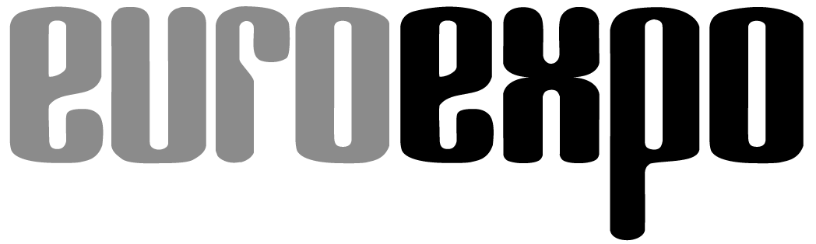
Messe- und Kongress-GmbH
Joseph-Dollinger-Bogen 7
D-80807 Munich, Germany
Phone: +49 89 32 391 259
Fax: +49 89 32 391 246
www.euroexpo.de/en
www.logimat-messe.de/en

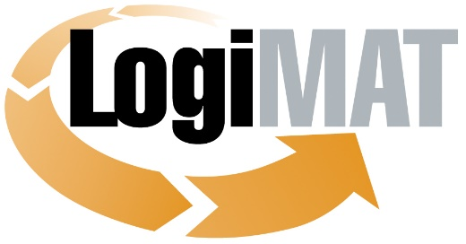

International Trade Show for
Intralogistics Solutions and Process Management
May 31 to June 2, 2022 | Messe Stuttgart

Munich, March 16, 2022

Press Release

LogiMAT 2022 in Stuttgart
LogiMAT—Back with a Bang

Munich, March 16, 2022—LogiMAT, the International Trade Show for Intralogistics Solutions and Process Management, returns in 2022 with a slate of exhibitors at pre-pandemic levels to reaffirm its reputation as the leading international logistics trade show. An expected 1,500 international exhibitors are coming to Stuttgart to present their latest product innovations and solutions for efficient and sustainable intralogistics.

LogiMAT opens its doors again with this year’s theme of “Smart – Sustainable – Safe” at the Messe Stuttgart convention center from May 31 to June 2, 2022. “The exhibitors look forward to being in the room again with customers and industry professionals and have big things planned,” promises Michael Ruchty, Exhibition Director at EUROEXPO Messe- und Kongress-GmbH in Munich. “Visitors can expect a broad spectrum of the latest technologies and efficient systems and solutions for smart, sustainable, safe automation in intralogistics. Visitors can also tap into LogiMAT’s popular accompanying program for the extra information they need.”

Capacities at LogiMAT 2022 will reach pre-pandemic levels with an expected 1,500 exhibitors, a third arriving from outside Germany, and an exhibit space of more than 120,000 square meters in all ten halls of Stuttgart Messe. “When adjusted for the optimized safety standards in line with current public health requirements, we actually have more exhibit space than before the pandemic,” Ruchty emphasizes. “Exhibitors have booked the entire gallery space in Hall 1 for the first time, for example.” The East Entrance exhibit space for startups sponsored by the Federal Ministry for Economic Affairs and Climate Action has nearly doubled in size. Outdoor spaces have also been opened up for live demonstrations by forklift manufacturers. And the expert forums, with their mix of exciting presentations, are moving from the exhibit halls into the LogiMAT Arena—centrally located in the East Entrance Atrium with space that allows up to 150 people to follow a presentation while socially distancing. LogiMAT is once again fully booked. “This reaffirms the reputation of the LogiMAT brand and the International Trade Show for Intralogistics Solutions and Process Management as the leading international industry meetup in 2022 and the primary platform for presentations, information, and communication—a business-oriented trade show for direct sales in the intralogistics industry,” says Ruchty.

Easier navigation with clear exhibit hall layout

Industry professionals will find ten exhibit halls filled with new products and innovations for sustainable and resource-efficient processes. The trends toward automation, tech, and omnichannel—along with the ongoing shortage of skilled workers—continue to drive new developments. The spectrum of resulting products and solutions includes high-performance robots, forklift innovations, automated guided vehicles (AGVs), concepts for scalable automated warehouse systems that can grow to keep pace with your needs, energy-efficient power and memory modules, and cloud-based software solutions for smart warehouse management, data analytics, and control.

To make it easier for visitors to find what they’re looking for, the exhibit halls are once again organized around exhibitor groups. Plant and equipment manufacturers will be on hand alongside system providers and integrators to showcase their latest products and innovations in Halls 1, 3, 5, and much of 7. This leading exhibitor group will bring many new products and innovations to Stuttgart, including new shuttle systems, carrying robots, autonomous picking robots, space-saving sorting solutions, conveyor components, innovative pouch sorters, and picking and palleting cobots. Several system integrators will also be on hand to present AutoStore systems and the latest innovations for the automated storage system. Other exhibits focus on tech-driven optimization using system and data integration for integrated data transfers and comprehensive data analytics.

The rest of Hall 7 and Hall 9 features products and innovations from the related fields of cranes, loading technology, handling systems, gates, and fire safety and security systems. Robots and AGVs, a growth segment that has attracted over 80 registered exhibitors, will fill all of Hall 2 and its foyer for the first time at LogiMAT 2022 with the latest developments in intralogistics automation.

In Hall 8 and parts of Hall 6, logistics software developers and providers offer many paths to the future. IT systems provide the foundation by supporting the seamless, end-to-end integration of cross-enterprise digital workflows. LogiMAT 2022 will feature systems for fleet management, transport management, resource management, yard management, and time slot management plus the latest software solutions for customs, shipping, and export controls. You’ll also find high-performance apps, modules, and systems for data consolidation, analytics, and optimization. AI technologies and high-performance algorithms support IoT apps and big data analytics to optimize intralogistics and supply chain operations. Several exhibitors also offer cloud-based end-to-end warehouse management systems whose mix-and-match modules, functionalities, and various billing models give even smaller companies an affordable gateway to cutting-edge technology.

The software companies share Hall 6 with suppliers of container and storage solutions, packaging and packaging machines, and labeling and identification technology, which are also concentrated in Hall 4. Visitors there can also find the latest transport boxes for last-mile logistics in food e-commerce, new roller containers, dynamic freight measurement solutions, object recognition solutions, and modified security label printers, (RFID) labels, and scanners. A well-known logistics service provider will also address the theme of sustainability through decarbonization with a net zero carbon program for transports along the entire supply chain.

Industrial truck manufacturers to exhibit many new products in Stuttgart

Manufacturers of industrial trucks, attachments, and loading technology make up another key exhibitor group. They’ll be on hand to present their latest developments in equipment and accessories, driver assistance and fleet management systems, alternative drive technologies, and battery and energy management solutions in Halls 9 and 10, in Rothaus Park, and in the outdoor areas between the halls. Nearly all the world’s leading industrial truck manufacturers are coming to LogiMAT 2022 with a complete selection of their current product portfolio. Many have also announced plans to unveil innovations never before presented publicly in areas such as self-driving platform transporters, multidirectional sideloaders, and both internal combustion and electric counterbalanced trucks with payloads from 2.0 to 3.5 metric tons. Highlights include automated mobile robots and reach trucks plus scalable new forklift series. In the area of drive technology, you’ll find innovative sensors that show battery electrolyte levels and mobile power supplies based on lithium-ion technology.

The popular accompanying program at LogiMAT features the extensive lecture series at the expert forums, which this year are consolidated in the LogiMAT Arena in the East Entrance Atrium. The on-site event is augmented by the new “Forum Innovation.digital” program on the LogiMAT.digital online platform. From April 26 to May 25, you’ll find entertaining and informative 25-minute exhibitor presentations by as many as 120 companies offering sneak previews of the new products, solutions, and services that they’ll bring to Stuttgart. “LogiMAT 2022 once again offers an exciting mix of useful information and the opportunity for a side-by-side comparison of all the latest products and solutions for efficient intralogistics,” concludes Peter Kazander, Managing Director of EUROEXPO. “Visitors to LogiMAT 2022 can look forward to a scintillating display of forward-looking innovations and smart tools for efficient workflows. It is the greatest intralogistics industry meetup anywhere in the world.”

Organized by: EUROEXPO Messe- und Kongress-GmbH
Joseph-Dollinger-Bogen 7 | 80807 Munich, Germany
Phone: +49 89 32 391 259 | Fax: +49 89 32 391 246
www.logimat-messe.de | www.logimat.digital

8,213 characters (with spaces)

Munich, March 16, 2022—This text may be reprinted free of charge, but please send a copy to EUROEXPO Messe- und Kongress-GmbH, Press and Public Relations, 80912 Munich.

About LogiMAT

LogiMAT, the International Trade Show for Intralogistics Solutions and Process Management, will take place at the Messe Stuttgart convention center, directly adjacent to Stuttgart International Airport, from May 31 to June 2, 2022. Presented by EUROEXPO Messe- und Kongress-GmbH, LogiMAT ranks as the world’s largest trade show for intralogistics solutions with a complete market overview of everything driving the intralogistics industry, from procurement to production to shipping. International exhibitors showcase innovative technologies, products, systems, and solutions for streamlining operations, optimizing processes, and cutting costs in a company’s internal logistics. Beyond the exhibitor booths, visitors can also experience a different program of presentations each day in the East Entrance Atrium covering a wide range of topics.
EUROEXPO has also partnered with Landesmesse Stuttgart since 2014 to present the annual LogiMAT China, which returns to Shanghai alongside transport logistic China, June 15–17, 2022.
Bangkok is the site of LogiMAT | Intelligent Warehouse, October 12–14, 2022. Focused on the Southeast Asian market, this event follows in the footsteps of Intelligent Warehouse, presented by local organizer Expolink Global Networks Ltd. from 2015 to 2019.
LogiMAT.digital is the platform that brings together top providers of the world’s best intralogistics solutions with high-quality leads, bridging the time and space between on-site events.

