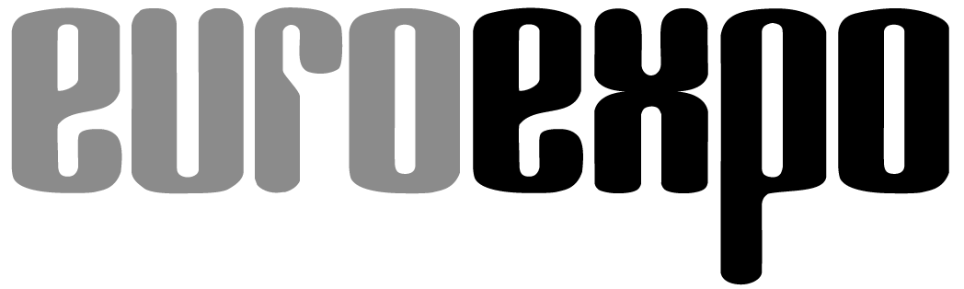
Messe- und Kongress-GmbH
Joseph-Dollinger-Bogen 7
D-80807 Munich, Germany
Phone: +49 89 32 391 259
Fax: +49 89 32 391 246
www.euroexpo.de/en
www.logimat-messe.de/en
www.tradeworld.de/en

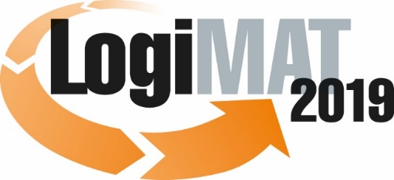

The 17th International Trade Show for
Intralogistics Solutions & Process Management
February 19–21, 2019 | Messe Stuttgart

Also featured at LogiMAT:
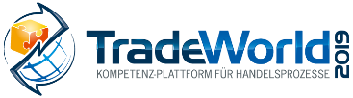

Munich, January 17, 2019

Press Release

LogiMAT 2019 in Stuttgart
LogiMAT 2019 – First-hand logistics software

At the 17th annual LogiMAT, the software industry is turning to the key trends of system integration and data analytics with products to help achieve digital transformation and manage streamlined processes. Increasingly, this involves methodologies and procedures of artificial intelligence, including machine learning and neural network integration.

What will the future bring? The omnipresent theme of digital transformation occupies tech consumers like almost no other issue today. Innovative sensors for the internet of things, lightning-fast computers and processors, storage capacities, and algorithms that further automate software processes themselves – all this is ushering in an entirely new era for automation and digital innovation. Information technology is key to efficiently processing the collected data, managing the processes, and tapping into the added value and competitive edge that these new technological innovations offer.

Developers and providers of intralogistics software solutions will be on hand at the 17th International Trade Show for Intralogistics Solutions and Process Management in Halls 6 and 8 to present a comprehensive overview of today’s products and services for IT infrastructure. Alongside a variety of warehouse management system designs, including new features for fully integrated processes and cutting-edge applications that harness the power of artificial intelligence (AI), industry professionals in Stuttgart will find innovative solutions in such diverse fields as industrial wearable-based augmented reality, telematics and transport management, information security management systems, and the latest software solutions for customs, shipping, and export controls.

“From sub-systems and partial systems for best-of-breed solutions to comprehensive supply chain suites, LogiMAT 2019 offers industry professionals from around the world the opportunity to learn about the latest functional developments and software for the future-ready design of their IT infrastructure and directly compare different solutions side by side,” says LogiMAT Exhibition Director Michael Ruchty from event organizer EUROEXPO Messe- und Kongress-GmbH. “The exhibitors are focusing specifically on system integration and data analytics. From embedded simulation models to integrated machine learning, one sees a rich diversity of functionalities that help customers in more and more areas use data more efficiently and make better decisions.”

A bit of background: The horizontal integration of supply chain applications continues to grow in parallel with increased vertical integration of up- and downstream systems. As the industrial sector embraces IT technology, the smart and seamless coupling of IT systems at both levels will define future system engineering and product spectrums. Developers have already created the foundation for this with the modular design of their systems and service-oriented architectures. On the level of horizontal systems, for example, both transport management systems and warehouse management systems each now increasingly incorporate the functionalities of the other. Going forward, warehouse management system modules will be integrated into ERP systems as needed and vice versa. PSI Logistics GmbH (Hall 8, Booth D76) is presenting this kind of approach with the cross-system, modular integration of products from the PSI Logistics Suite into the ERP infrastructure. The software company is also presenting the planning and control system for logistics networks, PSIglobal, in a big data function as a converter for harmonizing heterogeneous data from various sources. PSI is even introducing an AI application in which deep learning with a neural network integrates process control, auto ID, documentation and back-tracing with surveillance camera systems, and closed circuit television.

Machine learning (ML) is one of the fastest-growing fields in all of data analytics, and it forms the basis of today’s AI applications. Advanced analytics and ML together offer wide-ranging opportunities to further improve process management. The underlying algorithms calculate and identify hidden patterns and expose interrelationships to uncover further potential for optimization. Moreover, looking ahead at future developments, it’s likely that AI emerging from today’s digital revolution will have a long-term impact on the changes in IT infrastructure and the replacement of today’s proprietary software with open systems. That’s why so many exhibitors at LogiMAT 2019 are presenting ML-based applications for extended data analytics, customer relationship management, process control, and predictive maintenance.

Team GmbH (Hall 8, Booth B21) is a software company focusing on data analytics with its ProStore® warehouse management system, featuring brand-new analytical and visualization capabilities. The startup FPrimeZero GmbH (Hall 6, Booth F62) is unveiling its new Supplybrain software, which fuses control engineering and the tools of artificial intelligence (AI) to achieve high-efficiency supply chain management. Supplybrain delivers real-time analytics of orders and material flows in the supply chain and manages process workflows accordingly, simulating sub-processes in the background with the help of a digital twin and optimizing them to the current order volume with the help of AI and control engineering technologies. MotionMiners GmbH (Hall 8, Booth C18), a startup launched by the Fraunhofer Institute for Material Flow and Logistics (IML), is presenting its Motion-Mining® technology, which draws on sensors and deep learning to automatically analyze manual processes for the high-tech industry of tomorrow. Inform GmbH (Hall 8, Booth D61) is coming to LogiMAT to present a new process for automatically managing regional locations by service level and budget, allowing enterprises with complex network architectures to calculate reorder points and maximum stock levels for each item at each location.

Salt Solutions AG (Hall 8, Booth D35) is showcasing its eye-catching Dobot M1 industrial robot, which uses deep learning frameworks to recognize objects and automatically perform predefined workflows based on modular coding blocks. Inconso AG, (Hall 8, Booth D55) is an all-rounder for smart collaboration with options for integrating robots, sensors (IoT and industrial IoT), augmented reality, voice applications, and artificial intelligence. Their focus at LogiMAT is on integration as the key to efficient logistics management.

Exhibitors are also bringing along a wide range of products and innovations to illustrate the sub-system level and how it can be managed. Anronaut GmbH (East Entrance, Booth EO80) is presenting its proprietary software platform at LogiMAT 2019 as a control tower for automated guided vehicles (AGVs). In the interests of reducing and synchronizing interfaces, the platform has been designed to be forward-compatible with the next version of the German automotive industry’s VDA/VDMA standard. iFD GmbH (Hall 10, Booth A01) is introducing its transport control system with a new module for tugger train control and interfaces to semi-automated and fully automated transport systems. sysmat GmbH (Hall 8, Booth B23) is featuring its material flow computer software matCONTROL graphics, a solution for the system-neutral integration and control of automated areas that enables direct control of automated storage and retrieval systems and system components from an ERP system. The Paari® Group (Hall 6, Booth G67) is also presenting a self-service terminal with facial recognition – a first at LogiMAT 2019. It can handle the task of check-in and identity verification using a driver ID or RFID card and issue yard permits or routing slips.

“Flexibility, automation, and integration are the themes driving software development in this new age of high-tech industry,” concludes Exhibition Director Michael Ruchty. “At the 17th edition of LogiMAT, software exhibitors from around the world are responding with products that emphasize both their innovation and the potential for development that arises from the integration of new technologies. Given the current changes in the system environment and rapid developments in the related technologies of sensors, robotics, imaging, and AI, it will be exciting to watch how logistics software evolves – as the examples outlined above make clear.”

Event organizer: EUROEXPO Messe- und Kongress-GmbH
Joseph-Dollinger-Bogen 7 | 80807 Munich, Germany
Phone: +49 89 32 391 259 | Fax: +49 89 32 391 246
www.logimat-messe.de | www.tradeworld.de

8,458 characters (with spaces)
Munich, January 17, 2019 - his text may be reprinted free of charge, but please send a copy to EUROEXPO Messe- und Kongress-GmbH, Press and Public Relations Department, 80912 Munich.

About LogiMAT

LogiMAT 2019, the 17th International Trade Show for Intralogistics Solutions and Process Management, takes place February 19–21 on the grounds of Messe Stuttgart, directly adjacent to Stuttgart International Airport. LogiMAT, the world’s largest intralogistics trade show, offers a comprehensive overview of everything driving the intralogistics industry, from procurement to production to shipping. International exhibitors gather early in the year to showcase innovative technologies, products, systems, and solutions for streamlining operations, optimizing processes, and cutting costs in a company’s internal logistics.

TradeWorld, the Professional Platform for Trade Processes embedded within LogiMAT, features products and solutions for e-commerce and omnichannel. Beyond the exhibitor booths, visitors to this combined event can also experience a different program of presentations each day covering a wide range of topics.

