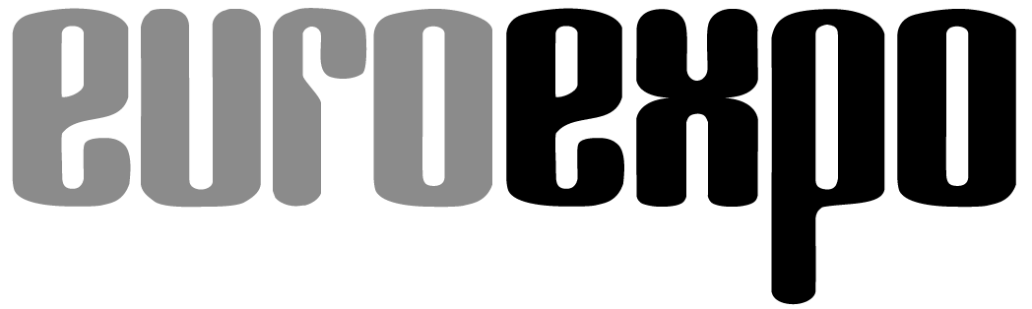
Messe- und Kongress-GmbH
Joseph-Dollinger-Bogen 7
D-80807 Munich, Germany
Phone: +49 89 32 391 259
Fax: +49 89 32 391 246
www.euroexpo.de/en
www.logimat-messe.de/en
www.tradeworld.de/en

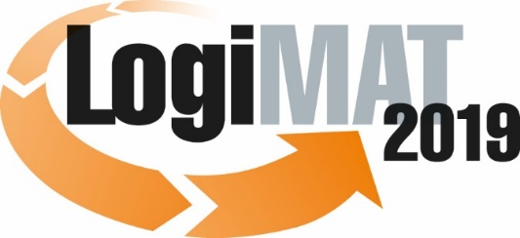

The 17th International Trade Show for
Intralogistics Solutions & Process Management
February 19–21, 2019 | Messe Stuttgart

Also featured at LogiMAT:
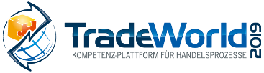

Munich, January 21, 2019

Press Release

LogiMAT 2019 in Stuttgart
LogiMAT 2019 – First-hand auto-ID

Representatives of the auto ID sector are coming to the 17th annual LogiMAT with groundbreaking innovations for encoding, capturing, and integrating data – reinforcing their reputation as enablers of the digital revolution. Solutions ranging from security labels and RFID tags to transport monitoring and automated volume optimization provide customers with a wide range of benefits.

The auto ID sector can expect further growth in 2019. Automatic identification and data capture technologies – known simply as “auto ID” – deliver reliability and traceability and pave the way for digital innovation and next-gen industry and logistics. Recent studies show that German businesses are lagging behind their international competitors in digital technology. That underscores the need to gain ground in the smart encoding, capture, and integration of production and logistics data. Auto ID technology providers from around the world can be found in Halls 4 and 6 on the southern flank of the Messe Stuttgart convention center for the 17th edition of LogiMAT, offering a one-of-a-kind overview of how their solutions can help businesses innovate digitally. In the words of AIM Managing Director for Germany Peter Altes: “The digital supply chain, the smart factory, and an internet of things worthy of the name – these things are no longer a pie in the sky. LogiMAT 2019 is a good place to discover how much of this has already come down to earth.”

Michael Ruchty, LogiMAT’s Exhibition Director at event organizer EUROEXPO Messe- und Kongress-GmbH, adds more context: “The spectrum of solutions ranges from optical readable media (ORM), radio frequency identification (RFID), real-time locating systems (RTLS), and 3D measurement to innovative sensor technology and every type of auto ID technology and process. More specifically, you’ll find innovative shock sensors for transport monitoring, new RFID transponders/tags, RFID label printers, RFID-based picking gloves, and much more. Exhibitors are also bringing along innovative digital signage solutions, electronic shelf labels (ESL), and digital labels for warehouse and production environments. Visitors can even marvel at measurement stations that can customize outer packaging directly within the material flow.”

Meanwhile, the 17th International Trade Show for Intralogistics Solutions and Process Management also offers industry professionals in attendance an informative accompanying program. Forum C in Hall 4 features presentations examining the many applications of auto ID: in the control and optimization of business processes for the “smart” factory (Feb. 19), in the digital transformation of the supply chain (Feb. 19), as a base technology for next-gen industrial innovations (Feb. 20), and in the accelerated development of new products (Feb. 21). AIM, the industry association for the auto ID industry and mobile IT systems, is setting up its ever-popular Tracking & Tracing Theatre in Hall 4, Booth F05 —directly across from the AIM booth – with guided tours and auto ID live presentations about digital technology in the supply chain. “Auto ID technologies, including near-field communication (NFC) and RTLS, are fast and secure,” emphasizes AIM Managing Director Peter Altes. “They help achieve increasingly automated and autonomous processes in which objects of all types identify and verify one another.” In the process, as demonstrated by the products from around the world exhibited at the 17th LogiMAT, the breakthroughs in supporting disciplines such as transmission and sensor technology will be continually integrated into the products and solutions.

Opticon Sensoren GmbH (Hall 6, Booth A66), the German subsidiary of Japan’s Optoelectronics Co. Ltd., is coming to Stuttgart with its latest solutions in the area of digital signage and ESL, plus scan engines for the integration of industrial applications and scan solutions for the commercial and manufacturing sectors. Faubel & Co. Nachfolger GmbH (Hall 4, Booth G15) is presenting new smart labels featuring battery-free active matrix displays with data that can be regularly modified: ship-to address, storage location, contents, etc. troniTAG GmbH (Hall 6, Booth A70) is showcasing its digital labels for production and storage environments – a convenient solution for labeling and describing storage locations, equipment, and boxes. This technology eliminates the need for manual labeling, digitizing the documentation used to track each step in the production process. The contents of the container can be displayed on the digital label, and UWB-based localization technology makes it possible to track and label the unit load devices.

Gustav Wilms oHG Supply Chain Technologies (Hall 4, Booth D05) is introducing an innovative new tag installation machine, underscoring the reputation of RFID as an enabler of digital innovation. RFID transponders in boxes, kegs, and casks – together with the appropriate scanning stations – make it possible to track the reusable unit load devices through the processes and control them based on defined data. Böllhoff GmbH (Hall 4, Booth A77) is exhibiting its new Ecolabel electronic shelf display, an RFID-based picking system that offers flexible labeling options and accelerates pick-by-signal processes. The RFID-based Ecoglove eliminates picking errors and simplifies handling by reading the information from the RFID transponder with each hand movement and comparing it against the order.

Aspion GmbH (Hall 6, Booth A64) has focused on the issues around transport monitoring and developed Aspion G-Log 2, a shock sensor adapted specifically to system and equipment exports with its event-triggered shock and environmental temperature data capture, long battery life, and diverse communication options. The Aspion G-Log 2 will be on display to an international business audience for the first time at LogiMAT 2019. And speaking of transport: Transport industry watchers estimate that as a result of standardized, greatly oversized outer packaging, 50 percent of what is shipped each day is air. To make matters worse, the empty spaces are stuffed with filler materials, often made of plastic. This is leading to greater efforts to measure volumes and weights accurately and find sustainable packaging solutions. G. Kraft Maschinenbau GmbH (Hall 4, Booth D61) is presenting its new KRAFT VMB 100 scanner, a specialized machine that identifies, weighs, and measures products for packaging when they pass through a scanning area with an integrated load cell and camera. The captured data is documented for the subsequent packaging process and either archived or transmitted to the stations. A downstream KRAFT VPS 100 box-cutting machine takes all the parameters into account, automatically selects the ideal packaging design and cardboard type, and generates the custom outer package just in time.

LogiMAT Exhibition Director Ruchty sums it up: “The examples outlined above show that auto ID technologies, deployed collaboratively with the appropriate software systems, can harness digital technology and data capture to control and optimize production, supply chain, and logistics processes. This not only provides the foundation for digital innovation, it also gives customers a significant boost in the quality and optimization of their processes and helps them differentiate themselves in the marketplace.”

Event organizer: EUROEXPO Messe- und Kongress-GmbH
Joseph-Dollinger-Bogen 7 | 80807 Munich, Germany
Phone: +49 89 32 391 259 | Fax: +49 89 32 391 246
www.logimat-messe.de | www.tradeworld.de

7,437 characters (with spaces)
Munich, January 21, 2019 –This text may be reprinted free of charge, but please send a copy to EUROEXPO Messe- und Kongress-GmbH, Press and Public Relations Department, 80912 Munich.

About LogiMAT

LogiMAT 2019, the 17th International Trade Show for Intralogistics Solutions and Process Management, takes place February 19–21 on the grounds of Messe Stuttgart, directly adjacent to Stuttgart International Airport. LogiMAT, the world’s largest intralogistics trade show, offers a comprehensive overview of everything driving the intralogistics industry, from procurement to production to shipping. International exhibitors gather early in the year to showcase innovative technologies, products, systems, and solutions for streamlining operations, optimizing processes, and cutting costs in a company’s internal logistics.

TradeWorld, the Professional Platform for Trade Processes embedded within LogiMAT, features products and solutions for e-commerce and omnichannel. Beyond the exhibitor booths, visitors to this combined event can also experience a different program of presentations each day covering a wide range of topics.

