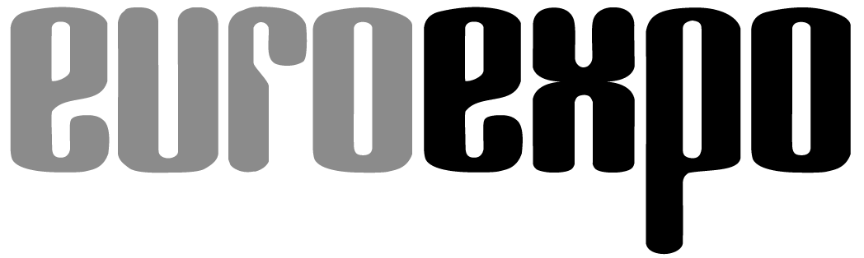
Messe- und Kongress-GmbH
Joseph-Dollinger-Bogen 7
D - 80807 München
Tel.: +49 (0)89 32391-259
Fax: +49 (0)89 32391-246
www.EUROEXPO .de
www.logimat-messe.de
www.tradeworld.de

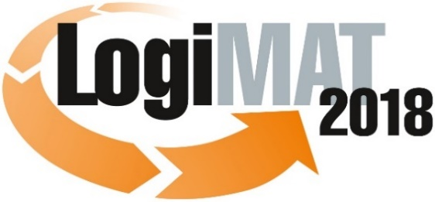

16th International Trade Fair for Intralogistics
Solutions and Process Management
13 to 15 March 2018, Messe Stuttgart

Part of LogiMAT:
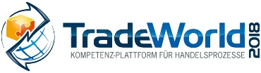

Munich, 15.01.2018

Press release

LogiMAT 2018 in Stuttgart
LogiMAT 2018 – First-hand AutoID Intralogistics

At the 16th LogiMAT, the AutoID industry presents itself as an enabler of Industry 4.0 and its many product launches will demonstrate the latest innovative developments available from its current range of digitisation and networking products and services.

“Automation processes and digitisation depend on all kinds of objects being mutually and securely identifiable,” says Peter Altes, managing director of the sector association AIM-D e.V., outlining the challenges for ”smooth, safe processes in logistics and production – and ultimately communication via the internet of things.” In this context, Altes describes AutoID technologies as a whole as ”Enabling technologies for Industry 4.0“. Just how multi-dimensional the range of technology in this sector is and the range of innovative products and instruments currently available for smart AutoID solutions will be showcased by the exhibitors at the 16th LogiMAT International Trade Fair for Intralogistics Solutions and Process Management between 13 and 15 March 2018 in Halls 4 and 6 and in the entrance foyer of the Stuttgart exhibition centre. “LogiMAT 2018 will be a crucial trade fair and networking platform for the AutoID community” sums up Altes.

This applies equally to users and trade visitors to LogiMAT. Anyone thinking about the integration of current technologies and solutions as part of the digital transformation of their business or anyone “just” wanting to keep up to date with developments in their existing AutoID infrastructure tools should visit LogiMAT 2018. “The demand for smart AutoID solutions, as the sector sales figures indicate, is unwavering in the face of the requirements of Industry 4.0 and Logistics 4.0,” says Peter Kazander, managing director of EUROEXPO GmbH and LogiMAT exhibition director. “LogiMAT 2018 offers the trade audience a comprehensive overview of the most up-to-date equipment and innovative concepts in the AutoID sector. This includes ORM (Optical Readable Media) and sensor components as well as RF identification and navigation systems, and includes 3D scanning and RTLS solutions with IoT chips.”

Tags with IoT chips

For example, at LogiMAT 2018, conbee GmbH (Hall 6, Stand C61A) will be launching new tags with smart IoT sensors that gather and connect data throughout the entire supply chain. Among other things, the sensors offer temperature and battery status, 3D acceleration and authentication and cloud-ready function. The standard tags use Bluetooth Low Energy, have a range of up to 450 metres for the transfer of the sensor data gathered, and enable direct communication with smartphones and tablets.

Syndicate RFID (Hall 4, Stand D18), a Syndicate Printers Ltd. company, will use LogiMAT for the market launch of its new RFID labels. These labels with strong adhesive have been developed specially for use on plastic boxes, pallets and other reusable transport containers. With a special antenna design, reload per series also operates in the immediate vicinity of objects with high dielectricity constants.

In a specialist talk in the LogiMAT Forum, Frank Linti, RFID expert in the ProTech division of Schreiner Group GmbH & Co. KG (Hall 4, Stand D20) describes a supply chain IoT connected and optimised down to the production cells, taking as his example a process chain with smart RFID containers. For such applications, the Chinese company Shenzhen Chainway Information Technology Co. Ltd presents its latest innovations – smart mobile computers H100 Healthcare PDA, C70 and C71, the C72 long range UHF RFID reader and the C75 handheld with printer. Honeywell Safety & Productivity Solutions (Hall 6, Stand B05) will present to a transport, logistics and retail trade audience for the first time the Dolphin™ CT60 handheld computer, a new mobile device for the Mobility Edge platform. For highly mobile employees in scan-intensive workflows, M3 Mobile GmbH (Hall 6, Stand C11) is exhibiting the M3 SM15X, a robust touchscreen mobile computer with the fastest CPU (2.0 GHz, 2.2 GHz Octa Core) in the world.

The AutoID sector at LogiMAT spotlights RFID as the key to overall smart communication between production, assembly and production logistics – with many innovations, such as wearables. Avus Services GmbH (Hall 4, Stand F02) will demonstrate avus RFID cuffs, prototypes for direct data gathering in the work process – without additional scanning: When accessing articles, containers or cartons, the system reads all the required information automatically, processes it and shows the results immediately.

Lotus-effect labels

In the context of all new technologies: Around 160 years after slips of paper and parchment were attached to goods for the first time to show their price and quality, around 90 years after use of the first self-adhesive labels and 66 years after the first barcode was patented, ORM (optical readable media) have become the most widespread ID solution. In this segment, label and printing system producers are integrating the latest material developments into their optimised products. Among the multitude of innovations in this product segment, for example, are four new label-printing machines in the TrojanLabel™ and QuickLabel® series launched by American company AstroNova, Inc. (Stand ES60) at LogiMAT 2018. The innovations include black and white high-speed thermal transfer printing (QuickLabel QL-30 and QL-60), high-volume label production with a desktop printer (Trojan™ T2-C) and a digital all-in-one solution (Trojan™ T4).

In parallel, the label manufacturers will be showing what additional identification possibilities are available with new materials. Dynamic Systems (Hall 4, Stand F02, AIM community stand), for example, has made innovative and resilient materials the focus of their LogiMAT presence. New labels with polyamide film (DE-F567), for marking items at high temperatures, which can be inscribed using ordinary thermotransfer printers, are heat resistant up to 300 or 400° C – for shorter periods this can be increased to 600° C. Toptack GmbH (Hall 4, Stand D27) will be exhibiting protective lotus-effect labels designed in particular for parts running through a paint or powder-coating line. The lotus effect means that paint or powder residues can be removed from the label easily – conventional “double marking” can be dispensed with.

Accompanying programme expands on current AutoID topics

The informative LogiMAT 2018 accompanying programme also explicitly addresses current AutoID issues: Both specialist forums (Forum C, Hall 4) ‘Auto-ID Technologies for Logistics & Automation – Application of Innovative Identification & Data Entry Technologies’ (Tue. 13.3.) and ‘AutoID Technologies for Logistics 4.0 – Digitisation of Material Flow & Logistics’ (Wed. 14.3.) covers AutoID technology-based digitisation opportunities. The serial Live-Event Tracking & Tracing Theatre of the AIM industrial association (Hall 4, F05) will also be showing, on all three exhibition days, in various individual stages how moving objects can be tracked using AutoID technologies and what systems are predestined for what applications.

The aforementioned examples show that the AutoID sector can offer smart solutions using the most diverse technologies for every specific field of application. “By their very diversity, AutoID technologies offer a comprehensive range of solutions incorporating current developments from research, science and technology” sums up Exhibition Director Kazander. “They open up a wide variety of advantages in terms of process efficiency, optimisation and connected information and data exchange. The presence of international exhibitors at LogiMAT 2018 will present the trade audience with the most recent developments, innovations and opportunities for optimisation currently available in the sector. Anyone who does not want to pass up the opportunity to engage with this vital segment should not fail to visit the 16th International Trade Fair for Intralogistics Solutions and Process Management.”

Organiser:
EUROEXPO Messe-und Kongress- GmbH
Joseph-Dollinger-Bogen 7; 80807 München, Tel.: +49 (89) 32391-259;
Fax: +49(0)89 32391-246

Further information: www.logimat-messe.de

8.073 characters (with spaces)
Munich, 08.01.2018 Reproduction free of charge. Copies of publication to: EUROEXPO Messe- und Kongress-GmbH, Presse- und Öffentlichkeitsarbeit, 80912 Munich, Germany.

About LogiMAT
The next LogiMAT, 16th International Trade Fair for Intralogistics Solutions and Process Management, takes place at Messe Stuttgart, directly adjacent to the airport, from 13 to 15 March, 2018. This event is now regarded as the world´s largest specialist trade fair for intralogistics. It presents a comprehensive overview of the market, featuring everything of importance to the intralogistics sector from procurement to production and delivery. Here, early in the year, international exhibitors present innovative technologies, products, systems and solutions for rationalisation, process optimisation and cost-reduction in in-company logistics processes.
TradeWorld – a part of LogiMAT – is a competence platform for trading processes; it showcases products and solutions for e-commerce and omnichannel. Located in the middle of the halls, this event features an exhibition section and also each day different lecture blocks on a wide range of themes.

