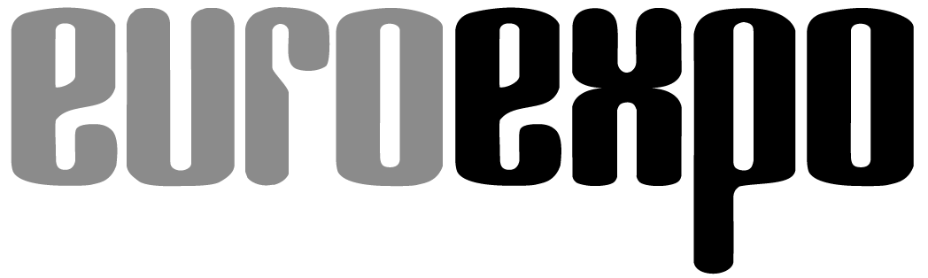
Messe- und Kongress-GmbH
Joseph-Dollinger-Bogen 7
D - 80807 München
Tel.: +49 (0)89 32391-259
Fax: +49 (0)89 32391-246
www.euroexpo.de
www.logimat-messe.de
www.tradeworld.de

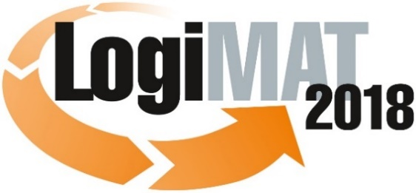

16th International Trade Fair for Intralogistics
Solutions and Process Management
13 to 15 March 2018, Messe Stuttgart

Part of LogiMAT:
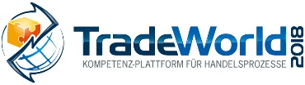

Munich, 22.01.2018

Press Release

LogiMAT 2018 in Stuttgart
LogiMAT 2018 – First-hand packaging

The range of exhibitors at the 16th International Trade Fair for Intralogistics Solutions and Process Management reflects the current trends in packaging technology, making LogiMAT an important presentation platform and working trade fair for the packaging sector.

Up-to-date surveys conducted by the joint committee for German packaging manufacturers, the GADV, have revealed some impressive figures. Almost 19 million tonnes of packaging materials (a rise of 3%) were produced by German manufacturers alone in 2016 – achieving a turnover of 32 billion euros. The highest proportion in terms of volume was represented by paper, cardboard and paperboard packaging at around 46%. The second-largest group is plastic packaging, packaging film, carrier bags and plastic bottles representing around 4.3 million tonnes. The remainder is made up of glass (4.2 million tonnes), steel (1.3 million tonnes) and aluminium (0.4 million tonnes). Persistent trends in segment are as follows: Retailers are resorting ever more frequently to plastics and returnable systems for packaging and load carriers. Corrugated cardboard manufacturers are responding with customisable designs and film-and-cardboard combination solutions. And the packaging of the future will be smart, control its own path through the supply chain and will assume guarantee functions as it does so. In the packaging of high-value individual items for dispatch, 3D printing is also taking on an ever more important role. “Megatrends such as the growth in online retailing resulting in ever more diverse items having to be stored and transported in ever smaller batches, demand flexible, volume-reducible packaging, transport containers and load carriers,” is the analysis delivered by Peter Kazander, Managing Director of EUROEXPO GmbH and LogiMAT’s Exhibition Director. “International packaging technology exhibitors will cover the majority of current trends in the ranges of state-of-the-art products and solutions they will be presenting at LogiMAT 2018.”

The packaging technology exhibitors will be present in Halls 4 and 6 and in the exhibition centre foyer. They will be showing a range of new developments ranging from new high-capacity packaging lines through to packing stations with camera-based object recognition and 3D packaging configurations and versatile returnable packaging. For ‘smart container and storage solutions’, the exhibition management has also created a new exhibition area in Hall 6. There, world-leading suppliers will be presenting appropriate, complete cross-sector solutions. “For example, the integration of RFID components ensures increased transparency and fast response in the supply chain, as well as closer interconnections within value-creation chains,” Peter Kazander explains.

Container filler of sunflower seed husks

Schoeller Allibert GmbH (Hall 6, Stand F31), for instance, with its RackPal 1208 M, will be presenting at the 16th LogiMAT a new rack-storable pallet for loads weighing between 800 and 1,250 kilograms available in twelve variants which can be custom-identified using RFID tags and barcode labels. Nedupack Thermoforming GmbH (Hall 4, Stand F59) is joining the trend in individual, product-specific transport and dispatch packaging with the presentation of its innovative deep-drawn ReFlex® cushions. The company sees these as an alternative to conventional foam and polystyrene packaging.

The innovativeness of the sector is demonstrated by many manufacturers with, for example, innovations in returnable packaging and material mixes. NOVOSTRAT Services GmbH (Hall 6, Stand G36) will be showing Proplite™, innovative system boxes made from a new kind of polypropylene foam. The surfaces of the stackable recyclable and washable returnable containers can be co-extruded with various materials such as fibre webs or a conductive layer, and fitted as appropriate with separators. BVM Brunner GmbH & Co. KG, of Reutlingen, is bringing to Stuttgart the world’s first bubble-wrap packaging machine (Hall 4, Stand B31). Bito-Lagertechnik Bittmann GmbH (Hall 6, Stand C33) will be presenting containers made from sunflower compound (SFC), a sunflower seed husk filling. “An environmentally-friendly, sustainable milestone in the sphere of container production” claims the company.

New ways to network stand-alone devices will be presented by Hagenauer+Denk KG (Hall 3, Stand F67) with its PX-2000 R rotary disc stretch winder. The HDconnect newly developed for it enables complete communication with higher-level control consoles and tablet remote control. Another innovation in the field of conventional corrugated cardboard packaging will be shown by Wellstar-Packaging GmbH (Hall 6, Stand A61) with its ‘PrintYourBox®’ brand, for the first time at LogiMAT 2018. The manufacturer offers this packaging series with self-adhesive closure as customised shipping packaging with individual design and serial print.

Smart cartons, not your basic box

Several exhibitors such as Beumer-Group (Hall 5, Stand A41), also offer entire modular packaging lines. From components such as the fillpac form/fill/seal system for bagging, the paletpac layering palletiser and stretch hood film stretcher, this system supplier assembles packaging installations for sector-specific applications.

In addition to the product and solution ranges from the exhibitors, the 16th LogiMAT will include an informative accompanying programme with trade forums, providing an important source of information on current trends in packaging technology. More explicitly, experts, for instance in the specialist forum ‘Packaging logistics 4.0 – Smart cartons, not your basic box’ (Thurs., 15.3., Forum C, Hall 4) will discuss the opportunities offered by smart transport packaging for an optimised supply chain and customer satisfaction. The forum shows just how smart cartons etc. already are, where there is still room for improvement and what advantages smart transport packaging offers users. So, “True to its motto of ‘first-hand logistics’, the 16th LogiMAT will offer an international trade audience both a comprehensive overview of the current state of the art in packaging technology as well as a look ahead to the requirements and approaches to solutions of the future,” sums up Exhibition Director Peter Kazander. “This makes LogiMAT 2018 an important presentation platform and working trade fair for the packaging industry too.”

Organiser:
EUROEXPO Messe-und Kongress-GmbH
Joseph-Dollinger-Bogen 7; 80807 München, Tel.: +49(89)32391-259;
Fax: +49(0)89 32391-246

Further information: www.logimat-messe.de

6.471 characters (with spaces)
Munich, January 22, 2018 Reproduction free of charge. Copies of publication to: EUROEXPO Messe- und Kongress-GmbH, Presse- und Öffentlichkeitsarbeit, 80912 Munich, Germany.

About LogiMAT
The next LogiMAT, 16th International Trade Fair for Intralogistics Solutions and Process Management, takes place at Messe Stuttgart, directly adjacent to the airport, from 13 to 15 March, 2018. This event is now regarded as the world´s largest specialist trade fair for intralogistics. It presents a comprehensive overview of the market, featuring everything of importance to the intralogistics sector from procurement to production and delivery. Here, early in the year, international exhibitors present innovative technologies, products, systems and solutions for rationalisation, process optimisation and cost-reduction in in-company logistics processes.
TradeWorld – a part of LogiMAT – is a competence platform for trading processes; it showcases products and solutions for e-commerce and omnichannel. Located in the middle of the halls, this event features an exhibition section and also each day different lecture blocks on a wide range of themes.

