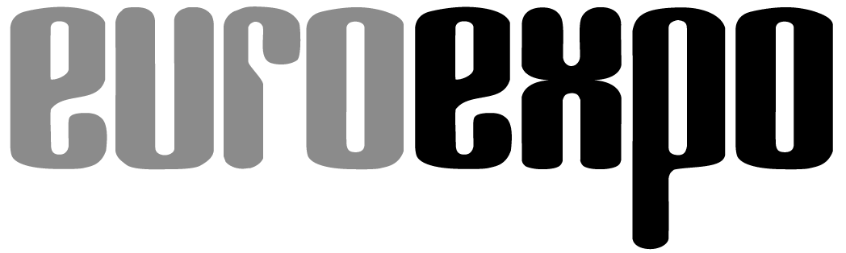
Messe- und Kongress-GmbH
Joseph-Dollinger-Bogen 7
D-80807 Munich, Germany
Phone: +49 (0)89 32391-259
Fax: +49 (0)89 32391-246
www.EUROEXPO.de/en
www.logimat-messe.de/en
www.tradeworld.de/en

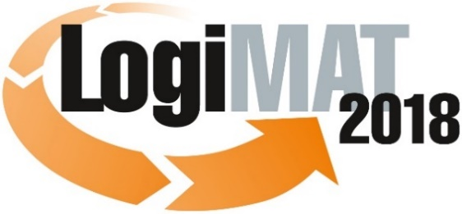

16th International Trade Show for Intralogistics Solutions and Process Management
March 13–15, 2018, Messe Stuttgart

Featured at LogiMAT:
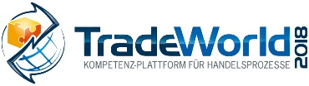

Munich, January 17, 2018

Press Release

LogiMAT 2018 in Stuttgart
LogiMAT 2018 – One-Stop Shop for Intralogistics Software

The software companies exhibiting at LogiMAT 2018 offer a broad spectrum of forward-looking features and cloud-based apps for efficient warehousing and process management. Integration of the latest technological innovations supports the smart processing, analysis, and exchange of data coupled with the increasing interconnectedness of production and logistics.

Rapid advances in technology – together with such forward-looking initiatives as Industry 4.0, Logistics 4.0, and the internet of things (IoT) – present a host of new challenges to both developers and users of logistics software systems. On the hardware end, the aim is to anticipate and accommodate the technological innovations of tomorrow in fields such as sensor technology, imaging, robotics, and augmented reality (AR). Meanwhile, the digital transformation accompanying the aforementioned initiatives underscores the importance of a holistic view of the supply chain and the information-sharing that this requires. Cloud apps also change user behavior and business models. “LogiMAT offers the opportunity to actively engage with the providers of intralogistics software and examine how well the warehouse management systems on display will equip businesses for the challenges that lie ahead,” explains Matthias Thurm, Project Manager at logistics consulting firm IWL AG. “It is the perfect platform to learn about new technologies and current trends in software development, especially in the field of intralogistics.”

“Smart IT infrastructure, together with auto-ID technologies for encoding and capturing data, forms the foundation for integrated information-sharing in intralogistics and the supply chain,” emphasizes Peter Kazander, Managing Director of EUROEXPO GmbH and Event Director of LogiMAT. “The software industry will gather in Stuttgart to showcase a wide range of innovative features and modules in a broad spectrum of solutions to manage processes efficiently and to process, analyze, and deploy accumulated data intelligently.”

The international software community will come together at LogiMAT 2018 in Hall 8 and the new Hall 10 to present its innovations and solutions for sustainable warehouse, transport, and supply chain management. In addition to the integration and coordinated management of intralogistical processes, the current focus is primarily on AR apps and on cloud-based apps and IT platforms. “Smartphones, with their broader functionality and warehouse apps, offer technological advantages over traditional handhelds,” notes Thurm, explaining the trends. “And AR offers new options that leave both hands free for picking.”

Cloud-based apps as an entry-level option

Salt Solutions AG will be on hand in Hall 8, Booth D35 to illustrate how supply chains can be digitized and integrated by linking the exchange of data between existing SAP systems and the ERP suite SAP S/HANA in the Google cloud. With its in-memory database, the suite offers new options for collecting, storing, and above all analyzing data. The company shows the benefits of such analyses in the areas of IoT and analytics. When SAP TM and SAP EWM share data with S/4HANA, for example, sensor data on transport handling and environmental conditions are received, processed, and passed along in real time.

Many such processes are already being handled through cloud-based apps hosted by the app developers on IT platforms run in their own data centers. Cloud-based warehousing solutions provide practical entry-level opportunities particularly for small and medium-sized businesses to optimize their processes and capture and digitize their data. That’s why nearly all the IT developers at LogiMAT 2018 offer cloud-based warehousing features and modules. Such solutions work well where there is no need to control complex automation processes with fast response times.

Mobile devices with cockpit functionalities

Many international exhibitors at LogiMAT 2018 will also present AR-supported apps that go beyond strict warehousing. One example is “digital intralogistics planning” (E&K Automation GmbH in Hall 7, Booth C11; Kardex Deutschland GmbH in Hall 1, Booth H51; Sconvey GmbH Fördertechnik & Materialfluss in Hall 3, Booth C48), where AR headsets enable a virtual tour through a simulated facility for optimizations in advance of project planning. Other examples include support for hands-free picking processes (BEO GmbH in Hall 8, Booth C28) and plant maintenance (Aberle GmbH in Hall 1, Booth C16). Cinovation GmbH (Hall 4, Booth G40) teamed up with an international forklift manufacturer to develop a head-mounted display that offers an alternative to conventional forklift control systems by reading barcodes and QR codes and reporting the successful completion of driving orders.

In the area of traditional warehouse management systems (WMS), LogiMAT 2018 serves as a forum for unveiling new releases with innovative features. S&P Computersysteme GmbH (Hall 8, Booth C41) will focus in part on features for mobile warehouse management that brings control station functionalities to iOS and Android phones and other common mobile devices. “The warehouse control interface is too often neglected,” warns IWL expert Thurm. “We’d like to see control station cockpits that end users can easily create for themselves.”

The speed with which software companies incorporate new technologies and developments is evidenced by PSI Logistics GmbH (Hall 8, Booth D76) with its “2018” versions of the PSI Logistics Suite. Visitors to the PSI booth can experience a live demo showcasing cloud-based material and replenishment management for kanban production, inventory verification, pallet position tracking and management using an IoT chip, and integration of the voice-activated intelligent personal assistant Amazon Alexa into the picking processes. Sintesia Srl. (Hall 10, Booth A62) will also present an “e-kanban” solution that streamlines kanban material management by monitoring internal material flows and providing real-time communication with customers and suppliers—thereby opening the doors to supply chain collaboration.

Accompanying program digs deeper

Route planning and transport management systems (TMS) are yet another field of innovation to be presented at LogiMAT 2018. Dr. Malek Software GmbH (Hall 8, Booth A06), for example, will unveil its redesigned TMS along with a mobile order management app for sharing shipment data, statuses, and documents—now enhanced with additional features and modules. Kratzer Automation AG (Hall 10, Booth C65) has optimized its yard management suite to include the control of transfer vehicles and swap bodies. Dispatchers now use the power of IT to send transport orders directly to the mobile devices of the drivers. The resulting business intelligence data is presented on user-friendly dashboards using visual analytics.

The expert forums included in LogiMAT’s accompanying program feature proven experts sharing their insights into sustainable IT strategies for intralogistics. The timely themes include “Real-Time Data Goldmine Mastery” (March 13, Forum A, Hall 1), “Intelligent Evaluation of Sensor Data Using SAP” (March 14, Forum D, Hall 8), “Digital Transformation Culture” (March 15, Forum A, Hall 1), and “Indoor Localization: A Key to Industry 4.0” (March 15, Forum B, Hall 3).

“In the world of intralogistics software, the realignment of IT systems to the internet of things, augmented reality, and the cloud-based apps of tomorrow has already begun,” affirms Event Director Peter Kazander with a proud eye on the spectrum of international software companies who will showcase their solutions at LogiMAT 2018. “The collaborative integration of logistics and production is in full swing.”

EUROEXPO Messe-und Kongress-GmbH
Joseph-Dollinger-Bogen 7; 80807 Munich, Germany, Phone: +49(89)32391-259;
Fax: +49 (0)89 32391-246

Learn more at: www.logimat-messe.de

7,782 characters (with spaces)
Munich, January 17, 2018 Reproduction free of charge. Copies of publication to: EUROEXPO Messe- und Kongress-GmbH, Presse- und Öffentlichkeitsarbeit, 80912 Munich, Germany.

About LogiMAT

LogiMAT 2018, the 16th International Trade Show for Intralogistics Solutions and Process Management, will take place March 13–15 on the grounds of Messe Stuttgart, directly adjacent to Stuttgart International Airport. LogiMAT, now the world’s largest intralogistics trade show, offers a comprehensive overview of everything driving the intralogistics industry, from procurement to production to shipping. International exhibitors gather early in the year to showcase innovative technologies, products, systems, and solutions for streamlining operations, optimizing processes, and cutting costs in a company’s internal logistics.

TradeWorld, the Professional Platform for Trade Processes embedded within LogiMAT, features products and solutions for e-commerce and omnichannel. Beyond the exhibitor booths, visitors to this combined event can also experience a different program of presentations each day covering a wide range of topics.

