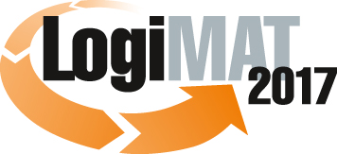
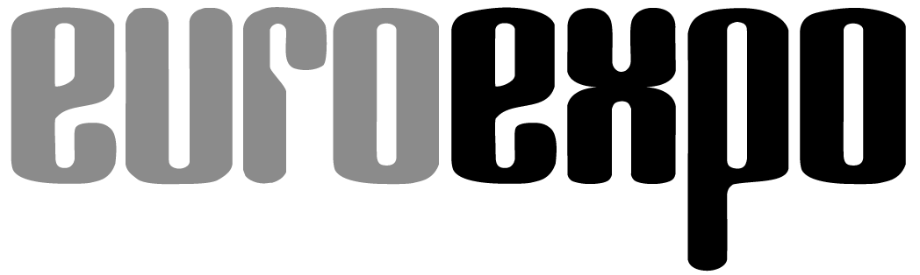
Messe- und Kongress-GmbH
Joseph-Dollinger-Bogen 7
D - 80807 München
Tel.: +49 (0)89 32391-259
Fax: +49 (0)89 32391-246
www.euroexpo.de
www.logimat-messe.de

15th International Trade Fair for Distribution,
Materials Handling and Information Flow
14 to 16 March 2017, Messe Stuttgart

Munich, 14.03.2017

Press Release

Position paper on LogiMAT 2017 in Stuttgart
LogiMAT 2017 – the trade fair for experts and expertise

This year the 15th edition of LogiMAT is impressively underlining the status of this event as the largest and most important international trade show for intralogistics and supply chain management. As an innovative combination of information platform, working trade fair and trend and sector barometer, the concept behind LogiMAT has proven over the last one-and-a-half decades to be a magnet for exhibitors and visitors involved in the intralogistics sector. It has also prepared the ground for the implementation of new technologies and solutions.

The key trends evident from the exhibits on show at the 15th LogiMAT are: comprehensive software solutions, identification systems as basic components in digitalisation, robotics to increase picking efficiency and increasing automation in transport and conveying technology. The many innovations presented are proof of the status of LogiMAT as the No. 1 international presentation platform for the latest products and solutions for the intralogistics sector. “LogiMAT has established itself as the most important trade fair in the intralogistics sector,” was the judgement of Mathias Thomas of Dr. Thomas + Partner GmbH & Co. KG.

That dispenses immediately with any recurring doubts as to whether intralogistics merits its own trade fair. “In particular as regards digital change, Industry 4.0 and the future shape of processes in the internet of things, intralogistics offers such a wide variety of innovations and adjustment screws for process optimisation that we were only able to do justice to our aim of offering the audience a comprehensive display if we restrict the maximum size of stands,” explained Exhibition Director Peter Kazander, Managing Director of the LogiMAT organiser EUROEXPO Messe- und Kongress-GmbH, Munich. “We want to present diversity and quality so that the trade visitors can make a comparison among the international suppliers.” Beyond this, he said, intralogistics is the enabler for both the physical material flows as well as digitalisation and the data-based exchange of information in logistics – all along the supply chain. That is reflected not least in the exhibits and solutions of the exhibitors. “Many exhibitors define themselves now with their product range as integrated suppliers,” said Kazander. As such this important “International Trade Fair for Distribution, Materials Handling and Information Flow” is also, in terms of content, the leading trade fair for process management along the entire supply chain.

Two dominant factors for success and growing internationalisation

Not surprisingly interest on the part of the exhibitors is correspondingly high. Demand is greater than ever before – and that trend shows no signs of stopping. With additional space, for example in the East Entrance and in the gallery between Hall 1 and Hall 3, the organiser has activated a further 3,000 square meters of space in the Stuttgart exhibition centre, in addition to the hall space already taken up. Nevertheless LogiMAT 2017 was already fully booked up by autumn last year. What is quite noticeable is the broad international coverage of LogiMAT. Now some 25 percent of the exhibitors come from outside Germany – many from overseas. China now has more exhibitors at LogiMAT than come from the immediate neighbours of Switzerland and Austria.

Key factors in the success of LogiMAT, according to Kazander, are on the one hand the exhibition concept developed by EUROEXPO, featuring a congress-level supporting program which offers the audience added value in terms of not only product innovations but also information on strategic questions and investment projects. “Often copied, never matched,” noted the Exhibition Director. The second factor in LogiMAT´s success, says Kazander, is in the consistent orientation of the fair to the customers, the trade visitors. “The planning, organisation and implementation of a trade fair is not an end in itself, aimed at bolstering the reputation of the trade fair company and exhibitors,” commented the EUROEXPO MD. “Taking part in a trade fair as an exhibitor is an expensive undertaking for a company. And it has to be worthwhile. This is the basic thinking behind the development and implementation of the trade fair concept offering added value for the visitors. Because success for the trade audience is also success for the exhibitors.”

With its 31 forums featuring high-calibre speakers, three live events and many information events by the exhibitors, LogiMAT offers the trade visitors a supporting programme at no extra cost. This programme gives comprehensive orientation to the audience, in that it helps them select products and decide on the future design of their intralogistics and supply chain processes. The trading platform TradeWorld, which is featured as part of LogiMAT in 2017 for the fourth time, opens up the logistics operations of another important target group with its focus on e-commerce and omnichannel. “Without optimised logistics a company engaged in trade cannot be successful nowadays,” explained Kazander. “Companies in all areas of the e-commerce process chain are most concerned about logistics in particular.”

Working trade fair with added value and a unique atmosphere

The chance to compare a wide range of suppliers, see all the latest innovations and benefit from the added value delivered by the easy-to-navigate exhibition centre in Stuttgart is what makes LogiMAT into a working trade fair where projects are mapped out and business deals signed. Many of the trade visitors come to Stuttgart with specific investment projects in mind, and they actively look for inspiration among the solutions at the stands of the exhibitors and seek orientation in the information events. “LogiMAT is an outstanding format – not only as a place to present one´s own services, but also as a source of information on new products and innovations,” confirmed Ralph Ehmann, CEO and founder of IWL AG.

In the talks the exhibitors benefit from the customer scenarios described to them about specific investment projects. Products and solutions are presented and also developed as a result of these talks. In this respect LogiMAT has established itself over the last 15 years as a pioneer in the development and implementation of the latest technologies and future-capable solutions. “LogiMAT has become the platform for change in intralogistics,” is how IML Institute Director Professor Dr. Michael ten Hompel summed it up.

Face-to-face exchange with like-minded professionals is another key characteristic of the special atmosphere at LogiMAT. In this the trade-fair company sees itself as a coordinator facilitating the contact between exhibitors and trade visitors. “As the organiser we see it as our duty to on the one hand give the exhibitors an attractive platform for direct contact, presentation of new technologies and the latest solutions, and on the other to generate added value for the trade audience and enable them to compare the offerings across the entire, heterogeneous sector,” explained Kazander. “LogiMAT offers intralogistics direct, it presents all you need to know, first-hand knowledge and experience from the people who know. That´s why intralogistics and process-management experts from around the world come to LogiMAT in Stuttgart.”

About LogiMAT

The next LogiMAT will take place at Messe Stuttgart, directly adjacent to Stuttgart airport, March 14–16, 2017. LogiMAT 2016 drew 1,280 international exhibitors from 32 countries, filling eight exhibition halls with the latest solutions and product developments for smart, sustainable intralogistics. The three-day trade show attracted 43,466 trade visitors from 60 countries in 2016. It offers a complete overview of the market and is now regarded as the largest annual event of its type in the world. Within the framework of LogiMAT, TradeWorld features exhibitors showcasing e-commerce and omnichannel solutions for businesses in the manufacturing, commercial, and service sectors. The exhibition, and the accompanying programme of forums at TradeWorld represent a strategic competence of LogiMAT. Alongside the exhibition LogiMAT also offers a diverse program of lectures each day, staged in the heart of the halls, on a wide range of themes.

Further information: www.logimat-messe.de and www.tradeworld.de

Munich, 14.03.2017 Reproduction free of charge. Copies of publication to: EUROEXPO GmbH, Presse- und Öffentlichkeitsarbeit, 80912 Munich, Germany.

