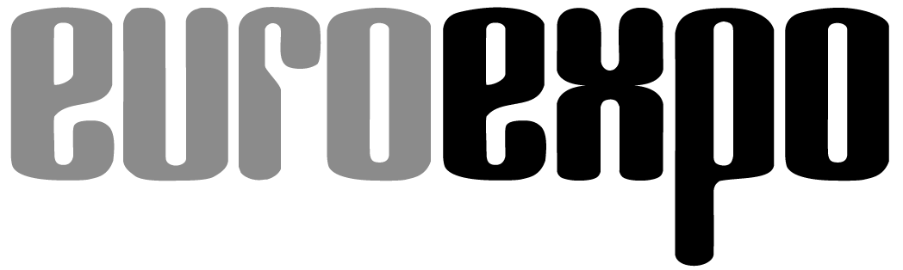
Messe- und Kongress-GmbH
Joseph-Dollinger-Bogen 7
D- 80807 München
Tel.: +49 (0)89 32391-259
Fax: +49 (0)89 32391-246
www.euroexpo.de
www.logimat-messe.de
www.tradeworld.de

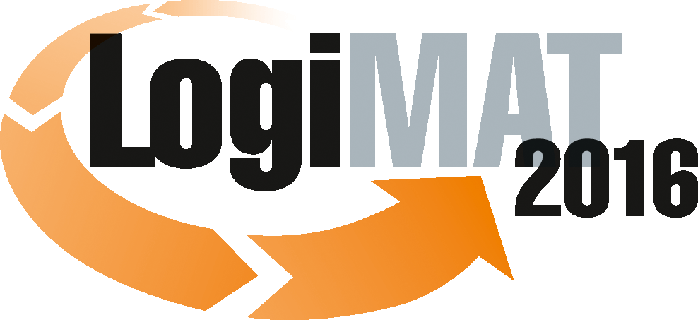

14th International Trade Fair for Distribution,
Materials Handling and Information Flow
8 to 10 March 2016, Messe Stuttgart

Munich, 8 March 2016

Press Release

Position paper on LogiMAT 2016 in Stuttgart
Stability in times of change

Dynamic – that´s an adjective that certainly applies to both intralogistics and LogiMAT. For the 14th time this International Trade Fair for Distribution, Materials Handling and Information Flow is bringing together the suppliers of products and solutions for efficient logistics with a trade audience from industry, commerce and the services sector. For the 14th time LogiMAT is offering a unique and diverse overview of the current offering for efficient logistics. And for the 14th time in succession LogiMAT is expanding – and thereby consistently confirming its outstanding positioning as the largest annual intralogistics trade fair.

For a company to be successful it needs efficient intralogistics. No other area of a company´s operations is so impacted by current developments in technology and the market than in-company materials handling and information flow. At the same time in no other area of the company are there so many ways of influencing efficiency and optimising processes than in intralogistics. The spectrum ranges from labelling and data-capture systems to identification technology, stackers and dynamic warehouse systems, as well as software solutions. At LogiMAT 2016 the product and solutions suppliers in all segments will be presenting the latest developments with which the users can turn intralogistics from a cost-factor into a “profit-booster”.

Challenges, technologies and drivers
The rapid development cycles, for example in sensorics, robotics and imaging, offer brand new automation solutions for intralogistics. In parallel with this, maximum system flexibility is required in the ever increasing field of e-commerce, with its ever smaller order and batch sizes. The digitalisation necessary for future competitiveness goes hand in hand with an increasing interlinking of data and information. In this maelstrom of challenges, development drivers and technological developments, LogiMAT has for almost one and a half decades been providing its visitors from industry, commerce and the services sector with real orientation to help them gear up to meet the future with efficient, cost-effective intralogistics.
Statement by Peter Kazander, Managing Director, EUROEXPO Messe- und Kongress-GmbH, München, Exhibition Director of LogiMAT 2016: “The market requirements and solutions offered in intralogistics are subject to dynamic change. With its comprehensive and clearly structured offering, and a wide range of relevant information on the latest trends and future options for business, LogiMAT offers a compact overview of current solutions and an opportunity to compare them on an international level. That makes this event the premium platform for the innovations capability of small and medium-sized companies.”

Importance of LogiMAT
From its beginnings, shortly after the start of the new millennium, when it was still being held at Stuttgart´s Killesberg exhibition centre, through to this year´s edition, which for the first time is taking up all the available space at the new exhibition centre at Stuttgart Airport – the history of LogiMAT is itself a mirror of the dynamic development that is taking place in intralogistics. For those who are looking to make investments in intralogistics in the near future, and also for every supplier of products and solutions keen to present their latest innovations to the trade audience, LogiMAT has become a firm date in the diary. In the international trade-fair landscape, LogiMAT is recognised as the leading showcase and trend barometer, as a real working fair and an important information platform.

Statement by Peter Kazander, Managing Director, EUROEXPO Messe- und Kongress-GmbH, München, Exhibition Director of LogiMAT 2016: “The continuous growth of LogiMAT is inseparable with the success of the users and exhibitors. It reflects on the one hand the changed view of intralogistics as a decisive factor in competitiveness. On the other it shows the status and the growing importance of the fair over the last 15 years in the strategic orientation of the companies. In addition it confirms the trust of the exhibitors and trade audience in the concept behind this intralogistics fair and the intensive work that this compact and efficient B2B event enables. Today on both the exhibitor and visitor sides LogiMAT is a must-attend event, it´s for everybody who wants to get ahead and stay ahead in the intralogistics business.”

Perspectives
The megatrends of Industry 4.0 and the Internet of Things are finding expression in the development of products and solutions for efficient intralogistics. Both trends will be dominating fields of activity and innovations for quite a few development cycles to come. At LogiMAT 2016 already many exhibitors, across all segments, are specifically addressing these future challenges in their product developments. As such LogiMAT offers users, today, an overview of the options for the future orientation of their investment in intralogistics.
Statement by Peter Kazander, Managing Director, EUROEXPO Messe- und Kongress-GmbH, München, Exhibition Director of LogiMAT 2016: “In intralogistics Industry 4.0 has long since arrived. One of the most exciting core issues and a key theme for LogiMAT is and continues to be how people will in future interact with this complex environment. With all these upcoming developments it is important to implement optimum communication between man and machine in logistic processes. Complexity therefore has to remain manageable.”
EUROEXPO, the organiser of LogiMAT is also facing up to the future challenges in its strategic orientation. In view of the continuing strong interest on the part of the exhibitors and the corresponding growth of LogiMAT and the trading platform TradeWorld, as well as expanding international activities, e.g. with LogiMAT China in Nanjing, at the end of last year the management team at EUROEXPO was expanded.
Statement Peter Kazander, Managing Director, EUROEXPO Messe- und Kongress-GmbH, München, Exhibition Director of LogiMAT 2016:
“We want in future to drive the activities within the framework of our trade-fair, seminar and congress business and open up new fields of business. The priorities lie in the successful expansion of the trade fair LogiMAT and TradeWorld and in further internationalisation through events in growth markets abroad.”

Further information: www.logimat-messe.de and www.tradeworld.de

Munich, Reproduction free of charge. Copies of publication to: EUROEXPO GmbH, Presse- und Öffentlichkeitsarbeit, 80912 Munich, Germany.

