Messe- und Kongress-GmbH
Joseph-Dollinger-Bogen 7
D- 80912 München
Tel.: +49 (0)89 323 91-259
Fax: +49 (0)89 323 91-246
www.logimat-messe.de
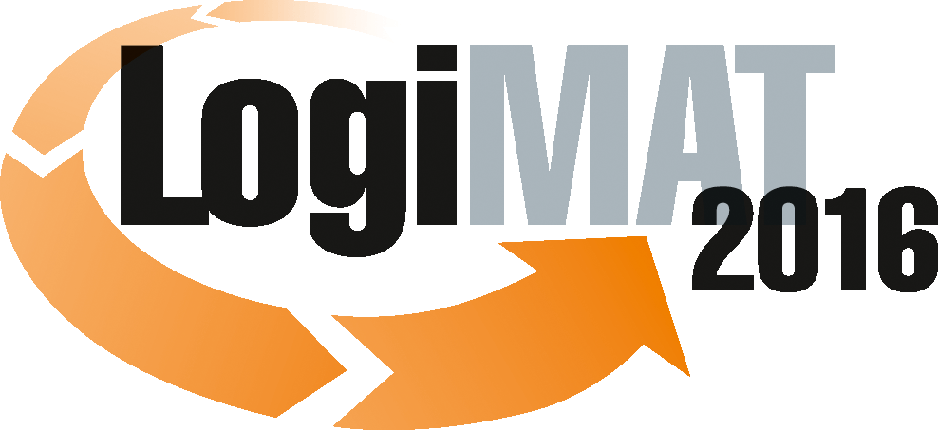

14th International Trade Fair for Distribution,
Materials Handling and Information Flow
8 to 10 March 2016, Neue Messe Stuttgart

Munich, 11.12.2015

Press Release

LogiMAT 2016 in Stuttgart
Congress-standard supporting programme

A high-calibre supporting programme, featuring 30 trade forums and over 100 speakers, three live demonstrations and many events organised by the exhibitors, is to accompany the 14th International Trade Fair for Distribution, Materials Handling and Information Flow. This platform for knowledge-transfer and information exchange extends over all three days of the fair.

On the dedicated platform and special areas in Halls 1, 3, 4, 5, 6, 7 and 9, expert speakers from business, industry, science and research and the media will be discussing the latest trends in intralogistics, reviewing technologies and exploring the background and perspectives for the benefit of trade visitors. The supporting programme is backed by the leading trade institutions, among them the industrial association AIM Deutschland, the Co-operative State University of Baden-Württemberg Lörrach (DHBW), the Institute of Mechanical Handling and Logistics, University of Stuttgart (IFT), the Institute for Distribution and Trade Logistics (IDH) at VVL e.V., the Fraunhofer Institute for Material Flow and Logistics (IML), the Fraunhofer Institute for Manufacturing Engineering and Automation (IPA), the Intralogistics-Network in Baden-Württemberg e.V. (I.N.) and the Association of German Engineers (VDI).

In a number of forums the various facets of Industry 4.0 will be explored, a subject of great importance for the future. For example, on the first day of the fair Professor Dr. Michael ten Hompel, Managing Director of the Fraunhofer Institute of Material Flow and Logistics (IML), Dortmund, will be addressing the subject of “Industry 4.0 and Industrial Data Space®”.

Also on 8 March, Dr. Günter Ullrich will be looking at the demands Industry 4.0 places on automatic guided vehicle systems. Then, on the next day, in a lecture on “Auto ID and sensorics in the light of Industry 4.0”, Wolf-Rüdiger Hansen, AIM Germany, Lampertheim, will be setting out the importance of automatic identification (AutoID), sensors and data integration for Industry 4.0. Also, Professor Dr. Kai-Oliver Schocke, Frankfurt University of Applied Science, will be looking at the linking of production, logistics and IT in a lecture on “Traceability on the road to Industry 4.0”. On the third day of the show – March 10 – the various technologies for object localisation and how they can maximise efficiency in materials handling processes will be analysed by Prof. Dr. Michael Hauth, Chairman, Intralogistics-Network in Baden-Württemberg e.V., in a lecture entitled ”Indoor navigation: Key technology for Industry 4.0”.

Other themes explored in the 90-minute lecture slots include current trends in packaging logistics, alternative energy storage in ground conveyor technology, the impact of demographic change, efficient customer relations management in logistics and intelligent order-picking strategies. Attendees at these expert lectures can look forward to hearing about valuable and workable solutions.

With the trading platform TradeWorld being integrated into LogiMAT for the third time in 2016, the whole area of e-commerce is of course being looked at in the LogiMAT forums, e.g. in a session entitled “Logistics as the backbone of e-commerce in B2B and B2C”. And it is being dealt with in an exciting lecture block and various discussion forums, exploring current trends and challenges of omnichannel trading. The forums will be held in Hall 6, in the TradeWorld exhibition area. The range of themes includes “Payment in digital commerce”, “Urban logistics: Trends and projects in ‘the last mile’”, the presentation of practical experience in “Software applications in omnichannel trading”, “Fulfilment: Fit for international business in e-commerce”, and the question of “Retail 4.0 – Is logistics fit for the trends of digital trade?”,

On all three days of the show, live demonstrations will be held throughout the day on the special display areas in Halls 4, 6, 7 and 9. Visitors can look forward to picking up lots of useful and practical information here. As well as the popular “Tracking & tracing theatre”, organised by the AIM industry association (Hall 4, Stand 4F05), which focuses on the theme of the “industry scenario”, there is a second interactive sequence in cooperation with SALT Solutions: “Industry 4.0 within reach”. Here the visitors can walk through the installation themselves, taking on the role of objects in the production chain. In that way the concept of Industry 4.0 is presented in a very immediate and interesting way.

Under the title of “Logistra City Check” (Hall 6, Stand 6D41) there will be a special exhibition on “Alternative vehicles for city logistics”. This presents an overview of which low-emission vehicles can be used by CEP logistics service providers today and tomorrow.

In Hall 7 (Stand 7A71) visitors can look forward to the “Logistics Innovations Forum” organised by the software company E+P. This presents solutions for current and future mega trends in logistics, Industry 4.0, the Internet of Things, and Data. As well as Android solutions, augmented and virtual reality data glasses, also on display will be new options in the area of analytics.

Under the heading of “We make logistics! – But what is day-to-day practice in transport?” (Hall 9, Stand 9A77), experts from SELogCon and L.K.W. Schmid will be discussing the CTU Code 2015 for ocean-shipping containers and load securing for trucks in upstream and downstream processes.

In addition to this, on the second day of the show in Forum E in Hall 9, the IFT Institute of Mechanical Handling and Logistics, Stuttgart, will be organising an “Intralogistics – Future – Technology Day”. Under the guidance of Prof. Dr.-Ing. Dr. h. c. Karl-Heinz Wehking, Head of the IFT, University of Stuttgart, new technologies in intralogistics will be presented and weighed up.

The Forums – an overview

Tuesday, 08.3.2016
- It´s big. It´s important! – Industry 4.0 and the Industrial Data Space®
- How sensors are changing automated guided vehicle systems
- Developments and trends in packaging logistics – New impetus through innovative concepts and developments
- Payments in digital commerce – From coins and notes to bitcoins
- New transport robots – fast, strong, versatile
- Service 4.0: Global strategies urgently required – How high-tech SMEs can build up global service organisations
- Energy for electric stackers – Li-Ion or lead-acid: Opportunities and risks of two battery technologies
- Auto-ID technologies and solutions in logistics – Automation via barcodes, RFID and marking

Wednesday, 09.3.2016
- Actively shaping demographic change – Approaches, strategies and solutions for logistics
- The right amount of stock for the supply chain – What, when, where, how much?
- Logistics as the backbone of e-commerce in B2B und B2C – How manufacturers are positioning themselves for retail logistics
- IFT Day – Intralogistics – Future – Technology – New technologies in intralogistics
- AutoID and sensorics in the light of Industry 4.0 – New aspects in the digitalisation of materials handling
- Urban logistics: Solutions urgently required – Trends and tendencies for the ‘last mile’
- Shelving: Buy new or repair? – How companies can best deal with damaged shelving
- Software applications in omnichannel trading – Users and suppliers report on their experiences, in a series of ultra-short presentations (à 6 minutes and 40 seconds)

Thursday, 10.3.2016
- Planning of tugger train systems – Types, implementation options and potential
- Order-picking strategies in times of e-commerce – How companies are getting their logistics fit for online trading
- Production is changing – Personalisation, automation and adaptability through Industry 4.0
- Careers in in-company logistics – Jobs profiles, salaries, continuing professional development – Your opportunities in intralogistics
- Future Forum Trade 2016 – Retail 4.0 – Is logistics fit for the trends in e-commerce?
- Traceability on the road to Industry 4.0 – The linking of production, logistics and IT in Big Data?
- Customer Relationship Management in logistics – Ideas for efficient and effective controlling
- Indoor navigation: A key technology for Industry 4.0 – Precise localisation, effective route-planning – here´s how to do it
- Qualified personnel – how to find them
- Fulfilment: Fit for international trade in e-commerce – How logistics professionals are creating the right conditions.

Further information: www.logimat-messe.de and www.tradeworld.de

Munich, 11.12.2015 Reproduction free of charge. Copies of publication to: EUROEXPO Messe- und Kongress-GmbH, Presse- und Öffentlichkeitsarbeit, 80912 Munich, Germany.

