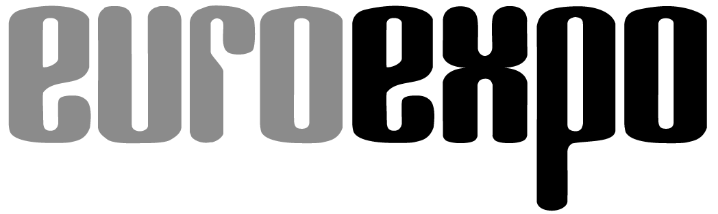
Messe- und Kongress-GmbH
Joseph-Dollinger-Bogen 7
D- 80912 München
Tel.: +49 (0)89 323 91-259
Fax: +49 (0)89 323 91-246
www.logimat-messe.de
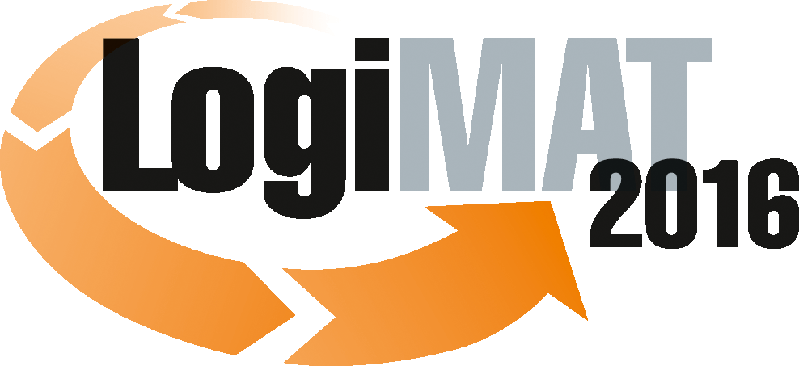

14th International Trade Fair for Distribution,
Materials Handling and Information Flow
8 to 10 March 2016, Neue Messe Stuttgart

Munich, 11.12.2015

Press Release

LogiMAT 2016 in Stuttgart
Mapping out the future of intralogistics

In 2016 LogiMAT will for the first time be taking up all the available space at the Stuttgart trade fair centre. The exhibitors will be showcasing many innovations and new products in a range of different fields. Industry 4.0, the Internet of Things and the ever-expanding area of e-commerce are overarching themes addressed by the solutions providers and in the high-calibre accompanying programme. LogiMAT 2016 will also feature – for the third time at the show – the “Platform for Modern Trading Processes”: TradeWorld.

Under the motto of “Being innovative – Shaping change”, LogiMAT takes place in Stuttgart between 8 and 10 March, 2016. The exhibitors here will be presenting their products, services and solutions for intralogistics aimed at improving the efficiency of processes in in-company materials handling and transport and in data-collection and processing and process control in the warehouse. This unique showcase of intralogistics solutions is being presented by over 1,200 international exhibitors (+ 10 percent) from 32 countries. Visitors can look forward to reviewing all their latest solutions and product developments for intelligent, future-capable intralogistics. And in 2016, for the first time, LogiMAT will be taking up all eight halls – 95,000 m² of exhibition space (+ 12 percent) – at the Stuttgart exhibition centre located right by Stuttgart Airport, thus underpinning its strong position as the biggest annual intralogistics trade fair in Europe.

“Thanks to the optimum position and architecture of the exhibition centre, LogiMAT 2016 remains a very efficient event,” explained Peter Kazander, Managing Director of EUROEXPO Messe-und Kongress-GmbH, Munich, the organizer of LogiMAT 2016. “With the compact arrangement within the halls and the clear structuring of content, making it easy for visitors to identify and get to the areas of interest to them, LogiMAT continues to be an efficient and effective platform for business.” Flanked by its now traditional high-calibre and informative accompanying programme, and with the valuable information provided by the exhibitors and the participating organisations, LogiMAT 2016 is once more a mirror of all the products, services and solutions, market players and current trend themes in the sector. “The solutions offerings on show here point out ways in which companies can optimise their intralogistics processes, thus enabling them to be innovative and meet the challenges facing intralogistics in the future,” said Kazander. “The future in intralogistics has already started.”

The future demands changeable, flexible systems to enhance competitiveness, in the interests of both the companies themselves and also Germany, as a technology and logistics location. Visitors to the 14th International Trade Fair for Distribution, Materials Handling and Information Flow will be able to acquire a foretaste of the products, solutions and different approaches. Many exhibitors from right across all segments in the sector will be addressing the mega trends of Industry 4.0 and the Internet of Things, in their presentations. “The two mega trends, plus e-commerce, are the main drivers in business and solutions developments in intralogistics,” affirms Kazander. “They are identified as key projects with importance for the future and they will be shaping development cycles for some time to come.”

LogiMAT is seen as a trend barometer, an information platform for customer relations and as an important working show,” explains Kazander. “Many trade visitors come along to Stuttgart with a specific intention to invest – and they benefit from the comprehensive display on show here of all the latest developments for efficient intralogistics.”

The exhibition sections at LogiMAT are clearly set out according to segment. The largest section is taken up by exhibitors of materials handling technology, rack construction, warehousing and operational equipment. The system and plant constructors will be showcasing their latest product ranges and innovations for coordinated materials handling in Halls 1, 3 and 5. As well as the suppliers of entire systems, the range of products exhibited here includes world firsts, such as the fully automatic scan portal for logistics applications, based on image-processing technology (Datalogic ADC S.r.L., Hall 3, Stand 3D50) as well as transport robots that can move freely in space, take two small load carriers or stacks, move them and set them down (Förster & Krause GmbH, Hall 3, Stand 3C47). The trade audience can inspect newly developed flow storage racks with integrated reading tunnel (Schmale Logtec GmbH, Hall 1, Stand 1G18) and vertical lift modules for handling and storage of small parts that can move five containers both vertically as well as horizontally (EffiMat Storage Technology A/S, Hall 1, Stand 1B66). Other new products include driverless transport vehicles (e.g. Egemin Automation, Hall 1, Stand 1G64), innovative storage and retrieval equipment that can handle eight to ten times more volume than conventional equipment (Daifuku Co., Ltd., Hall 3, Stand 3D41) and a new mobile solution for unloading and loading pallets of goods from containers (Copal Development B.V., Hall 3, Stand 3A77).

Also in Hall 5 and taking up all of Hall 7 are the developers and suppliers of logistics software, who will be showcasing their new products, systems, modules and functional improvements in process control, data networks and information processing. The product range on show here is as wide and diverse as the fields of application for intralogistics software. It includes not only the latest solutions for export trade, for example customs-processing systems (e.g. from BEO GmbH, Hall 7, Stand 7C28), but also transport management systems and a world first: a forklift management system with laser-based location for independent localisation without conventional reference points or bases (IdentPro GmbH Hall 7, Stand 7F75). Also on show are entry versions for Cloud applications in small- and medium-sized businesses (CIM Logistik-Systeme GmbH, Hall 7, Stand 7C38), omnichannel-capable systems for central management of all retail logistics operations (Sievers- SNC Computer & Software GmbH & Co. KG, Hall 7, Stand 7B64) and optimisation processes with combined monitoring of production and logistics as well as control of entire logistics network (PSI Logistics GmbH, Hall 7, Stand 7D76).

System and plant constructors in the area of materials handling technology, but also manufacturers of ground conveyors are often now also supplementing their usual ranges with IT solutions, facilitated not infrequently by company acquisitions. The IT solutions presented by them at LogiMAT range from materials handling control and resource and vehicle fleet management to warehouse administration systems. “The two segments of materials handling technology and software, and the section on ground conveyors, including driverless transport vehicles and systems, have attracted the most interest from companies wishing to exhibit,” explained Kazander. “And the growth in exhibitor numbers and exhibition space underlines the importance of the three segments for intralogistics processes.”

In Halls 8 and 9 the trade visitors to LogiMAT 2016 can look forward to an exciting display of stacker competence. All the leading manufacturers of ground conveyors, driverless transport systems and stacking technology will be showcasing their state-of-the-art product and IT developments here. They offer a complete overview of the latest developments in the stacker segment. For example, one of the key players in driverless transport systems (JBT Corporation Automated Systems, Hall 9, Stand C51) will be presenting at LogiMAT 2016, for the first time in Continental Europe, an automatic driverless stacker system specially developed for small- and medium-sized companies.

A new multi-function stacker with mast (Crown Gabelstapler GmbH & Co. KG, Hall 8, Stand 8A03), a series of new pedestrian stackers (Cesab Material Handling, Hall 8, Stand 8D03), small, compact vehicles and tow tractors with intelligent 3D-sensorics (E&K Automation GmbH, Hall 8, Stand 8D50) are just a small selection of the innovations awaiting the trade audience at LogiMAT. This showcase is rounded off by an array of innovations, many presented for the first time at LogiMAT 2016. Among them are, for example, an entirely newly developed tri-lateral stacker/retriever (Jungheinrich AG, Hall 9, Stand 9B02 and 9B04), a newly developed carry vehicle for payloads of up to 1.2 tonnes (Grenzebach Maschinenbau GmbH, Hall 9, Stand 9C37) and also the latest developments in alternative drive technology and in fuel technology (Hald & Grunewald GmbH, Hall 8, Stand 8B03).

A special focus are the exhibitors of labelling and identification technology, and of packaging and packaging systems. They are located in Halls 4 and 6. The new products for these specific areas of application range from particularly high-strength Unikraft sealing tapes for high-load cardboard packaging (Herbert Schümann Papierverarbeitungswerk GmbH, Hall 6, Stand 6C29) to new RFID gate solutions (Kathrein RFID GmbH, Hall 4, Stand 4F57) and RFID-based process management systems (Waldemar Winckel GmbH & Co. KG, Hall 4, Stand 4C26). In addition new mobile equipment for industrial direct marking, coding and signing (Schneider-Kennzeichnung GmbH, Hall 4, Stand 4D55), ergonomically designed workplace systems for pack stations (Easypack GmbH, Hall 4, Stand 4B41), industrial NFC printers (Sato Europe GmbH, Hall 6, Stand 6F09) and new foil-packaging technologies for maximum flexibility in packaging processes (e.g. Kallfass Verpackungsmaschinen GmbH, Hall 4, Stand 4C35).
TradeWorld, the platform for modern trading processes, is being held at LogiMAT in 2016 for the third time; and this time, it has even more exhibitors than before. Located in a prominent position in the middle of Hall 6, it offers wide-ranging information on solutions for the design, management and digitalisation of purchasing, marketing, sales, payment and distribution processes, returns management and after-sales.

The intralogistics themes at LogiMAT 2016 will be supplemented and explored in detail in a first-class accompanying programme that is of congress standard. Trade forums and live events taking place in the halls themselves provide all the key information. “The interlinking of systems globally will further promote automation,” Kazander sums up. “Each exhibit presented at LogiMAT is a part of the mosaic of technological developments and system designs for an increasingly dynamic whole.” Suppliers and traders are increasingly opting for automated systems and looking to link up their systems with production. The associated investment in IT and identification, warehouse and materials handling technology will strengthen the competitiveness of the companies. With its unique overview of the latest solutions, LogiMAT 2016 gives optimum guidance on how to design the intralogistics of the future – in industry, trade and the services sector.

Further information: www.logimat-messe.de and www.tradeworld.de

Munich, 11.12.2015 Reproduction free of charge. Copies of publication to: EUROEXPO Messe- und Kongress-GmbH, Presse- und Öffentlichkeitsarbeit, 80912 Munich, Germany.

