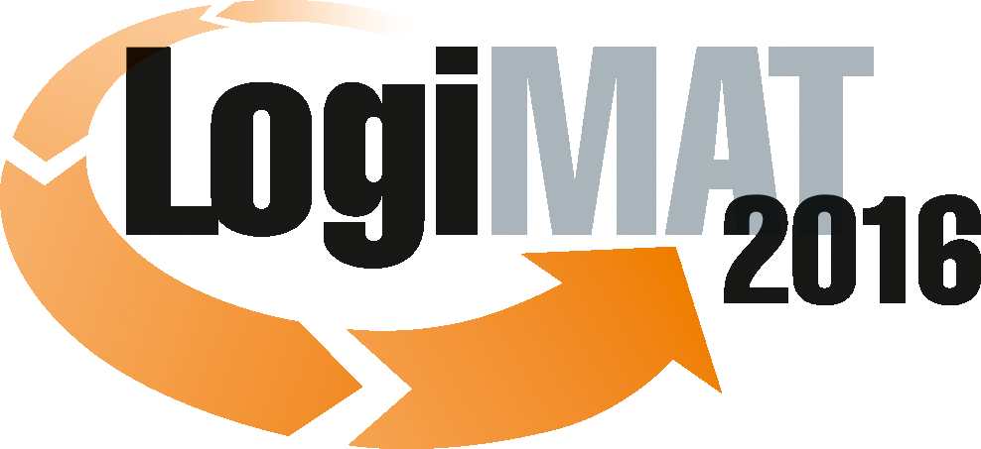
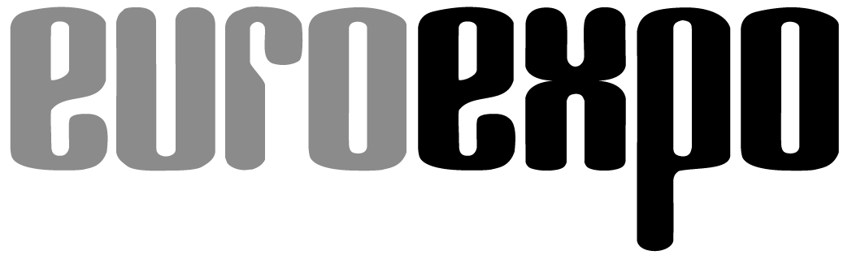
Messe- und Kongress-GmbH
Joseph-Dollinger-Bogen 7
D - 80807 München
Tel.: +49 (0)89 32391-259
Fax: +49 (0)89 32391-246
www.euroexpo.de
www.logimat-messe.de
www.tradeworld.de

14th International Trade Fair for Distribution,
Materials Handling and Information Flow
8 to 10 March 2016, Messe Stuttgart

As part of LogiMAT
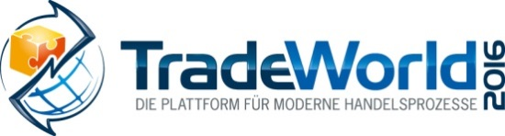

Munich, 10.03.2016

Press Release

LogiMAT 2016 in Stuttgart – Closing Report
LogiMAT 2016 leaps above the 40,000 visitor mark

In 2016, the biggest annual intralogistics trade fair has turned in a record-breaking performance on all fronts: exhibitor and visitor numbers and size of exhibition space. As such LogiMAT has once again underlined its leading position in the international competition.
With an enormous leap in visitor numbers of around 25 percent as compared to last year, LogiMAT 2016, the 14th International Trade Fair for Distribution, Materials Handling and Information Flow, came to a close on Thursday, March 10th. During the three days of this event, a total of 43,465 trade visitors (+23.8 % as compared to 2015) came to the exhibition centre in Stuttgart – that´s 8,360 more than last year. These statistics were recorded by independent market researchers Wissler & Partner of Basel. “The high level of interest from the visitors is a vote of confidence in the concept behind this event and in the general growth trend of LogiMAT,” confirmed Exhibition Director Peter Kazander, Managing Director of EUROEXPO Messe- und Kongress-GmbH, Munich, referring to the growing international scope of this trade fair. In recent years, too, the number of visitors coming to LogiMAT has been growing fast, distorted only slightly in 2015 because of a train strike. “This year´s figures are setting the record straight, and underlining the outstanding significance of LogiMAT for intralogistics and its leading position in the international competition,” said Kazander. As “the first guest organizer to fill all the space at the exhibition centre”, according to the Stuttgart exhibition company, LogiMAT 2016 filled all the halls at the Stuttgart exhibition centre between 8 and 10 March 2016. 1,280 international exhibitors (+10.2 %), of which almost one quarter were from 32 countries (+15 %) around the world, presented their latest solutions and product developments for intelligent, future-capable intralogistics, on 95,400 square metres of exhibition space (+12 %) in eight halls. The rise in the number of international exhibitors and visitors also points to the high profile LogiMAT enjoys abroad, said Kazander.

“Extremely satisfied” is how the exhibition managers described the result – a double-digit percentage increase in exhibitor numbers and exhibition space, and a significant rise in visitor interest. According to the Basle-based independent market researchers Wissler & Partner, more than one third of the visitors (35.7 %) had travelled over 300 kilometres to get to the show. More than 20 percent of the trade audience had travelled to the event from outside Germany. Of those 69 percent came from EU member states, 17 percent from the rest of Europe and 14 percent from overseas, Asia and the Middle East. More than 88 percent of the trade visitors said they came from small or medium-sized businesses and had decision-making powers on capital investments. Around 40 percent of the trade visitors came to the show with a specific intention to place orders, and one in five either placed an order directly at LogiMAT or would be doing so in the time afterwards. In an overall assessment of the fair, 78.3 percent of the LogiMAT visitors gave this intralogistics event top marks - either a grade 1 or 2 rating.
In many cases the exhibitors at LogiMAT 2016 made use of this presentation platform to showcase their latest products and innovations, among them often specific solutions addressing the megatrends of Industry 4.0, the Internet of Things and e-commerce. “This underlines the reputation of LogiMAT as an information platform, a working fair and a trend barometer for developments in intralogistics,” said Dr Petra Seebauer, Managing Director of EUROEXPO Messe- und Kongress-GmbH. “If you can´t find it at LogiMAT, then it doesn´t exist,” added Kazander.
Great interest on the part of exhibitors and the trade audience was also evident in the trading platform TradeWorld, which this year was held for the third time as part of LogiMAT. This focuses on the close integration of logistics with the trading and distribution processes in B2B and B2C. This year the exhibitors presented solutions in Retail 4.0, e.g. on e-procurement, payment, marketing, shop solutions, dispatches management, fulfilment and returns handling. “This year´s TradeWorld has confirmed that e-commerce and omnichannel processes and the logistics that underpin these processes do indeed complement each other very well,” explained Dr Seebauer, Director of TradeWorld 2016. “The integration of the trading platform TradeWorld into the trade fair LogiMAT has proven to be the right decision. E-commerce is a particular growth engine. With this TradeWorld shows the enormous added value that a close integration of e-commerce and logistics can offer. We will further expand the presentation of corresponding solutions.”
LogiMAT 2016 was fully booked, even though it was the first event to take up all the available space at the Stuttgart exhibition centre. By 2018, the date the new hall – Hall 10 – will be finished at the exhibition centre, the event is expected to expand into this new space, with a further rise in exhibitor numbers. “We want to offer the trade audience not only a bigger event, but also diverse and attractive solutions,” summed up Exhibition Director Kazander. “Whatever the future development of LogiMAT, it remains a highly efficient B2B platform, a compact showcase for gathering information and for comparing the offerings of international suppliers of efficient intralogistics.”
The next LogiMAT opens in just six weeks time – between 19 and 21 April 2016, in Nanjing, China.
LogiMAT 2017 in Stuttgart takes place from 14 to 16 March 2017.

Further information: www.logimat-messe.de and www.tradeworld.de

München - Reproduction free of charge. Copies of publication to:
EUROEXPO GmbH, Presse- und Öffentlichkeitsarbeit, 80912 Munich, Germany.

Exhibitor Statements

Importance of LogiMAT

“LogiMAT is continuing to grow in significance and it is now established as one of the world´s leading trade fairs for materials handling equipment. For Crown LogiMAT has a high status.”
Ken Dufford, Vice President Europe, Crown

“LogiMAT is for us the most important intralogistics fair in Germany.”
Hagen Schumann, Head of Sales and Consulting, Klinkhammer Group

“The importance of LogiMAT rises from year to year, because this trade fair has developed from a purely German-speaking trade event into an international showcase.”
Heimo Robosch, Executive Vice President, KNAPP

“As we see it, LogiMAT really does highlight the innovations capability of the European intralogistics sector.”
Pano Papamanoglou, Chief Technology Officer, Körber Logistics Systems

“LogiMAT is a real ‘working fair’, in other words the visitors come to the stands with specific issues for which they are looking for innovative solutions. Often these inquiries result in orders for our sales partners.”
Tobias Zierhut, Head of Product & Service Marketing, Linde Material Handling

“At LogiMAT the intralogistics optimisers present many solutions to help in tackling the challenges of the future. From automation to software, the international trade audience here can find a compact overview of the international market and make direct comparisons between suppliers. With this background, for PSI Logistics as an exhibitor, LogiMAT is one of the most important trade events in the calendar.”
Dr Giovanni Prestifilippo, Managing Director, PSI Logistics

“For us LogiMAT is one of the most important European logistics trade fairs and very well established.”
Horst Reichert, Managing Director, S&P Computersysteme

“Over the years LogiMAT has developed into one of the most important meeting points for the materials handling industry in Europe. An event like LogiMAT serves no other purpose than to provide product information: namely and above all as a forum in which trade professionals can discuss new developments and meet up with customers and business partners.”
Bengt Kristiansson, Managing Director UniCarriers Germany GmbH and Vice President Sales & Marketing, UniCarriers Europe

Importance of TradeWorld

“TradeWorld closes the gap between intralogistics, classical logistics and the digital linking of trading processes in companies. This is not offered by any other fair in such variety and in this combination. We look forward to coming back again next year.”
Mark Winkelmann, Managing Director at the shipping services company ITA Shipping

“At F.X. Rauscher trading companies are a core target group. For that reason TradeWorld is a platform at which we can review the developments and trends in trading in a concentrated way and gather important information. This enables us to adapt our systems as part of intralogistics even more precisely to the customers´ requirements in these logistics chains.”
Stefan Rauscher, Managing Director, F.X. Rauscher

“Our presentation at TradeWorld brought us good contacts to established large companies and also to start-ups from the field of e-commerce. That offer us good potential for new business.”
Jochen Hoffmann, Sales Director at the fulfilment provider KS-Europe

“TradeWorld is an excellent forum for logistics and trade, a place to engage in intensive exchange on the themes of sustainability and the last mile in deliveries. Among the partners at our stand were trading companies as well as representatives from city authorities and municipalities – an unexpected target group mix.”
Klaus Stodick, Manager, Public Relations, UPS Germany

“TradeWorld was very successful for us – as regards making contacts not only with other exhibitors at TradeWorld and other market players in e-commerce, but also with a very well informed expert audience that was looking for webshop solutions.”
Volker Gerhards, Head of Sales, Mifitto

“The trade visitors came to our stand to find out above all about financing and safeguarding options along the entire supply-chain-finance chain. There was particular interest in paydirect payment solutions for online shops.”
Alfred Engelhard, Director Marketing & Business Management at the Hypovereinsbank subsidiary GTG – Global Transaction Banking Germany

“The close connection between trading and logistics offers interesting synergies and potential in regard to efficiency and productivity in the supply chain. We hope that the inclusion of TradeWorld in LogiMAT will bring us an added bonus in terms of interesting new customer contacts from the world of trading.”
Ken Dufford, Vice President Europe, Crown

“Manufacturers, exhibitors and trade visitors alike were very interested in our advice on the development of logistics properties. The inquiries were already very specific. For us taking part in TradeWorld was very definitely worthwhile.”
Nikolai Windhäuser, Managing Director, Logivest Stuttgart GmbH

“The integration of the trading platform TradeWorld in LogiMAT will, we hope, attract even more trade professionals from the area of trading and e-commerce.”
Heimo Robosch, Executive Vice President, KNAPP

“E-commerce and online trading are of high strategic relevance for all logistics companies, because they are among the key growth drivers in our industry. Therefore we welcome the integration of the trading platform TradeWorld in LogiMAT. Comprehensive expertise in digital trading is important to both manufacturers and customers.”
Tobias Zierhut, Head of Product & Service Marketing, Linde Material Handling

