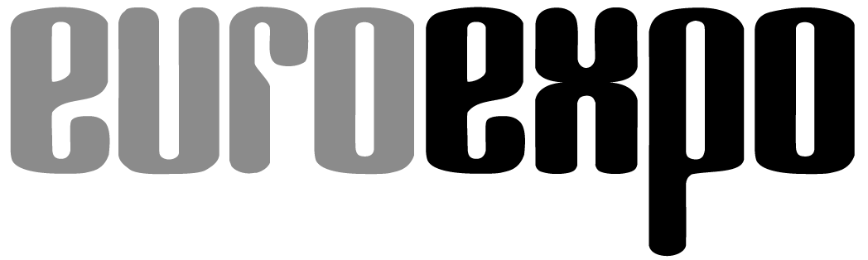
Messe- und Kongress-GmbH
Joseph-Dollinger-Bogen 7
80807 Munich, Germany
Phone: +49 89 32 391 259
Fax: +49 89 32 391 246
www.euroexpo.de/en
www.logimat-messe.de/en
www.logimat.digital
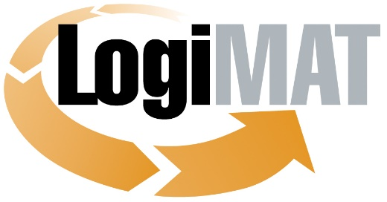

International Trade Show for
Intralogistics Solutions and Process Management
April 25–27, 2023 | Messe Stuttgart

Munich, March 21, 2023

Press Release

LogiMAT in Stuttgart—Powered Industrial Trucks
Latest trends and developments

Munich, March 21, 2023—The world’s leading manufacturers in the powered industrial truck industry are bringing lots of innovations to LogiMAT 2023. Exhibitors have announced plans to unveil never-before-exhibited reach trucks, electric counterbalance and multi-directional forklifts, vertical order pickers, narrow aisle trucks, low-lift pallet trucks, and much more. Industry professionals can also get an overview of what’s currently on offer in related fields such as assistance systems and alternative power technologies.

Despite all the innovations to automate intralogistics: Powered industrial trucks—whether they’re forklifts, hoists, or tuggers with self-driving, semi-automated, or fully manual controls—are still the mainstay for mobility in warehouse intralogistics. The latest surveys published by the European Materials Handling Federation with the World Industrial Truck Statistics (WITS) indicate that orders and deliveries of industrial trucks continued to rise in 2022 and will surpass the already outstanding results from 2021 by number of units sold, with especially strong demand for Class 1 electric forklifts and Class 31 electric low-lift pedestrian pallet trucks. All told, manufacturers estimate having booked some 2.4 million new orders and shipped over 2 million units in 2022. Global Research Consulting forecasts continued growth of the global market by some 7.6% annually through 2026 relative to 2020, driven by the growing demand for automated industrial trucks. “Forklift manufacturers are continuously refining their equipment, giving users the opportunity to further optimize and streamline intralogistical transports,” remarks Exhibition Director Michael Ruchty of LogiMAT organizer EUROEXPO Messe- und Kongress-GmbH in Munich. “They’re optimizing vehicle fleets and enhancing safety with assistance systems while investing heavily in alternative power technologies and autonomous driving features. All the latest innovations from international industrial truck makers will be on display at LogiMAT 2023.”

The world’s leading industrial truck manufacturers are presenting their newest innovations and upgrades in forklifts, pickers, and automated guided vehicles (AGVs) in Halls 9 and 10. Exhibitors have announced plans to unveil never-before-exhibited reach trucks, electric counterbalance and multi-directional forklifts, vertical order pickers, narrow aisle trucks, low-lift pallet trucks, and much more. Industry professionals can also survey new features such as innovative alternatives to the traditional steering wheel and the latest developments in driver assistance and fleet management systems, alternative power technologies, and battery and energy management. Further innovations and optimizations in the field of energy management will also be on display with the integration of three-phase AC technology, energy recovery systems, high-frequency charging technology, and hydrostatic drives.

Next-gen forklifts

The general trend in industrial trucks, especially in Europe, is toward electric forklifts, which are being equipped with increasingly complex technologies and the option for multipurpose models that make various workflows even more economical. The latest vehicles are designed to offer lower operating costs and a more comfortable, ergonomic experience for drivers. Hubtex (Hall 10, Booth 10B20) and Linde Material Handling (Hall 10, Booths 10B21 and 10B17) have announced plans to exhibit new models. Hubtex debuts the FluX 30 series (3 metric ton capacity class), its new generation of electric multidirectional counterbalance forklift trucks designed for both front and side loading for combined pallet and long load transport—now featuring an available mast tilt and increased maneuverability thanks to a reduction in dimensions by up to 20%. Linde MH has announced various premieres, including the Linde T20 SP low-lift truck and Linde V vertical order picker, a narrow-aisle truck with a liftable platform, a maximum picking height of 14.5 meters, and a top speed of 13 km/h. Thanks to its modular design, the Linde V offers various cab designs, assistance systems, mast variants, battery sizes, and payload capacities.

Still (Hall 10, Booth 10B41) will present low-lift pallet trucks with a newly developed tiller concept and foldable stand-on platform and unveil its next-generation electric forklift trucks in the “Xcellence” and “Classic” lines. The new Classic Line is designed as a preconfigured entry-level solution with a focus on core functions, while the Xcellence Line is highly variable and customizable, led by the cutting-edge RXE models. Still will also present a simulated typical material handling process to demonstrate automation options using EXV iGo systems high-lift trucks and an autonomous mobile robot (AMR) from the company’s ACH series.

Irish handling specialist Combilift (Hall 9, Booth 9B45) is coming to Stuttgart to present the first of five new products developed on the basis of the C4000 multidirectional forklift model for the company’s 25th anniversary. EP Equipment Europe (Hall 10, Booth 10G21) introduces an optimized design for its EFL series lithium-powered electric forklifts based on a T8 chassis and featuring a streamlined counterweight, plus the new XP15 AMR with an EP plug-in lithium-ion battery pack. Baoli EMEA (Hall 10, Booth 10C53) presents KBS 12, a compact new family of high-lift trucks powered by lithium-ion batteries and designed as an entry-level electric model for light-duty applications in small and medium-sized warehouses.

Product launch in the AGV segment

Jungheinrich (Hall 9, Booth 9B05) has announced an exclusive product launch at LogiMAT in the field of mobile robotics. The material handling specialist is also positioning itself as a provider of automation solutions with automated storage systems, announcing a versatile and easily scalable solution designed to give customers a simple entry-level automation option and support sustainable warehouse processes. Overall, Jungheinrich wants to show visiting professionals a path to achieve sustainable growth while significantly reducing emissions. Toyota Material Handling Deutschland is coming to LogiMAT 2023 to exhibit its latest innovations in two locations: In Hall 10 (Booth 10F41), the focus will be on forklifts and lift trucks as sustainable, efficient, ergonomic solutions, while the exhibits in Hall 3 (Booth 3A25) will showcase how equipment and components can be combined into integrated overall automation solutions. One centerpiece will be the new mobile load carrier Autopilot CDI120, which can carry loads of up to 1,200 kg and communicate with other AGVs with Toyota’s proprietary T-ONE software.

BYD Europe (Hall 9, Booth 9D17) is presenting advanced energy-efficient forklift truck equipment. The latest ECB25i-C counterbalance truck has been optimized with a new drive unit and an electronic parking brake with automatic battery sleep mode, plus a redesigned steering axle for a reduced turning radius. For the rated capacity of 3.5 metric tons, the ECB35i-C counterbalance truck also on display in Stuttgart features the same improved steering system plus enhanced power steering. Bulmor Industries (Hall 10, Booth 10F50) presents the new generation EQ of its electric sideloaders with lifting capacities of 5 to 18 metric tons, exhibited alongside the myBulmor fleet management system and the modular HiTech energy packages and high-performance motor technology.

“Experts believe that the equipment of tomorrow will rely increasingly on new drive technologies and fleet and energy management systems,” notes Exhibition Director Ruchty. “These segments are served not only by industrial truck manufacturers but also by many specialized companies exhibiting their new products in Stuttgart.” ELOKON (Hall 10, Booth 10F09) is a good example, combining cloud-based fleet management with a forklift assistance system that can be operated through their own Android smartphone app—a combination touted for its innovative user options. Linde MH is promoting the theme of “Green Performance,” presenting energy and power systems optimized for sustainability and efficiency in the Rothauspark open area between Halls 9 and 10.

Energy costs cut by 30 percent

Hoppecke Batterien (Hall 10, Booth 10F32) is presenting the new Hoppecke trak | charger HF giant, an all-in-one high-frequency charger designed to cut energy costs by up to 30% using an electrolyte circulation system and features such as soft charge start and automatic time delay when operating multiple chargers. Still is exhibiting the latest lithium-ion models, fuel cell vehicles, and intelligent charging management with smart energy management solutions. Toyota MH is focusing on alternative power technologies, in particular fuel cell and lithium-ion technology, and will be on hand in Stuttgart to talk about recent innovations such as integrated telematics hardware and the I_Site fleet management system for optimized battery life and energy use. Linde MH will have a separate outdoor area to present its latest forklift truck features, including innovative alternatives to the steering wheel such as the mini-wheel and joystick, a decoupled driver station that protects the operator from vibrations, and various safety and assistance systems.

Parts and accessories suppliers and manufacturers are also coming to LogiMAT to present their latest innovations, many of which integrate state-of-the-art sensor technology. Vetter Industrie (Hall 10, Booth 10A11) is showcasing its SmartFork family of innovative forks with integrated next-gen camera and sensor technology. The Lizzard attachment is unlike anything ever before exhibited, featuring a green cross laser and camera mounted on the fork carriage to help the operator easily store, inspect, and retrieve goods at heights. CAM attachments (Hall 10, Booth 10A61) is coming to LogiMAT 2023 with a clamp for electronic devices that uses sensors to detect the load and optimize surface clamping pressure. The company will also exhibit a new pulp bale clamp for recycling plants and a double pallet device for forklifts. Ravas Europe (Hall 10, Booth 10C75) will also be represented at LogiMAT 2023 with a new version of the iCP fork carriage scale with Weigh in Motion technology, designed to weigh difficult-to-pack products when using attachments such as clamps or rotators.

“Besides the AGVs and AMRs clustered in Halls 6, LogiMAT 2023 offers professionals from the industrial, manufacturing, and service sectors a comprehensive overview of the latest innovations in equipment and solutions from international industrial truck manufacturers with the exhibits in Halls 9 and 10, including the outdoor areas, plus a complete accompanying program of expert talks and forums,” concludes Exhibition Director Ruchty. “All this makes this year’s LogiMAT another must-attend event for anyone who is planning on investing in new industrial truck technology or simply wants to keep up with the latest trends and innovations in the industry.”

Organized by: EUROEXPO Messe- und Kongress-GmbH
Joseph-Dollinger-Bogen 7 | 80807 Munich, Germany
Phone: +49 89 32 391 259 | Fax: +49 89 32 391 246
www.logimat-messe.de | www.logimat.digital

11,120 characters (with spaces)

Munich, March 21, 2023—This text may be reprinted free of charge, but please send a copy to EUROEXPO Messe- und Kongress-GmbH, Press and Public Relations Department, 80912 Munich.

About LogiMAT

LogiMAT, the International Trade Show for Intralogistics Solutions and Process Management, will take place at the Messe Stuttgart convention center, directly adjacent to Stuttgart International Airport, from April 25 to 27, 2023. Presented by EUROEXPO Messe- und Kongress-GmbH, LogiMAT ranks as the world’s largest trade show for intralogistics solutions with a complete market overview of everything driving the intralogistics industry, from procurement to production to shipping. International exhibitors showcase innovative technologies, products, systems, and solutions for streamlining operations, optimizing processes, and cutting costs in a company’s internal logistics. Beyond the exhibitor booths, visitors can also experience a different program of presentations each day covering a wide range of topics.
EUROEXPO has also partnered with Landesmesse Stuttgart since 2014 to present LogiMAT China, planned as an annual event and returning to Shanghai June 14–16, 2023.
Bangkok became the newest venue in the portfolio with the debut of LogiMAT | Intelligent Warehouse in 2022, presented with local organizer Expolink Global Networks Ltd. and focused on the Southeast Asian market. The next event takes place October 25–27, 2023.
LogiMAT.digital is the platform that brings together top providers of the world’s best intralogistics solutions with high-quality leads, bridging the time and space between on-site events.

