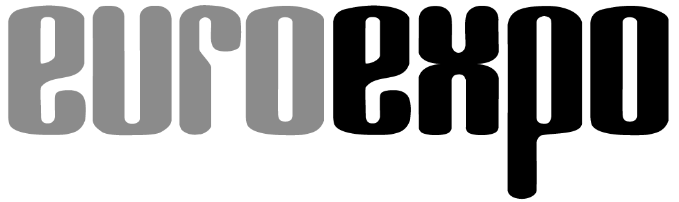
Messe- und Kongress-GmbH
Joseph-Dollinger-Bogen 7
D-80807 Munich, Germany
Phone: +49 89 32 391 259
Fax: +49 89 32 391 246
www.euroexpo.de/en
www.logimat-messe.de/en
www.logimat.digital
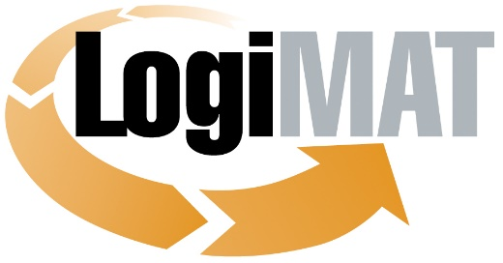

International Trade Show for
Intralogistics Solutions and Process Management
April 25–27, 2023 | Messe Stuttgart

Munich, March 16, 2023

Press Release

LogiMAT in Stuttgart—Automation
Automating and Optimizing Resources

Munich, March 16, 2023—International equipment makers and systems integrators at LogiMAT 2023 are presenting their latest systems and solutions for digital transformation and flexibility, a comprehensive toolkit for overcoming current challenges through efficient intralogistics.

The providers of material handling technology and intralogistics systems have proven resilient and crisis-proof in a difficult economic environment. The industry association VDMA forecasts continued growth for industrial machinery and equipment manufacturers in the intralogistics sector in the year ahead. Businesses need to design their supply chains, logistics, and intralogistics for greater flexibility, efficiency, and resilience to counteract the shortage of skilled labor and challenges of digital transformation. This drives up the demand for specialized automation solutions for intralogistics. Systems manufacturers and integrators are responding with a steady stream of new product developments that integrate the latest innovations in complementary technologies to deliver solutions that rise to today’s challenges of efficiency in intralogistics processes. “The industry already demonstrated its power for innovation amid a critical environment with the products and solutions it introduced at LogiMAT 2022,” remarks Exhibition Director Michael Ruchty from EUROEXPO Messe- und Kongress-GmbH in Munich. “The innovations in industrial machinery and equipment, presented overwhelmingly by small and medium-sized businesses at LogiMAT 2023, underscore the industry’s flexibility and adaptability and once again highlight how much potential still remains in many companies for maximizing efficiency and optimizing digital transformation in intralogistics.”

International equipment makers and systems integrators, the largest exhibitor group at this year’s LogiMAT, are presenting their current portfolio of products and solutions for the efficient flow of goods in intralogistics in Halls 1 (including the gallery), 3, 5, and 7. The products on display there meet the demands of today’s marketplace. “The focus is on automating processes with as much flexibility as possible while optimizing resources,” notes Ruchty. “The objectives are many and varied: reduce the need for personnel, make consistent use of available space, cut energy consumption, and make solutions more scalable and customizable.” The spectrum ranges from automated systems for small parts storage and compact storage, including shelving and automated storage and retrieval system components, to new solutions in the fields of intralogistics transports, automated picking, steel platforms, material handling and hoisting technology, and motors. The more sophisticated systems often integrate artificial intelligence (AI) into their control technology.

Customizable compact systems

Manufacturers of compact systems are bringing their latest updates and innovations to LogiMAT, including AutoStore (Hall 1, Booth 1J61). with the latest improvements to its popular automated storage and retrieval system, as well as Fb Industry Automation (Hall 5, Booth 5B32) and Westfalia Logistics Solutions (Hall 1, Booth 1C20). Fb Industry Automation is presenting software and picking hubs as well as the Fb Compact Warehouse with it new Fb Compact Shuttle. The automated small parts warehouse can be custom-designed for lengthwise or crosswise storage with up to six-deep loading and 120 kg of load weight per shuttle. Westfalia Logistics Solutions is exhibiting the latest version of its popular Satellite® storage system with patented load-handling technology. Westfalia reports a strong demand for Satellite®, which comes in a wide range of models and can be tailored to each customer’s specifications. The Simon Hegele Gesellschaft für Logistik und Service (Hall 7, Booth 7B13) also has a something special in store for visitors to Stuttgart, presenting a live demo with compact storage technology from SMB International to illustrate the journey into a fully automated compact storage warehouse from a completely unique perspective.

Among the exhibitors of system components for automatic small parts and pallet storage, Acme Intralog Europe (Hall 1, Booth 1L08) is coming to LogiMAT with standardized material handling solutions, a new picking cobot, and a higher-performance shuttle system for automated storage and retrieval systems (AS/RS) in pallet storage. SIBA System Integration (Hall 1 upper level, Booth 1OG15) is presenting custom pallet AS/RS in various models featuring a slim, lightweight single-mast construction that delivers superior performance. Other new shuttles for AS/RS and traditional warehouse applications include Heber Fördertechnik (Hall 1, Booth 1C61) with a shuttle system in action, ROCKETSOLUTION (Hall 1, Booth 1A35), and Megvii Automation & Robotics (Hall 1 upper level, Booth 1OG82). Megvii presents the latest generation of its 3D pallet shuttle system, featuring a distinct and uniquely failsafe design that offers a distributed control architecture for system redundancy. The system’s critical component is the 3D pallet shuttle, which can move freely in both directions within the shelf. With its presentation, Megvii seeks to demonstrate how it is possible to grow capacities, improve the use of space, cut energy consumption and carbon emissions, and boost productivity. ROCKETSOLUTION is presenting its RSX1 shuttle system, a robust automated small parts storage system for warehouse goods up to 50 kg touted as reducing space requirements by over 50% compared to conventional shuttle systems. AFB Anlagen- und Filterbau (Hall 3, Booth 3D16) is showcasing its new customizable Miniload telescopic fork units as the ideal load carriers for single-deep or multi-deep storage and retrieval in small parts storage.

Industrial robots for new picking solutions

Equipment makers and systems integrators are increasingly turning to robotics to maximize efficiency in picking processes, with several exhibitors focusing on stationary industrial robots. Knapp (Hall 3, Booth 3B03) is focusing its exhibit space on zero-touch fulfillment, presenting the INDU-Store compact storage system for small and very small parts and the latest versions of the fully automated Pick-it-Easy picking robot and the Open Shuttle autonomous mobile robot (AMR) for intralogistical transports. Dambach Lagersysteme (Hall 1, Booth 1F41) is presenting a redesigned version of the MONOFLEX rail-guided vehicle system for intralogistical transports of totes, capable of effectively sorting containers with a throughput of up to 450 carts per hour and special load transfer points.

SSI Schäfer (Hall 1, Booth 1D21) is presenting an enhanced, fully automated piece-picking application with patented grip point calculation, additional features such as pick-and-place, AI-assisted object recognition, and 100% product verification. Dutch systems integrator Inther Group (Hall 5, Booth 5B57) is offering a first-ever live presentation of the AI-assisted robotic picking solution Gripp (Gantry Robotic Intelligent Piece Picker). The system uses AI vision technology and light sensors to automatically measure the weight, length, width, and height of a product, and is touted as capable of picking up to 1,200 items per hour. Polish system developer Nomagic (Hall 1 upper level, Booth 1OG78) and Element Logic (Hall 1, Booth 1H21) are among the exhibitors showing the latest robot-assisted picking solutions designed specifically for use with AutoStore systems. Element Logic is presenting a live showcase featuring the robot picking solution eOperator in collaboration with material handling technology and an AMR from Addverb Technologies (Hall 3, Booth 3A39 ). Nomagic is showing a new solution with a picking robot from the justPick product line, a robotic arm for fully automated applications equipped with a scanner, imaging analytics, and AI processes for a throughput of up to 400 picks per hour.

Peripherals and new material handling components

Many exhibitors in the fields of lifting and material handling technology, both mobile and stationary, are also coming to Stuttgart with new peripherals and material handling components for the equipment makers. This includes new box-lifting devices and sorting systems (Fath, Hall 7, Booth 7A21); energy-efficient motors, motorized rollers, gearboxes, and roller conveyors for horizontal conveyor systems (ABM Greiffenberger Antriebstechnik, Hall 3, Booth 3B15); and sorter motors, gearless motors for AGVs, and AMR differential motors with integrated drive electronics (MTA, Hall 5, Booth 5F32). MUNK Günzburger Steigtechnik (Hall 3, Booth 3C17) is exhibiting a collection of crossover ladders and catwalks that can be individually configured and flexibly combined. Bizerba (Hall 5, Booth 5F28) is offering a static dimensioning and weighing system from the MetriXFreight product family that is integrated into Bizerba’s Global Shipping software. This makes it possible to capture all the relevant data and create and print a linerless shipping label all in a single step. Steel platform supplier MiTek (Hall 1, Booth 1K58) and CBS (Hall 3, Booth 3C81) are presenting redesigned metal shelving, stairs, and industrial platforms, among the lates mezzanine solutions ensuring the future viability of steel platforms.

“All this sets the stage at LogiMAT 2023 for the most comprehensive overview of the latest systems and solutions that equipment makers and systems integrators in the intralogistics industry are offering to meet the challenges of our time,” concludes Exhibition Director Ruchty.

Organized by: EUROEXPO Messe- und Kongress-GmbH
Joseph-Dollinger-Bogen 7 | 80807 Munich, Germany
Phone: +49 89 32 391 259 | Fax: +49 89 32 391 246
www.logimat-messe.de | www.logimat.digital

9,657 characters (with spaces)

Munich, March 16, 2023—This text may be reprinted free of charge, but please send a copy to EUROEXPO Messe- und Kongress-GmbH, Press and Public Relations Department, 80912 Munich.

About LogiMAT

LogiMAT, the International Trade Show for Intralogistics Solutions and Process Management, will take place at the Messe Stuttgart convention center, directly adjacent to Stuttgart International Airport, from April 25 to 27, 2023. Presented by EUROEXPO Messe- und Kongress-GmbH, LogiMAT ranks as the world’s largest trade show for intralogistics solutions with a complete market overview of everything driving the intralogistics industry, from procurement to production to shipping. International exhibitors showcase innovative technologies, products, systems, and solutions for streamlining operations, optimizing processes, and cutting costs in a company’s internal logistics. Beyond the exhibitor booths, visitors can also experience a different program of presentations each day covering a wide range of topics.
EUROEXPO has also partnered with Landesmesse Stuttgart since 2014 to present LogiMAT China, planned as an annual event and returning to Shanghai June 14–16, 2023.
Bangkok became the newest venue in the portfolio with the debut of LogiMAT | Intelligent Warehouse in 2022, presented with local organizer Expolink Global Networks Ltd. and focused on the Southeast Asian market. The next event takes place October 25–27, 2023.
LogiMAT.digital is the platform that brings together top providers of the world’s best intralogistics solutions with high-quality leads, bridging the time and space between on-site events.

