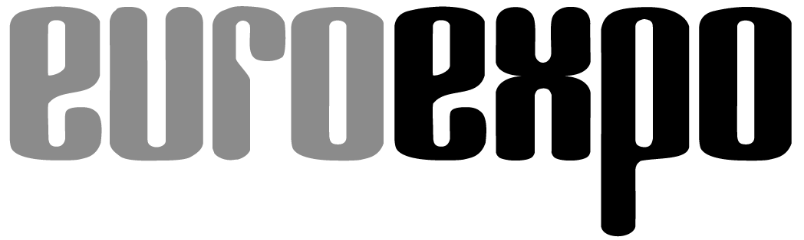
Messe- und Kongress-GmbH
Joseph-Dollinger-Bogen 7
80807 Munich, Germany
Phone: +49 89 32 391 259
Fax: +49 89 32 391 246
www.euroexpo.de/en
www.logimat-messe.de/en
www.logimat.digital
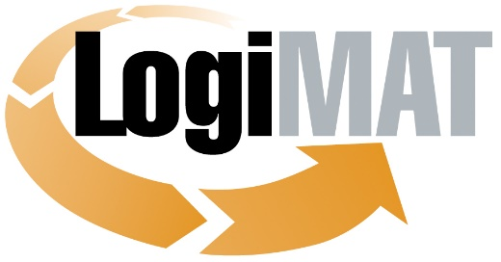

International Trade Show for
Intralogistics Solutions and Process Management
April 25–27, 2023 | Messe Stuttgart

Munich, March 14, 2023

Press Release

LogiMAT in Stuttgart—Information Technology
Software for Greater Efficiency and Digital Transformation

Munich, March 14, 2023—The software industry is reasserting its role as the source of solutions for modern, streamlined processes, bringing a diverse portfolio of new systems, modules, and applications to LogiMAT 2023 that reflect current demand while pointing the way toward the trends of tomorrow.

Developments in software for the intralogistics industry are defined by flexible automation solutions, a technology push by IoT devices, and the challenges of making analog processes digital. In many companies, progress on digital transformation remains halting. At the same time, the shortage of skilled workers is pushing companies to automate processes in order to reduce their dependence on personnel. But digital transformation projects often stall due to a lack of programmers. The tech industry in Germany alone faces a shortfall of 137,000 skilled workers. The demand for tech in intralogistics is strong, however, because software systems support modernization efforts and unleash a huge potential for cost-cutting and optimization when processes are coordinated with the help of automation. What’s needed are interconnected logistics systems that create visibility, simplify collaboration, and minimize risks and costs. Software developers are responding, continually refining their portfolios by integrating current automation hardware in warehouse technology and incorporating the latest technologies such as artificial intelligence (AI) and robotic process automation.

Intralogistics software developers are pursuing several strategies, as the international exhibitors at LogiMAT 2023 demonstrate,” explains Exhibition Director Michael Ruchty from LogiMAT organizer EUROEXPO Messe- und Kongress-GmbH in Munich. “The comprehensive warehouse management systems (WMS) and logistics suites reveal two trends. Providers are working on further integrating the software environment, using systems from a single source wherever possible, with a clear trend toward standardized software that can be scaled and customized to each customer’s unique specifications—sometimes even by the users themselves.” Several providers are building on these standardized products to develop unique industry solutions with predefined modular feature sets, typically cloud-based, that can be plugged in at short notice.

Second, many software companies are focusing their efforts in the intralogistics industry on expanding their product portfolio, in particular by integrating systems and features of horizontally adjacent systems and applications of downstream systems. “New systems, system modules, and applications with features like transportation and fleet management, route and resource planning, or dock and yard management are a clear focus among the software providers represented at this year’s LogiMAT in Hall 8,” Ruchty observes. “Innovations include both standalone systems and extended functionalities of WMS and material flow systems.”

Cloud and AI for transportation management

Soloplan (Hall 8, Booth 8C02) is presenting innovative new features in its CarLo® transportation management system (TMS), including a redesigned full-text search, a file API and web API, and fully integrated optical character recognition to more easily automate logistics processes and simplify and accelerate routine tasks. C-Informationssysteme (Hall 8, Booth 8F25) is coming with the new version 5.8 of its transportation management solution, which seamlessly blends TMS, warehouse logistics, and fleet management by integrating online portals, freight exchanges, data hubs, web services, mobile devices, and apps. The software can also connect to other systems linked through a bidirectional interface, including document management, enterprise resource planning, financial accounting, and business intelligence systems. LIS (Hall 8, Booth 8F65) is presenting a new “graphical hall layout” feature for the Cross-Docking Center module of its WinSped TMS that provides a visual overview of means of transport changes in the hub and is designed to simplify the management of LCL and collective cargo shipment. The new feature will be rolled out in April. The ICS Group (Hall 8, Booth 8A21) is introducing its new Transport Control System, available as a web app and designed to optimize resource planning in intralogistical transports and help companies accelerate their digital transformation.

ORTEC (Hall 8, Booth 8B46) combines and optimizes the functionalities of various system modules—including transport, shipping, capacity, route, and resource planning—with its new ORTEC Routing and Dispatch (ORD). The solution makes it possible to consolidate smaller picking orders into larger shipping orders when supplying stores, for example. The company also offers ORTEC Load Optimization (OLO) as a cloud-based SaaS solution. The Ehrhardt Partner Group (Hall 8, Booth 8A71) is presenting its own route planning solution Greenplan, part of the Supply Chain Execution Suite EPG ONE and capable of analyzing how traffic speeds vary by time of day to boost on-time delivery rates to over 97 percent. Opheo Solutions (Hall 8, Booth 8F61) also promises the potential for significant optimization with an AI-based route optimization system that relies on predictive planning and cloud-based truck dispatching. TIS Technische Informationssysteme (Hall 8, Booth 8A05) is focusing on helping smaller transport companies digitize their operations with TISLOG office Infodesk 5, the latest generation of its dispatcher platform, and a cloud-based fleet management solution. Leogistics (Hall 8, Booth 8G74) is coming to LogiMAT 2023 to present Yard Management for the first time, its new SAP-based solution for coordinating the complex processes at warehouse sites that uses a hybrid approach combining both on-premise and cloud-based components.
Hybrid software architectures, such as an SAP core extended through state-of-the-art cloud solutions, are increasingly in demand. A flexible response to events outside of your control often depends on quickly accessing cloud-based data and importing it into your company IT system for processing there. That’s why even cloud-friendly companies do not depend solely on cloud-based options. SAP (Hall 8, Booth 8B55) is coming to Stuttgart with automated solutions for warehouse and transportation management and customs and trade compliance. Several other exhibitors are also bringing along subsystems, modules, and applications that interact with SAP. LogiPlus Consulting (Hall 8, Booth 8C49), for example, is presenting the LP EasyWarehouseManager, a new add-on that can integrate various automation hardware components and deliver real-time workload visibility in SAP EWM to support the planning and control of warehouse activities. Flexus (Hall 8, Booth 8B31) is introducing a mobile loading app for SAP EWM that tracks and manages loading processes and provides unique, error-free identification of unit load devices. Photo documentation, signature capture, and the creation of electronic shipping documents are automatically integrated into the SAP system.

Portals and platforms for sharing, analyzing, and using data

Besides expanding their cloud offerings, software companies are also increasing their efforts to make their systems and applications into tools for smart data analytics by better integrating data-sharing capabilities and integrating AI logic into the WMS. The aim is to allow quick and detailed analyses of merged data and obtain reliable forecasting for deploying resources and optimizing processes. TUP (Hall 8, Booth 8A31) is putting artificial intelligence front and center, presenting new WMS-integrated AI solutions under the TUP.AI series that analyze intralogistics data to support and optimize operations. Paari (Hall 8, Booth 8D05) is also focusing on data analytics with its latest developments for the titan® libra software, including new dashboards and individually customizable user interfaces for better task management analytics. Hüngsberg (Hall 1, Booth 1B72) identified a problem that smaller enterprises experience in integrating their electronic data interchange, then developed webDAX as an EDI portal solution that requires nothing more than a computer with an internet connection. Companies without an ERP or EDI system can use the portal to successfully exchange documents with their business partners.

The portal and platform approach is another defining trend in intralogistics software today. Platforms are designed to connect multiple cloud providers and users in a transparent environment to share, manage, and access large volumes of data securely. There are many providers on the market responding to today’s challenges with platforms that make it possible to exchange supply chain data, run data analytics, or obtain IT support—all with no programs to install. Box ID Systems (Hall 4, Booth 4A53) is presenting with a management and analysis system for managing logistics data and inventory. At the core is a cloud-based data intelligence platform that makes it possible to fuse, aggregate, and automatically analyze unlimited quantities of mobile tracking devices with other sources of data, such as ERP systems. Robert Bosch (Hall 8, Booth 8F37) is teaming up with US-based cloud giant Amazon Web Services to introduce the Bosch L.OS Logistics Operating System platform, which will be rolled out to logistics and forwarding companies in Germany starting in mid-2023. The idea is to give transport and logistics companies better access to powerful software tools without the need to invest their own time and resources into costly IT projects. Logenios (Hall 8, Booth 8A80) is a registered cooperative presenting a logistics gateway that supports the direct, real-time, end-to-end flow of information among all supply chain participants. The Logenios File Converter turns static data into useful information. Every player—from consignors to carriers, freight forwarders, transport companies, and consignees—receives the relevant data directly into their own ERP, TMS, or telematics system.

“The snapshot of current solutions that software providers are bringing to LogiMAT illustrates the broad spectrum of approaches that software systems use to streamline processes, optimize resources, and support forward-looking intralogistics,” concludes Exhibition Director Ruchty. “No software, no digital transformation. The software solutions presented at LogiMAT 2023 illustrate current trends, showcase the latest breakthroughs in the integration of cutting-edge technologies, and show the path forward for the innovations of tomorrow. A comprehensive overview that spans the entire diversity of industry software systems.”

Organized by: EUROEXPO Messe- und Kongress-GmbH
Joseph-Dollinger-Bogen 7 | 80807 Munich, Germany
Phone: +49 89 32 391 259 | Fax: +49 89 32 391 246
www.logimat-messe.de | www.logimat.digital

10,780 characters (with spaces)

Munich, March 14, 2023—This text may be reprinted free of charge, but please send a copy to EUROEXPO Messe- und Kongress-GmbH, Press and Public Relations Department, 80912 Munich.

About LogiMAT

LogiMAT, the International Trade Show for Intralogistics Solutions and Process Management, will take place at the Messe Stuttgart convention center, directly adjacent to Stuttgart International Airport, from April 25 to 27, 2023. Presented by EUROEXPO Messe- und Kongress-GmbH, LogiMAT ranks as the world’s largest trade show for intralogistics solutions with a complete market overview of everything driving the intralogistics industry, from procurement to production to shipping. International exhibitors showcase innovative technologies, products, systems, and solutions for streamlining operations, optimizing processes, and cutting costs in a company’s internal logistics. Beyond the exhibitor booths, visitors can also experience a different program of presentations each day covering a wide range of topics.
EUROEXPO has also partnered with Landesmesse Stuttgart since 2014 to present LogiMAT China, planned as an annual event and returning to Shanghai June 14–16, 2023.
Bangkok became the newest venue in the portfolio with the debut of LogiMAT | Intelligent Warehouse in 2022, presented with local organizer Expolink Global Networks Ltd. and focused on the Southeast Asian market. The next event takes place October 25–27, 2023.
LogiMAT.digital is the platform that brings together top providers of the world’s best intralogistics solutions with high-quality leads, bridging the time and space between on-site events.

