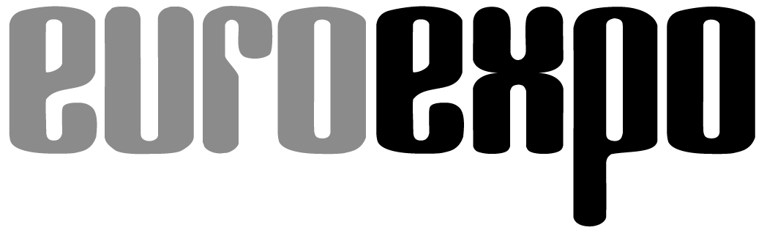
Messe- und Kongress-GmbH
Joseph-Dollinger-Bogen 9
D- 80912 München
Tel.: +49 (0)89 323 91-253
Fax: +49 (0)89 323 91-246
www.euroexpo.de
www.logimat-messe.de
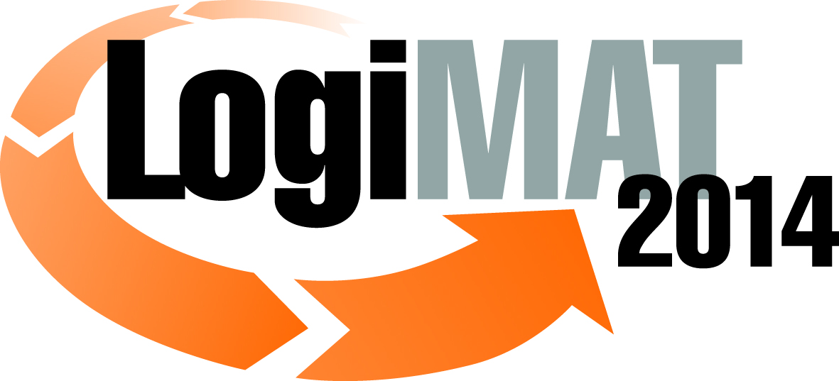

12th International Trade Fair for Distribution,
Materials Handling and Information Flow
25 to 27 February 2014, New Stuttgart Trade Fair Centre

Munich, 15.07.2013

Press Release

LogiMAT 2014 in Stuttgart – Announcing….
The first "Forum TradeWorld", focusing on modern trading processes

LogiMAT 2014 is being held under the motto of "Intelligent networking – Mastering complexity". Already 82 percent of the exhibition space has been sold – a good seven months before the show gets under way. That is a positive indication that the event is poised to expand yet again. A new focal theme, complete with its own dedicated series of lectures, is "Forum TradeWorld – Forum for modern trading processes".

LogiMAT 2014, taking place from 25 to 27 February 2014, has taken the motto of "Intelligent networking – Mastering complexity". This puts its finger on the need for highly efficient logistics coupled with flexible processes in response to a dynamic and often volatile market characterised by constantly rising customer demands. In the end it is about carefully choosing the right tools and processes to save on resources and increase efficiency.

At the present moment, seven months before the start of the event, already over 80 percent of the available exhibition space in Stuttgart has been booked. "We are very pleased that LogiMAT is a firm date in the diary each year for many leading firms. For us this is confirmation that the event has a clear profile – and that it is now a part of the trade-fair landscape for this sector," said Exhibition Director Peter Kazander.

Featured for the first time: Forum TradeWorld, a forum for modern trading processes
A large number of LogiMAT visitors come from the wholesale and retail trade, and they use a variety of different marketing channels: physical stores, catalogues, e-commerce and, increasingly, multi-channelling.
According to a recent report by the German E-Commerce and Distance Selling Trade Association (Bundesverband des Deutschen Versandhandels – bvh), sales in online and distance selling reached €10.7 billion in the first quarter of 2013 (cf. Q1 2012: €8.9 billion). That is an increase of 19.4 percent year on year. E-commerce in particular is growing fast in Germany. No less than €8.7 billion, or 81.5 percent, of the total sales for Q1 this year came in e-commerce. That´s 37.3 percent higher than in the same period last year.

In order to optimise trading processes, what´s needed to beat the competition is not only the right marketing approach within the respective trading platform, but also above all efficient logistics and secure payment processing systems. It is obvious that LogiMAT, with its concentration of logistics expertise, is the ideal platform in which to anchor these themes.

"We want to cater better than before to the information needs of this important group of visitors from the trading sector, and so for the first time we are including a Forum TradeWorld in the accompanying programme to LogiMAT 2014. This event will look at the whole issue of modern trading processes," said Exhibition Director Peter Kazander.

Here, at the Forum TradeWorld, is an optimum presentation platform for suppliers of products and services in the areas of fulfilment, payment and claims management, logistics and returns management, direct marketing, e-business and also consultation and creation.

The accompanying series of lectures covers the following themes: "Partnership CEP", "Fulfilment", "Returns management", "CRM & data protection", "Success factor: customer approach", and "Future forum retail". Attendance at these lectures is free to LogiMAT 2014 ticket-holders.

So far, the following industry organisations, companies and research institutes have signed up as cooperation partners for this event:

Bundesverband der Deutschen Versandbuchhändler e.V.,
Bundesverband Deutscher Inkasso-Unternehmen e.V. (BDIU),
Bundesverband Internationaler Express- und Kurierdienste e.V. (BIEK),
Fraunhofer-Institut für Materialfluss und Logistik (IML)
Institut des Interaktiven Handels GmbH (IDIH).

Talks are currently ongoing with further strategic partners.

The official deadline for close of registrations for LogiMAT 2014 and the Forum TradeWorld 2014 is 30 September 2013.

Further information, e.g. the nomenclature of the Forum TradeWorld 2014 is at: www.logimat-messe.de/tradeworld

This press release and the official logo for the Forum TradeWorld 2014 are available for download from the press centre at the LogiMAT 2014 website.

Review of LogiMAT 2013
Exhibitors: 1,003
Focal areas at LogiMAT:
Materials handling and storage technology, warehousing and operational equipment, warehouse and production controls/robotics, packaging, loading technologies, ground conveyors, information and communication technology, commissioning systems, labelling and identification, software for storage systems, despatches and transport, outsourcing partners, recycling and waste disposal, logistics facilities and consultation.
Exhibition area: 74,000 m² (gross) in Halls 1, 3, 5, 4, 6 and 8
Duration: 3 days
Venue: New Stuttgart Trade Fair Centre; Internet: www.logimat-messe.de

Munich, 15.07.2013 – Reproduction free of charge. Copies of publication to: EUROEXPO GmbH, Presse- und Öffentlichkeitsarbeit, 80912 Munich, Germany.

